Title: Global Imaging of Solar Wind-Planetary Body Interactions using Soft X-ray Cameras - A White Paper Submitted to the Planetary Decadal Survey

Author: Michael R. Collier, NASA/GSFC, 301-286-5256, Michael.R.Collier@nasa.gov

Coauthors:
Thomas E. Cravens, Univ. of Kansas, cravens@ku.edu
Mats Holmstrom, IRF-Sweden, matsh@irf.se
James Burch, Southwest Res. Inst., jburch@swri.edu
Konrad Dennerl, Max Planck-Germany, kod@mpe.mpg.de
Herbert Gunell, Univ. of West Virginia, hegunell@mail.wvu.edu
David G. Sibeck, NASA/GSFC, david.g.sibeck@nasa.gov
Steven Snowden, NASA/GSFC, steven.l.snowden@nasa.gov
F. Scott Porter, NASA/GSFC, frederick.s.porter@nasa.gov
Ina P. Robertson, Univ. of Kansas, robertin@ku.edu
Nick Omidi, Solana Scientific, omidi@adelphia.net
Kip Kuntz, Johns Hopkins Univ., kuntz@pha.jhu.edu
Steven Sembay, Univ. of Leicester, sfs5@star.le.ac.uk
Jennifer Carter, Univ. of Leicester, jac48@star.le.ac.uk
Andrew Read, Univ. of Leicester, amr30@star.le.ac.uk
Dimitra Koutroumpa, CNRS/IPSL, dimitra.koutroumpa@aerov.jussieu.fr
Massimiliano Galeazzi, University of Miami, galeazzi@physics.miami.edu
Susan Lepri, University of Michigan, slepri@umich.edu
K.C. Hansen, University of Michigan, kenhan@umich.edu
Dan McCammon, U. of Wisconsin, Madison, mccammon@wisp.physics.wisc.edu
Ruth Skoug, Los Alamos Nat. Lab., rskoug@lanl.gov
H. Kent Hills, Adnet, howard.k.hills@nasa.gov
Timothy J. Stubbs, UMBC and NASA/GSFC, timothy.j.stubbs@nasa.gov
Pavel M. Travnicek, UCLA pavel@igpp.ucla.edu
George Fraser Univ. of Leicester, gwf@star.le.ac.uk
Mark Lester Univ. of Leicester, mle@ion.le.ac.uk

Global Imaging of Solar Wind-Planetary Body Interactions using Soft X-ray Cameras

A common challenge in all of space physics - including studies of the terrestrial plasma environment – is the difficulty of imaging plasmas near planets. Auroral images capture some global aspects of the solar wind or magnetospheric interaction with the planets (e.g., Earth, Jupiter…). For example, Mars Express (MEX) auroral UV indicated regions of electron precipitation [Bertaux et al., 2006] and both UV and X-ray images of the Jovian aurorae provide some idea of the global magnetosphere-ionosphere interaction. Furthermore, the IMAGE mission provided dynamical images of the Earth’s plasmaspheric plasma [Burch et al., 2003]. Yet the distribution of the solar wind around the planets and the entry of solar wind into magnetosphere-atmosphere systems have not been imaged. We show in this white paper that, with suitable instrumentation on planetary and terrestrial spacecraft, soft X-ray emission associated with the solar wind interaction with planetary neutral atoms can map out the solar wind distribution around planets, including the locations of plasma boundaries such as magnetopauses and bow shocks.
1. Solar Wind Charge Exchange (SWCX) - In the mid-1990s observations of comet Hyakutake by the Roentgen Satellite, ROSAT, as shown in Figure 1, revealed unexpectedly strong soft X-ray emission [Lisse et al., 1996]. This was a mystery at the time: very hot objects are normally required to produce X-rays, and comets are far too cold. However, shortly thereafter Cravens [1997] provided the explanation for this mysterious emission. The solar wind, a radially flowing fluid of primarily protons and helium which fills the entire solar system, also contains a small percentage (<1%) of high charge state heavy ions like C⁶⁺, O⁷⁺, and Fe¹³⁺. These species which are ionized in the solar corona maintain their charge state as the solar wind flows outward through the solar system. When these solar wind ions encounter the high densities of neutral atoms close to a comet, they undergo charge exchange, basically “stealing” an electron from the cometary neutral atoms. The resulting heavy ion, which now has a charge state lower by one, ends up not in the ground state, but rather in an excited state. This excited state quickly relaxes, and in the process the product ions emit soft X-ray and EUV photons [cf. Cravens, 2002; Krasnopolsky et al., 2004]. This process is shown in Figure 2. Other X-ray production mechanisms were evaluated (e.g., scattered solar X-rays) and turned out to be much less efficient than SWCX [cf. Krasnopolsky et al., 2004; Bhardwaj et al., 2007].
However, the observation that settled definitively that the mechanism for cometary soft X-ray emission is solar wind charge exchange was the first Chandra comet spectrum. This spectrum showed clear lines which could be identified with specific high charge state solar wind ions. For example, when solar wind O⁸⁺ ions charge exchange with a neutral atom the excited O⁷⁺ produced emits at the characteristic lines at 654 eV, 775 eV, and 817 eV. And solar wind O⁷⁺ ions produce lines from excited O⁶⁺ at 561 eV, 568 eV, 574 eV, and 616 eV [cf. Lisse et al., 2001].
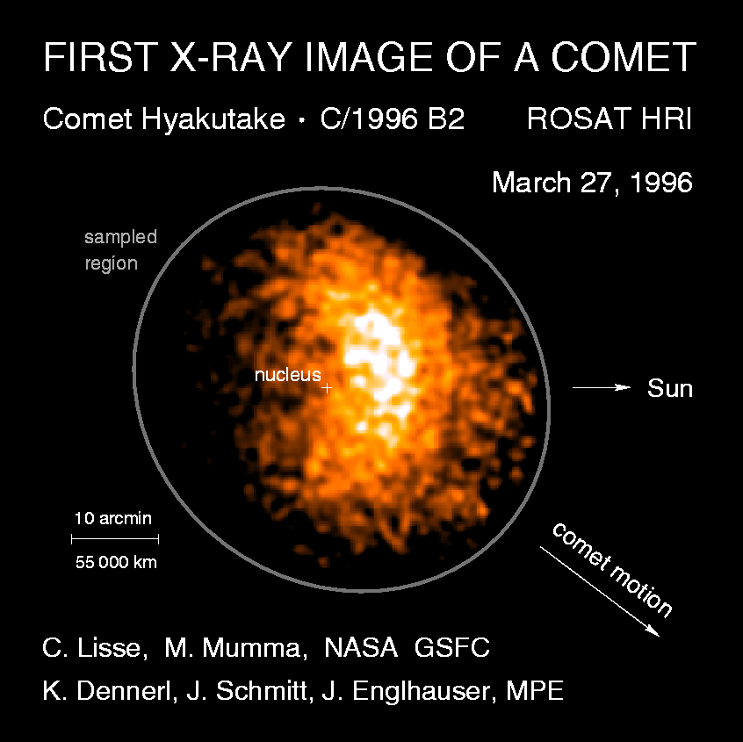
Figure 1 - Mysterious soft X-ray emission from comet Hyakutake.
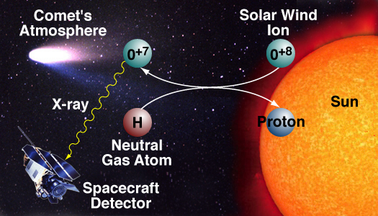
Figure 2 - Solar wind charge exchange soft X-ray emission mechanisms.
Subsequently, we have learned that all comets are X-ray sources with luminosities as high as 1 GW and with the emission extending over hundreds of thousands of kilometers [cf. Cravens, 2002; Dennerl et al., 1997; Krasnopolsky et al., 2004; Kharchenko and Dalgarno, 2000]. Figure 3 shows Chandra and EUVE satellite observations of the X-ray (panel A) and EUV (panel B) emission generated by SWCX at comet LINEAR. The emission is spread out due to the extensive nature of the comet’s atmosphere (coma) and the emission peaks sunward of the cometary nucleus due to collisional depth effects as the solar wind ions are attenuated by the charge transfer collisions. By contrast, the optical image (panel C) shows cometary ions (CO⁺ bands) concentrated in the comet’s magnetotail. Panel D shows simulation results. Lisse et al. [2001] and other observers have demonstrated with measured spectra that the soft X-ray emission is mainly in transition lines expected from solar wind high-charge state species. Kharchenko et al. [2003] used relative line strengths from soft X-ray spectra observed from comet McNaught-Hartley to deduce the solar wind composition (e.g., relative O⁸⁺ and Ne⁹⁺ to O⁷⁺ abundances) upstream of this comet. And Wegmann and Dennerl [2005] used XMM-Newton data to construct a spatial image of comet C/2000 W1 in soft X-rays. Derivatives of averaged soft X-ray images were used to map out the dynamic location and shape of the cometary bow shock, which was found to be in good agreement with expectations.
With the insight provided by the cometary soft X-ray observations, it was not much of an extension to realize that the same charge exchange process operating at comets is also operating at all times around Earth. This is because the Earth’s exosphere extends beyond the magnetopause, the magnetic boundary that separates the Earth’s geospace environment from that of the solar wind [Hodges, 1994; Østgaard et al., 2003]. The terrestrial exospheric hydrogen density, which exceeds the nominal density of the solar wind at the magnetopause, drops off rapidly and continuously with distance from the Earth. So, soft X-ray emission due to the solar wind interacting with the Earth’s exospheric hydrogen should also be observed near the Earth. Figure 4 shows the correlation between the solar wind proton flux observed by IMP-8 and the ROSAT soft X-ray flux and illustrates not only the presence of this signal, but also its exceptional correlation with local solar wind conditions. ROSAT experienced a high count rate even though it observed from low-Earth orbit and was constrained to look roughly perpendicular to the Earth-Sun line, and therefore through the flanks rather than through the most intense emission at the nose of the magnetopause. In addition, ROSAT showed an almost immediate response to rapid variations in the solar wind [Cravens et al., 2001].
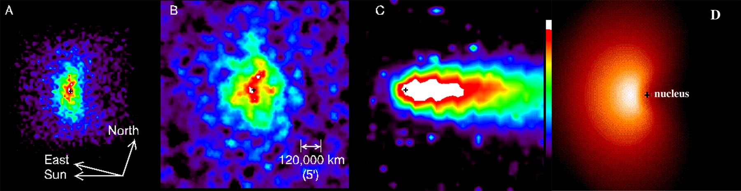
Fig. 3. Dramatic images of SWCX emission from comets graphically illustrate that the same type of imaging can be performed at other solar system bodies. Panels a-c from Lisse et al. [2001]. Panel d – X-ray emission calculated with a MHD simulation of the solar wind flow around comet Hyakutake [Haberli et al., 1997; Cravens, 2002].
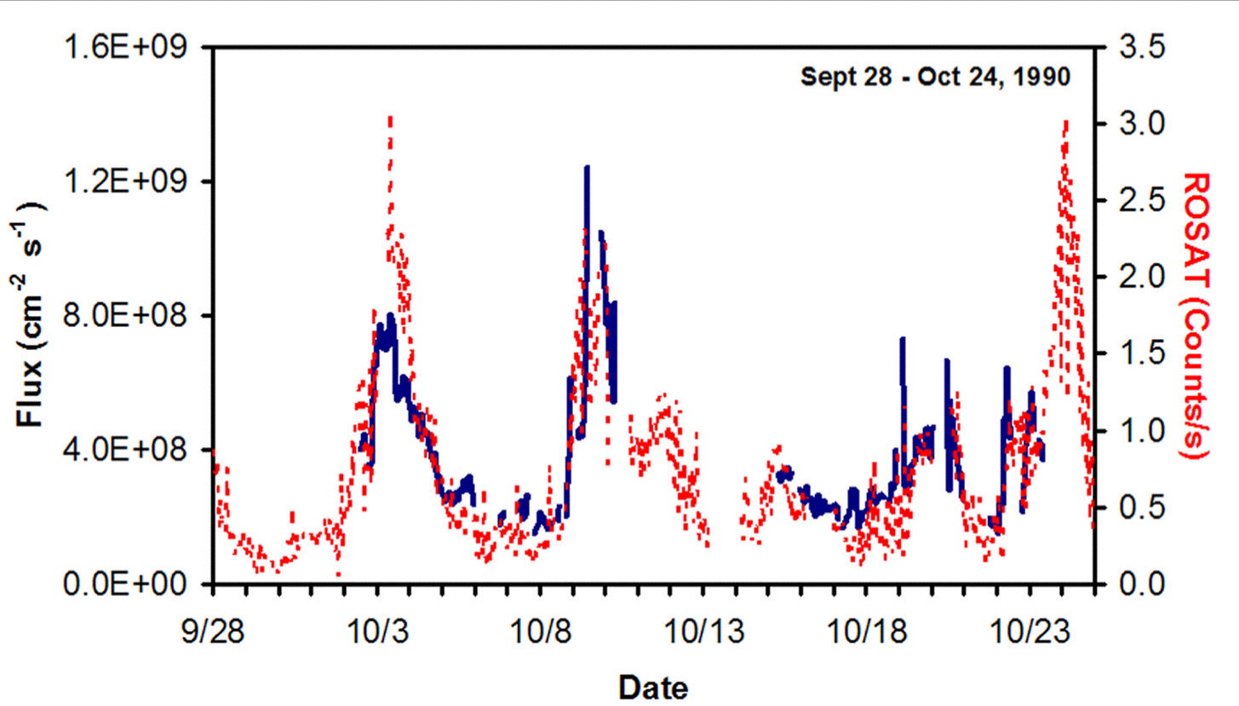
Fig. 4. The correlation between soft X-ray intensities (red dashed) and solar wind fluxes (blue solid) shows that the solar wind interacting with neutral atoms in the vicinity of Earth can be observed in soft X-rays.
Note that soft X-rays can also be produced by elastic and fluorescent scattering of solar X-rays from a gas, a fact well demonstrated by astrophysical X-ray observatories when looking at the sunlit Earth [Snowden and Freyberg, 1993]. This effect is also observable in other solar system objects. For example, Cravens and Maurellis [2001] predicted that the disk X-ray emission from Venus and Mars was largely due to X-rays associated with K-shell ionization of carbon dioxide which Dennerl et al. [2002] later confirmed with Chandra observations. However, the cross sections for either elastic scattering or K-shell photoionization are very small in comparison to those for SWCX and a large column of gas is needed to produce significant X-ray intensities. For comets, Krasnopolsky [1997] estimated that this source is orders of magnitude less efficient than the SWCX mechanism. Similarly, Krasnopolsky demonstrated that for comets, K-shell X-ray production from solar wind electron impact ionization is not important (this electron population is far too cold).
2. Current and Future Observations at Mars and Venus - The discussion above clearly demonstrates that solar wind charge exchange soft X-ray imaging provides global imaging in contrast to traditional in-situ measurements (e.g., Mars Global Surveyor, Mars Express, Pioneer Venus, Venus Express). Traditional in-situ imaging does not provide a global view of the plasma environment including the bow shock and the solar wind-ionosphere boundary layer (i.e., “ionopause” boundary layer). The upper ionosphere and any associated ionospheric/atmospheric escape at Mars strongly depend on how the solar wind interacts with the ionosphere, atmosphere, and crustal fields. The upper ionosphere, extending out through the magnetic pile-up boundary, is a region where ionospheric plasma can escape down the tail (on the nightside), or where pick-up processes are particularly effective. Global imaging of the solar wind distribution around Mars would greatly enhance our ability to determine the solar wind-related atmospheric escape.
Observations of global SWCX emission at Mars and Venus show that the soft X-ray emission from both planets are similar in nature to those from Earth. At Mars, the Chandra X-ray observatory in 2001 detected an X-ray halo due to solar wind charge exchange [Dennerl et al., 2006; Gunell et al., 2004, 2005; Dennerl, 2002; Holmstrom et al., 2001]. At Venus, because the mass of Venus is significantly larger than that of Mars, the exospheric density falls off faster [Gunell et al., 2007]. Consequently, identifying the SWCX X-ray halo in initial Chandra data in 2001 was unsuccessful due to solar maximum solar X-ray contamination. However, subsequent Chandra observations in 2006 and 2007, during solar minimum did reveal the Venusian exosphere to emit SWCX soft X-rays [Dennerl, 2008]. 30.4 nm UV emission from charge exchange of solar wind alpha particles with atmospheric species has been observed at both Venus and Mars and compared to soft X-ray emission [e.g. Krasnopolsky and Gladstone, 2005], so that UV observations supply complementary data to soft X-rays.
Figure 5 shows two simulations of solar wind charge exchange X-ray emission at Mars. In the figure on the left, the small white circle shows Mars’ surface and the large circle shows the outer limit of the X-ray halo. Recently, Suzaku imaged Mars and XMM-Newton will image Mars in November. For the XMM observation, we will have in-situ ASPERA-3 ion measurements, which will enable better modeling than we have had for past observations.
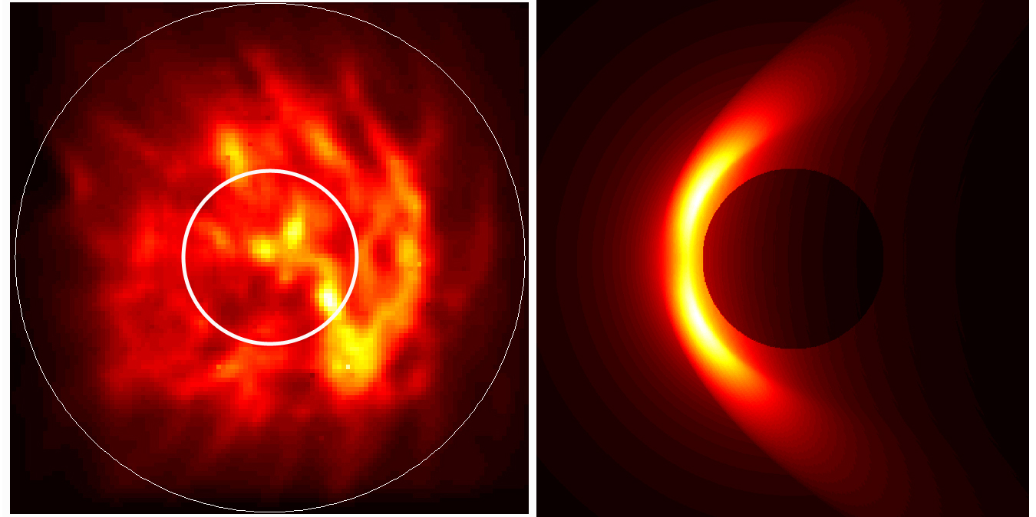
Fig. 5. Simulated images of solar wind charge exchange X-ray emission from Mars.
In this context, the terrestrial magnetosheath can also serve as a relevant example of potential observations at other planets. Figure 6 shows a simulation of the interaction between the solar wind and the terrestrial magnetosphere as observed in soft X-rays from both the front and side. The plasma configuration was determined from MHD simulations performed at the Community Coordinated Modeling Center (CCMC) for the March 31, 2001 storm [Robertson et al., 2006]. Note that the cusps should be particularly bright soft X-ray emitters because the solar wind has easy access along the open field lines to the high density neutral atom population close to the Earth.
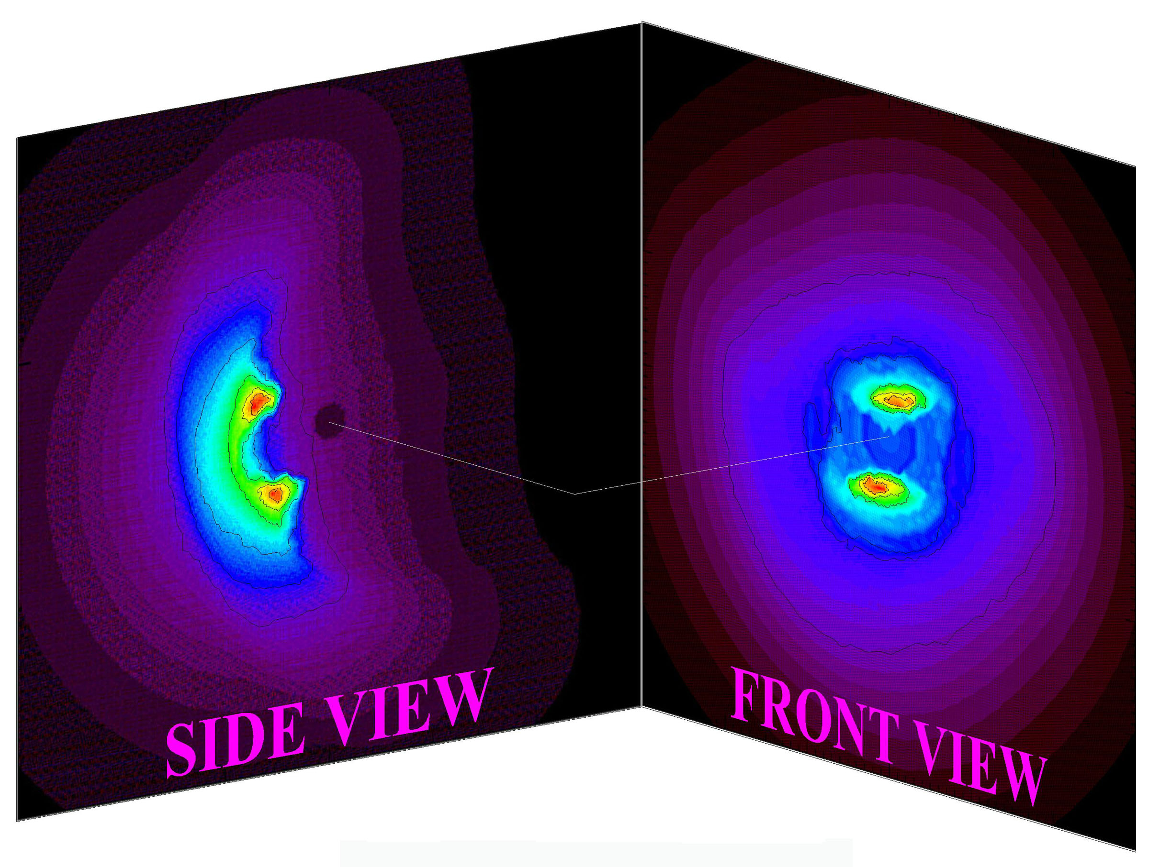
Fig. 6. Simulations of the solar wind interaction with the terrestrial magnetosphere in soft X-rays viewed from both the front and side.
3. Planetary Science Topics Addressed by SWCX Observations - Solar wind charge exchange soft X-ray observations address controversies about the solar wind interaction with planetary bodies and, in particular, the dynamic response. The most accessible of these extraterrestrial bodies is the Earth’s Moon.
Distribution of the solar wind around planets, particularly the moon, and solar wind penetration into wakes and tails - To illustrate the observability of soft X-ray emission from the solar wind-lunar interaction, we present some simulations in which we considered argon the main neutral constituent of the lunar atmosphere, based on Table 1 of Stern [1999] with a density of ~10⁵ cm⁻³ and a scale height of ~40 km. However, these results do not depend critically on the precise composition of the atmosphere and will be substantially the same even if, for example, neon [Heiken et al., 1991] or CO₂ is the dominant species [e.g. Vondrak, 1992]. Because the moon does not have a significant magnetic field (although there are magnetic anomalies, [Lin et al., 1998a,b]), the solar wind directly strikes the surface of the Moon and no bow shock is formed. However, at other planets in which a bow shock is formed, soft X-ray imaging will capture the global morphology of the shock, as has already been demonstrated at comets by Wegmann and Dennerl [2005].
The solar wind-Moon interaction shown in Figure 7 illustrates the lunar plasma wake, a void downstream of the Moon where the solar wind plasma is blocked by the Moon. Although plasma generally cannot reach this cone, there are some sputtered particles present. At the wake boundary, a significant density gradient forms, providing a wakeward electric field. Electrons move ahead of the less mobile protons to fill the cavity and form an ambipolar electric field which accelerates the ions and causes them to follow the electrons forming the red region in the middle.
The wake-filling rate depends on the orientation of the interplanetary magnetic field (IMF). If the IMF is oriented along the flow, the wake will be almost unfilled (there are no collisions in the plasma and charged particles cannot move in the direction perpendicular to the magnetic field lines). Figure 7 shows a simulated density profile near the Moon for the IMF at an oblique angle (45°) [Travnicek et al., 2005].
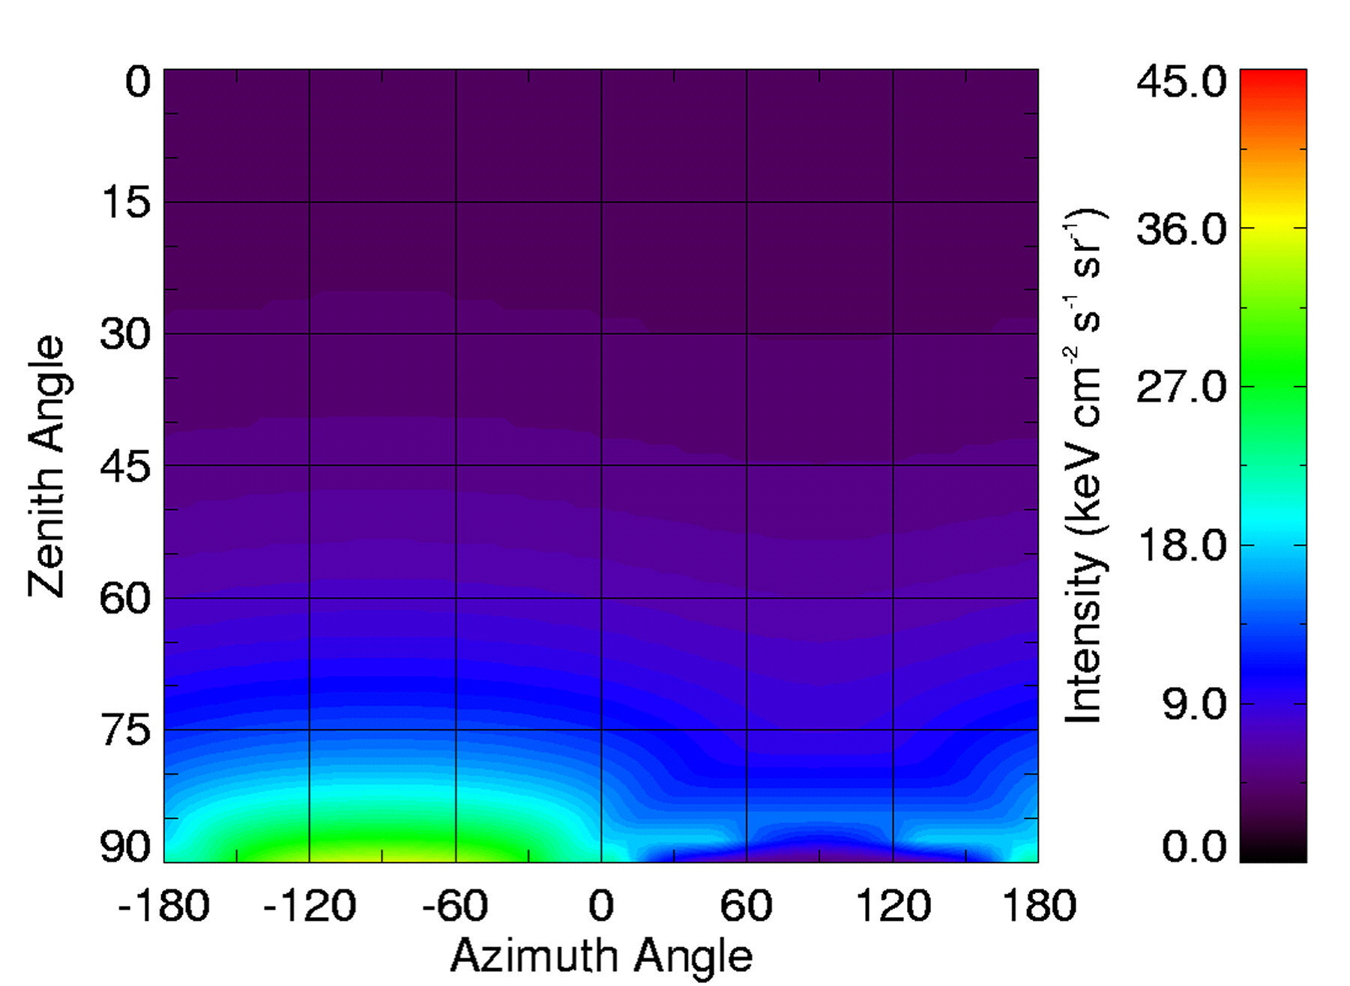
Fig. 8 – A simulation of the soft X-ray emission as a function of position in the lunar sky.
Figure 8 shows a simulation of soft X-ray emission from the solar wind-lunar interaction. When the zenith angle is 90°, the positive azimuth angles look through the lunar wake, so the X-ray fluxes are suppressed, while the negative angles look back over the pole where the intensities are higher. Therefore, SWCX soft X-ray emission can observe the global structure of the solar wind-lunar interaction. Determining the properties of this interaction has both practical and scientific benefits. For example, the surface of the Moon, like any object in a plasma, charges to an electric potential that minimizes the total incident current [Manka, 1973; Stubbs et al., 2006a,b]. The lunar dayside typically charges a few volts positive, since the photoemission of electrons usually dominates. As a result a “photo-electron sheath” forms above the surface, which in the solar wind extends about a meter, and effectively shields the charged surface from the surrounding plasma [Singer and Walker, 1962]. On the nightside, the lunar surface usually charges ~50-100 volts negative in the solar wind, since plasma electron currents typically dominate [Freeman and Ibrahim, 1975]. In this case a “Debye sheath” shields the surface potential and can extend from meters to possibly kilometers above the surface [Halekas et al., 2003]. Because the coupling between the solar wind plasma and the lunar surface and atmosphere affects surface charging, imaging this interaction globally in soft X-rays may enable accurate real-time modeling of the lunar surface potential over large regions of the Moon.
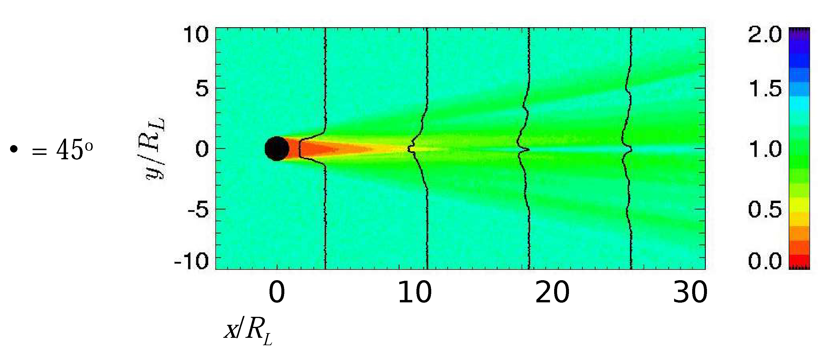
Fig. 7 – A simulation of the density of the solar wind near the Moon shows the lunar wake. A soft X-ray lunar observatory will be able to measure the extent of the wake.
Exospheric density and loss of atmosphere, sputtering, and pickup ions - Because the soft X-ray emission results from charge exchange, it provides a global window on processes that form and destroy planetary atmospheres and exospheres. In particular, the X-ray flux observed from SWCX is given by
4π I ~ α Φ_{sw} n_{o} L f (1)
where I is the X-ray flux, Φ_{sw} is the solar wind flux, n_{o} is the surface density of the planetary atmosphere, L is the exponential scale height, f is a factor that depends on viewing geometry (1 for radial and ~5 for limb viewing), and α is a factor that represents the possible transitions and their weighted cross-sections. The value of α typically used is 6x10⁻¹⁶ eV cm² [Pepino et al., 2004]. For high charge state species such as in the solar wind, the cross section is not very sensitive to the target species. The one exception to this general rule is for a target species of helium which is lower than hydrogen by about a factor of two [Greenwood et al., 2000].
Because each charge exchange of a high charge state solar wind ion with a neutral atom in the planetary atmosphere or exosphere results in the conversion of a neutral planetary atom or molecule into a charge state +1 pickup ion which will eventually be lost either to the planetary surface or to interplanetary space, SWCX emission provides not only information on the exospheric density and its variation, but also a window on atmospheric loss. It will literally image the solar wind “blowing away” the planetary atmosphere. Loss of atmosphere at non-magnetic planets (e.g., Venus and Mars) can result from ionization of neutrals above the ionopause followed by pick-up by the solar wind flow. This loss mechanism depends on the overlap of the neutral exosphere and the solar wind. SWCX X-ray emission also depends on the overlap of the neutral exosphere and solar wind. Measurements of the spatial distribution, and temporal variations, of this emission would provide much insight into the loss processes.
Furthermore, in the case of the Moon, which has no large scale magnetic field, the plasma will, in general, strike the surface, creating sputtered ions. However, above magnetic anomalies [e.g. Hood and Williams, 1989; Harnett and Winglee, 2003; Hood and Artemieva, 2008], such as Reiner Gamma, the solar wind may be deflected and not reach the surface. Soft X-ray imaging will be able to tell us how close to the lunar and other planetary surfaces the solar wind can penetrate, providing answers to space weathering questions.
Pickup ions themselves have suggested the presence of water at Mercury [Zurbuchen et al., 2008] and have been proposed for mapping the lunar surface and exosphere [Elphic et al., 1991]. Lunar pickup ions have even been observed by a handful of spacecraft [Yokota et al., 2009; Mall et al., 1998; Hilchenbach et al., 1992]. Solar wind charge exchange soft X-ray imaging will provide complementary global observations for in-situ pickup ion measurements which will lead to global surface composition maps and a determination of exospheric structure.
Auroral emission at Jupiter - A powerful aurora in both the UV and the X-ray parts of the spectrum has been observed at Jupiter by several X-ray observatories [Bhardwaj et al., 2006]. X-ray emission from the Io Plasma Torus [Elsner et al., 2005] and from Saturn’s rings [Bhardwaj et al., 2007] has also been observed by Chandra. The auroral X-ray luminosity of Jupiter is about 1 GW and the emission originates in the polar cap region, sometimes with a 40-minute periodicity. The source of the auroral X-rays has been suggested to be either solar wind ions precipitating in the cusp region or sulfur and oxygen ions in the outer magnetosphere that have been accelerated to energies of about 1 MeV/nucleon [cf., Cravens et al., 2003]. Bunce et al. [2004] suggested that the ion acceleration was associated with sporadic reconnection at the dayside magnetopause. An X-ray imager onboard a spacecraft orbiting Jupiter would be able to make high spatial and temporal resolution observations not possible from Earth-based platforms.
4. Concept Instrumentation - During the Apollo era, human missions to the moon deployed “suitcase science” packages called the Apollo Lunar Surface Experiments Package or ALSEP. In the future, such packages should include a soft X-ray imaging instrument for studying the solar wind-lunar interaction and the solar wind-terrestrial magnetosphere interaction.
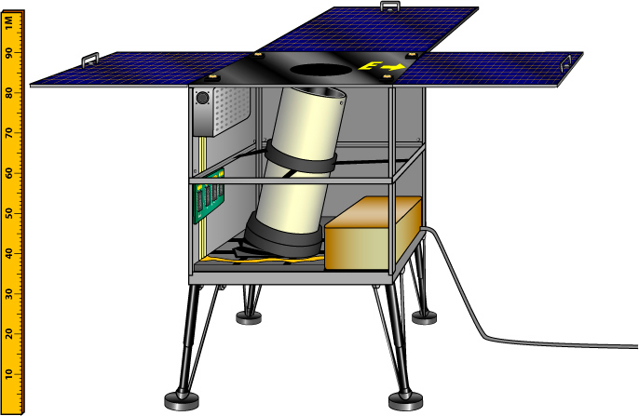
Fig. 9 – A sortie science X-ray observatory which will produce significant and unique scientific results while capable of withstanding the harsh lunar environment and being easily deployed by astronauts.
Figure 9 shows a concept design for a Lunar X-ray Observatory (LXO). This instrument is based on the constraints of the ALSEP packages from the Apollo era. The baseline concept for the LXO utilizes a moderate resolution, large area, X-ray CCD camera based on the design for the EPIC/MOS instrument on the XMM-Newton observatory. The CCDs are housed in a small vacuum vessel and have a thin aluminum on polyimide optical blocking filter. The Figure 9 design utilizes a 10º mechanical collimator. X-ray focusing optics are largely precluded by the mass constraints of a sortie science instrument. The X-ray CCD camera is housed in a vacuum vessel which is necessary for ground testing, for protection from outgassing, and for protecting the thin optical blocking filter. The analog readout electronics and the digital event-processing electronics are distributed around the CCD housing as shown schematically in Figure 9.
A spacecraft instrument designed for planetary observations would not be subject to the same constraints as an astronaut-deployed surface instrument, particularly in terms of ergonomics, thermal considerations, and power. There exist a variety of instrument techniques developed in astrophysics that could be used to detect soft X-rays for planetary imaging. However, X-ray telescopes using conventional nested mirror optics are optimized for the study of relatively compact objects and point sources within a small field-of-view. The proximity and scale of solar wind-planetary interactions are such that an X-ray camera designed to globally image the interaction must employ an alternative wide area optic technology such as the micropore (Lobster-Eye) optics design pioneered by the University of Leicester [Brunton et al., 1997; Fraser et al., 2002] which enable instrumentation with both wide field-of-view and low mass.
The design employs slumped microchannel plates (MCPs) with square channel cross-sections called micropore optics (MPOs), an example of which is shown in Figure 10 [Price, 2001]. The pore sizes on these MCPs are typically 20 microns on a side. The square pores provide an array of channels that approximates a Kirkpatrick-Baez system [Kirkpatrick and Baez, 1948], but in a small area, increasing the reflecting surface visible to the source and thus the effective area of an optic of a given size. Internal reflections from two orthogonal walls of the square cross-section channel reverse the direction of the two components of the ray’s velocity. By slumping the micropore optic such that the channel axes are perpendicular to the surface of a sphere, the optic can be used to focus X-rays from infinity to an image surface positioned at half the sphere’s radius.
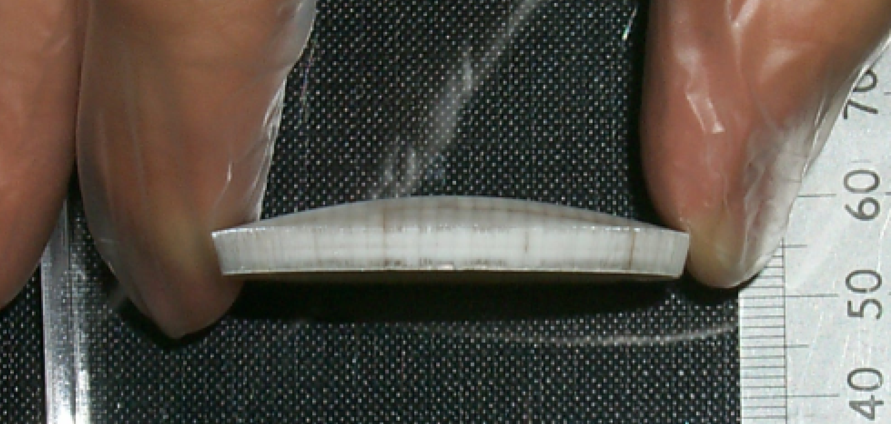
Fig. 10. This figure shows a slumped square pore MCP ideal for imaging soft X-ray emission from the solar wind-planetary interaction.
In planetary missions, the micropore optics design is currently undergoing laboratory development by Leicester as the focusing element of the Mercury Imaging X-ray Spectrometer (MIXS) on the upcoming BepiColombo mission. While not designed to image the solar wind-Mercury interaction, MIXS demonstrates the maturity level of this technology.
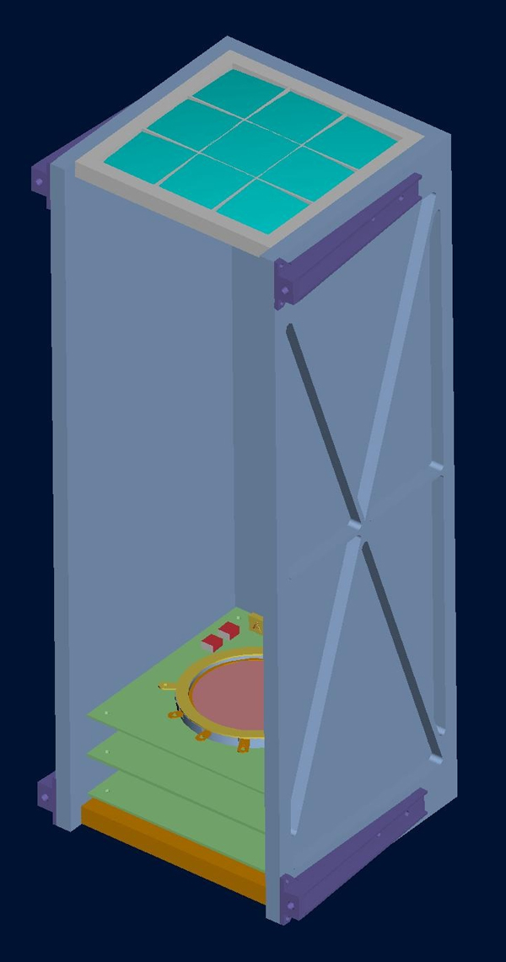
Fig. 11 – A concept for a solar wind-planetary interaction soft X-ray imager.
Figure 11 shows an initial design concept for an X-ray camera for imaging the solar wind-planetary interaction. The imager is shorter than 50 cm with a cross-section of ~15 cm x 15 cm. Soft X-ray photons enter the instrument through the micropore optics array at the top. The complete array will be built up from a number of individually fabricated plates of dimension ~4 cm x 4 cm (see Fig. 10) held together in a mounting bracket. The optics focus the soft X-rays to a point at about half the radius of curvature of the array. Theoretical and laboratory work at Leicester on the concept designs of a wide-area X-ray transient monitor with a ~30° x 30° field-of-view [Fraser et al., 2002] baselined a micropore array with a focal length of 37.5 cm.
5. Conclusion - Plasma boundaries involving abrupt changes in plasma parameters, such as shocks, will be very apparent in soft X-ray images. One critical part of interpreting the more general measurements is modeling as the solar wind charge exchange emission involves an inversion process to disentangle the contributions from the exosphere and from the solar wind. Still, significant progress has already been made on this topic. For example, Wegmann and Dennerl [2005] used XMM-Newton data to construct a spatial image of comet C/2000 W1 in soft X-rays similar to that shown in panel A of Fig. 3. Derivatives of averaged soft X-ray images were used to map out the dynamic location and shape of the cometary bow shock which was found to be in good agreement with expectations [cf. Flammer, 1991]. Models for SWCX X-ray emissions demonstrate that comparable tomographic reconstruction of shocks and plasma boundaries will be possible with soft X-ray imaging providing the first three dimensional global reconstruction of these boundaries.
An orbiting imager at Mars, Venus, the Moon, Earth or any space body with neutral gas around it would be capable of imaging the solar wind interaction with that body in soft X-rays. The optimal orbit would be one that takes the spacecraft beyond the plasma boundaries so that the imaging can be performed from the outside. However, even measurements from inside the boundaries, although complicating the interpretation, would provide imaging of the boundary extents and plasma properties.
Past observations of SWCX emission, although extremely valuable, were performed by astrophysical telescopes not optimized for imaging the solar wind interaction with planetary bodies. A dedicated soft X-ray instrument optimized to image the solar wind-planetary body interaction on a future mission will allow us for the first time to observe this interaction globally. The purpose of this white paper is to encourage mission planners over the next decade to include a soft X-ray imager in the strawman payloads.

References:
Bhardwaj, A. (2005), The discovery of oxygen K alpha X-ray emission from the rings of Saturn, Astrophys. J., 627, L73-L76.
Bhardwaj, A. et al. (2006), Low- to middle-latitude X-ray emission from Jupiter, J. Geophys. Res., 111, A11225.
Bhardwaj A., et al. (2007), X-rays from solar system objects, Planet. Space Sci., 55, 1135-1189.
Bertaux, J.L. et al. (2006), SPICAM on Mars Express: Observing modes and overview of UV spectrometer data and scientific results, J. Geophys. Res., 111, E10S90.
Brunton, A.N., G.W. Fraser, J.E. Lees, and I.C.E. Turcu (1997), Metrology and modeling of microchannel plate X-ray optics, Appl. Optics, 36, 22, 5461-5470.
Bunce, E.J. et al. (2004), Jovian cusp processes: Implications for the polar aurora, J. Geophys. Res., 109, A09S13.
Burch, J.L. (2003), The first two years of IMAGE, Space Sci. Rev., 109, 1-24.
Cravens, T. E. (1997), Comet Hyakutake x-ray source: Charge transfer of solar wind heavy ions, Geophys. Res. Lett., 24, 105-108.
Cravens, T. E. (2002), X-ray emission from comets, Science, 296, 1042-1045.
Cravens, T.E. and A.N. Maurellis (2001), X-ray emission from scattering and fluorescence of solar x-rays at Venus and Mars, Geophys. Res. Lett., 28, 3043-3046.
Cravens, T. E., et al. (2001), Temporal variations of geocoronal and heliospheric x-ray emission associated with the solar wind, J. Geophys. Res., 106, 24883-24,892.
Cravens, T.E. et al. (2003), Implictaions of Jovian X-ray emission for magnetosphere-ionosphere coupling, J. Geophys. Res., 108, 1465.
Dennerl, K. (2002), Discovery of X-rays from Mars with Chandra, Astron. Astrophys., 394, 1119-1128.
Dennerl, Konrad (2008), X-rays from Venus observed with Chandra, Planet. Space Sci., 56, 1414-1423.
Dennerl, K., J. Englhauser and J. Trümper (1997), X-ray emissions from comets detected in the Röntgen X-ray satellite all-sky survey, Science, 277, 1625-1630.
Dennerl, K., V. Burwitz, J. Englhauser, C. Lisse and S. Wolk (2002), Discovery of X-rays from Venus with Chandra, Astron. Astrophys., 386, 319-330.
Dennerl, K., et al. (2006), First observation of Mars with XMM-Newton – High resolution X-ray spectroscopy with RGS, Astron. Astrophys., 451, 709-722.
Elphic, R. C., et al. (1991), Lunar surface composition and solar wind-induced secondary ion mass spectrometry, Geophys. Res. Lett., 18, 2165-2168.
Elsner, R.F. et al. (2005), X-ray probes of magnetospheric interactions with Jupiter’s auroral zones, the Galilean satellites, and the Io plasma torus, Icarus, 178, 417-428.
Flammer, K. R. (1991), The global interaction of comets with the solar wind, in Comets in the Post-Halley Era, vol. 2, R. L. Newburn Jr. et al. (eds.), p. 1125.
Fraser, G.W. et al. (2002), LOBSTER-ISS: an imaging X-ray all-sky monitor for the International Space Station, Proc. SPIE, 4497, 115-126.
Freeman, J. W., and M. Ibrahim (1975), Lunar electric fields, surface potential and associated plasma sheaths, The Moon, 8, 103-114.
Greenwood, J. B. et al. (2000), Measurement of charge exchange and X-ray emission cross sections for solar wind-comet interactions, Astrophys. J., 533, L175.
Gunell et al. (2004), X-rays from solar wind charge exchange at Mars: A comparison of simulations and observations, Geophys. Res. Lett., 31, L22801.
Gunell, H., et al. (2005), Simulations of X-rays from solar wind charge exchange at Mars: Parameter dependence, Adv. Space Res., 36(11), 2057-2065.
Gunell, H., E. et al. (2007), Simulations of solar wind charge exchange X-ray emission at Venus, Geophys. Res. Lett., 34, L03107.
Haberli, R.M. et al. (1997), Quantitative analysis of H2O+ coma images using multiscale MHD model with detailed ion chemistry, Icarus, 130, 373-386.
Halekas, J.S., et al. (2003), Inferring the scale height of the lunar nightside double layer, Geophys. Res. Lett., 30, 2117, 2003GL018421.
Harnett, E.M. and R.M. Winglee (2003), 2.5-D fluid simulations of the solar wind interacting with multiple dipoles on the surface of the moon, J. Geophys. Res., 108, 1088.
Heiken, G.H., et al. (1991), Lunar Sourcebook: A User’s Guide to the Moon, pp. 42-44, Cambridge University Press and Lunar and Planetary Institute, Cambridge, UK.
Hilchenbach, M. et al. (1991), Detection of singly ionized lunar pick-up ions upstream of the Earth’s bow shock, Proc. of Solar Wind 7, E. Marsch and G. Schwenn (eds.).
Hodges Jr., R.R. (1994), Monte Carlo simulation of the terrestrial hydrogen exosphere, J. Geophys. Res., 99, 23,229-23247.
Holmström, M., S. Barabash, and E. Kallio (2001) X-ray imaging of the solar wind-Mars interaction, Geophys. Res. Lett, 28, 1287-1290.
Hood, L.L. and C.R. Williams (1989), The lunar swirls: Distribution and possible origins, Proc. 19th Lunar and Planet. Sci. Conf., 99-113.
Hood, L.L. and N.A. Artemieva (2008), Antipodal effects of lunar basin-forming impacts: Initial 3D simulations and comparisons with observations, Icarus, 193, 485-502.
Kharchenko, V. and A. Dalgarno (2000), Spectra of cometary X-rays induced by solar wind ions, J. Geophys. Res., 105, 18351-18359.
Kharchenko V. et al. (2003), Charge abundances of the solar wind ions inferred from cometary X-ray spectra, Astrophys. J., 585, L73-L75.
Kirkpatrick, P. and A.V. Baez (1948), Formation of optical images by X-rays, J. Opt. Soc. Am., 38(9), 766.
Krasnopolsky, V. (1997), On the nature of soft X-ray radiation in comets, Icarus, 128, 368-385.
Krasnopolsky, Vladimir A. and G. Randall Gladstone (2005), Helium on Mars and Venus: EUVE observations and modeling, Icarus, 176, 395-407.
Krasnopolsky, V. A., J. B. Greenwood and P. C. Stancil (2004), X-ray and extreme ultraviolet emissions from comets, Space Sci. Rev., 113, 271-373.
Lin, R.P., et al. (1998a), Lunar Surface Magnetic Fields and their Interaction with the Solar Wind: Results from Lunar Prospector, Science 281, 1480-1484.
Lin, R.P., et al. (1998b), Lunar-Surface Magnetic Field Concentrations Antipodal to Young Large Impact Basins, Icarus, 74, 529-541.
Lisse, C. M., et al. (1996), Discovery of X-ray and extreme ultraviolet emission from comet C/Hyakutake 1996 B2, Science, 274, 205-209.
Lisse, C.M., et al. (2001), Charge exchange-induced X-ray emission from comet C/1999 S4 (LINEAR), Science, 292, 5520, 1343-1348.
Mall, U. et al. (1998), Direct observation of lunar pick-up ions near the Moon, Geophys. Res. Lett., 25, 3799-3802.
Manka, R.H. (1973), Plasma and potential at the lunar surface, Photon and Particle Interactions with Surfaces in Space, D. Reidel Pub. Co., Dordrecht, Holland, pp. 347–361.
Østgaard, N., et al. (2003), Neutral hydrogen density profiles derived from geocoronal imaging, J. Geophys. Res., 108, A7, 1300.
Pepino, R., et al. (2004), Spectra of the X-ray emission induced in the interaction between the solar wind and the heliospheric gas, Astrophys. J., 617, 1347-1352.
Price, Gareth James (2001), Microchannel plates in astronomy, Ph.D. Dissertation, Leicester, UK, 180 pp.
Robertson, I. P., M.R. Collier, T.E. Cravens, and M.-C. Fok (2006), X-ray emission from the terrestrial magnetosheath including the cusps, J. Geophys. Res., 111, A12.
Singer, S.F. and Walker, E.H. (1962), Electrostatic dust transport on the lunar surface, Icarus, 1, 112-120.
Snowden, S.L. and M.J. Freyberg (1993), The scattered solar X-ray background of the ROSAT PSPC, Astrophys. J., 404, 403-411.
Stern, S.A. (1999), The lunar atmosphere: History, status, current problems and context, Rev. Geophys., 37, 453-491.
Stubbs, T. J., R. R. Vondrak, and W. M. Farrell (2006a), A dynamic fountain model for lunar dust, Adv. Space Res., 37, 59–66.
Stubbs, T.J., et al. (2006b), Impact of dust on lunar exploration, Proc. of the conf. ‘Dust in planetary systems’, Kauai/Hawaii, Sept. 2005, ed. H. Krüger, A.L. Graps.
Travnicek, P. et al. (2005), Structure of the lunar wake: Two-dimensional global hybrid simulations, Geophs. Res. Lett., 32, L06102, doi:10.1029/ 2004GL022243.
Vondrak, R.R. (1992), Lunar base activities and the lunar environment, 2nd Conf. on Lun. Bases and Space Act. of 21st Cent., Mendell (ed.), NASA Conf. Pub. 3166, 1, 337-345.
Wegmann R. and K. Dennerl (2005), X-ray tomography of a cometary bow shock, Astron. and Astrophys., 430, L33-L36.
Yokota S. et al. (2009), First direct detection of ions originating from the Moon by MAP-PACE IMA onboard SELENE (KAGUYA), Geophys. Res. Lett., 36, L11201.
Zurbuchen, T.H. et al. (2008), MESSENGER observations of the composition of Mercury’s ionized exosphere and plasma environment, Science, 321, 90-92.

