Tafsir Surah Ya-Sin
Shaykh Abdul-Nasir Jangda

Allaah ta’aala says in the Qur’aan,
{And We have certainly made the Qur’aan easy for remembrance, so is there any who will remember? (54, 17)}

The Qur’aan is easy, Allaah has made it easy. There is no doubt. The only requirement placed is li dhikri - whoever reads/listens/learns the Qur’aan to come closer to Allaah for him it is made easier. Then, it is placed on a silver platter - who will come forward to remember it?

table of contents

Introduction 2

Verse 1 2

Verse 2 2

Verse 3 2

Verse 4 2

Verse 5 2

Verse 6 2

Verse 7 2

Verse 8 2

Verse 9 2

Verse 10 2

Verse 11 2

Verse 12 2

Verse 13 2

Verse 14 2

Verse 15 2

Verse 16 2

Verse 17 2

Verse 18 2

Verse 19 2

Verse 20 3

Verse 21 3

Verse 22 3

Verse 23 3

Verse 24 3

Verse 25 3

Verse 26 3

Verse 27 3

Verse 28 3

Verse 29 3

Verse 30 3

Verse 31 3

Verse 32 3

Verse 33 3

Verse 34 3

Verse 35 3

Verse 36 3

Verse 37 3

Verse 38 3

Verse 39 3

Verse 40 3

Verse 41 3

Verse 42 3

Verse 43 4

Verse 44 4

Verse 45 4

Verse 46 4

Verse 47 4

Verse 48 4

Verse 49 4

Verse 50 4

Introduction

This is a Makkan surah, revealed during the time the Messenger of Allaah s lived in Makkah.
The Makkan suwar focus upon three main aspects in imaan:
- tawhid (the Oneness of Allaah)
- risalah (Messengership of Muhammad s, that he is a messenger sent by Allaah to guide all of creation and he receives divine revelation)
- and the reality of the al-aakhirah and what will be encountered therein.

Surah Ya-Sin’s (36) placement within the mus-haf: it follows Saba (34) and Faatir (35) which are also Makkan suwar. Saba and Faatir are also Makkan suwar so there focus is to discuss tawhid, risalah, and al-aakhirah. Ya-Sin continues with these themes, but it takes a different tone. It starts by focusing more heavily on the prophethood of Muhammad s. Faatir did discuss the prophethood and the importance of believing in the Messenger of Allaah s, but it more heavily focuses on tawhid. Ya-Sin places a heavy emphasis on the prophethood of Muhammad s.

There are few ahadith which discuss the virtue of Ya-Sin as mentioned by the Messenger of Allaah. There is discussion regarding the authenticity of these narrations, but the two that exist are
- Everything has a heart and Ya-Sin is the heart of the Qur’aan.
What this exactly means is heavily discussed by the scholars. The most apparent understanding, however, is the beauty with which Ya-Sin constructs this argument and the beauty with which it flows discussing themes and concepts. It is so comprehensive and coherent that it is a perfect example of the miracle of the Qur’aan. Second, it is so universally loved, admired, revered, and respected by Muslims. The most renowned scholar and the average Muslim who may not be able to recite with proper tajwid will hold in common their reverance and love for this surah. They still know it is something amazing and mindblowing. It is its acceptability in the hearts of people that alludes to it being the heart of the Qur’aan.

Another narration with this idea is “I wish for Surah Ya-Sin to be in the heart of every single believing person.” This is the focus behind this study: to memorize the surah as in the wish of the Messenger of Allaah s.

- Recite Surah Ya-Sin upon your dead.
Meaning when somebody is at the door of death, experiencing the pangs of death, the Messenger of Allaah s is advising us to recite it to ease their transition to the afterlife and make it easier for that person to leave this world.
This is a prevalent practice in the Muslim community, but it has been more into a ritual. They are the words of Allaah so they do have soothing, calming affect on people, but so do other suwar. Why this surah? It talks about imaan, it reaffirms tawhid, risalah, al-aakhirah. It talks about everything of great importance.
What the Messenger of Allaah s is actually alluding to is that when there is mass education in our communities of Qur’aan and the meaning and understanding, the recitation will reaffirm the faith of that person. It will reconnect him to Allaah. It will remind him of the fundamental principles of imaan leading him to a better death and place in the Hereafter.

Verse 1
Faatir ended on a powerful note
  - (35, 42) They take oaths upon Allaah and they would exhaust taking oaths e.g. they swear by each and everything they can image. Their oaths are that if somebody was to come to them and warn them, they would be one of the most guided amongst the people. Yet, when a prophet did arrive to them, it did not increase them in any way except they began to run away from him even more.

Ya-Sin
Huruf al-muqatt’aat (the disjointed letters)
These are repeated throughout the Qur’aan. What do they mean?
  - The most authentic and majority position of the ulema is that only Allaah knows the true meaning.
  - In this case, however, there is more discussion regarding what they mean. Some claim it means “O human being” others that it is a name of the Messenger of Allaah s. The reality of the matter, however, is that we have no confirmation of these facts. Nothing to establish these hypotheses exist. The most authentic and safest understanding is still that Allaah knows best what they mean.
They can also be seen from the miracle of the Qur’aan. These are the letters of the Arabic language. The Arabs of that time were some of the most poetic and eloquent people this earth has seen, the masters of this language. They had never before seen, however, the letters being used in this manner.
  - When the Arabs put together the letters alif-laam-mim they always assumed it meant alam; Ha-mim was ham; ya-sin was yas. It shocked and amazed them.
  - That is the purpose of these suwar beginnings. It catches the attention immediately. It captivates the listener as if it is an announcement. The fact that we don’t know what it means humbles the person. It humbles even the scholar of the language.
An interesting point regarding the suwar that begin with these letters is that the very next aayah is about the Qur’aan. Oftentimes, there is an oath involved as well. The word kitaab or Qur’aan occurs in this next verse. The point of these letters is to call your attention to the Qur’aan.

The Framework| What can we expect from Surah Ya-Sin?
The three main themes of imaan: tawhid, risalah, al-aakhirah.
This surah is very philosophical and will focus upon the fundamental ideas of our life and its purpose.
It will focus heavily upon gratefulness and what it requires of a person.
  - Why should we be grateful?
  - How should we express our gratitude?
  - Now that we are grateful, what is expected of us if we are grateful?
- The first part of the surah is a consolation to the Messenger of Allaah s that what he is doing is correct. He s should not pay heed to these people who slander him, curse him, abuse him, lie against him.
- The second part of the surah is giving a lesson to the Quraysh by referring to people of previous nations who were sent messengers but they rejected them just like the Quraysh. What happened to those people in return?
- The third part of the surah will talk to us about the beauty of Allaah’s creation. How we can look all around us and appreciate that Allaah is our Creator, Sustainer, and how Magnificent He must be if His creation is this magnificent.
- The fourth part of the surah will discuss that when the message is delivered, when the disbelievers are shown these magnificences and told to believe in Allaah, but they refuse and reject its truth, what happens to them.
- The fifth part of the surah will discuss the Hereafter. What will happen on the Day of Judgment with these two groups of people? The group that believed and the group that disbelieved.
- Finally, Allaah will issue a warning to people who have intelligence, faculties, money, assets, resources and talent. They are fully functioning human beings, but they refuse to believe in Allaah. To use their abilities to understand the Oneness in Allaah. This is a final warning to those people.
- The surah concludes by again providing consolation to the Messenger of Allaah s: by reminding him that he was given a task. His responsibility is to deliver the message. Some people will believe and he is to teach them, others will disbelieve and he is not to worry about them.

Verse 2
By the wise Qur’aan.

This is an oath. The waaw here means an oath (as opposed to its usual ‘and’). By the Qur’aan that is full of wisdom.

The Word Qur’aan Itself
This is the given name by Allaah to His Book. We call it the Qur’aan.
It comes from the root of the word meaning ‘to read something’.
The ending on the word (aan - ءان) it means “abundance”. That pattern alludes to abundance. So Qur’aan is that which is read in abundance.
It is not a coincidence that Allaah begins this surah with the term Qur’aan - for Ya-Sin is one of the most frequently recited parts of it.

Al-Hakim
It can have two possible meanings.
- We know that it means ‘Wise’. It comes from Hikmah (wisdom) and Hakim is someone who is full of wisdom.
  - There is a profound message in calling the Qur’aan wise. It is miraculous for many reasons. The science, the prophecies, the unmatched language. Its most prominent miracle, however, is its wisdom, profundity, depth. It tells us how to lead our life, exactly what to do to lead a successful, meaning life. It is the cure for whatever problem creation has. It is that deep in its wisdom.
- It can also comes from the word Hukm (authority) and Hakim would be someone who is full of authority (authoritative). It tells you what to do. It is decisive in delivering a message to you.
Which one does it mean? The reality of the matter is that it means both. This is part of the beauty of the Qur’aan that one word can have multiple meanings. This is called al-tawasu fi’l-ma’na fi’l-Qur’aan al-Karim. This creates depth in the meaning of the Qur’aan.

Thus, the Qur’aan is both full of wisdom and it is authoritative (e.g. it tells us what to do).

Verse 3
Indeed you, [O Muhammad], are from among the messengers,

Allaah has sworn by the Qur’aan that this is true.
In the Qur’aan, the singular, second person (you = kaaf) refers to the Messenger of Allaah s.
Inna is to provide emphasis, to remove doubt. Allaah is saying there should remain no doubt about the fact that You are most definitely (laam is for emphasis) from (min) al-mursalin.
Al-Mursalin is from the root of irsal (someone who has been sent by a higher authority). Mursal is someone who has been sent by a higher authority. Rasul is someone who has been sent to convey by a higher authority. Thus, if somone is a rasul or a mursal it doesn’t just mean he is a messenger. It’s connecting the word back to Allaah. The ultimate authority is Allaah. The word is connecting the people back to Allaah.
Thus, the verse means: there should remain no doubt that you are from the group of people who have been sent by Allaah to convey the message to the people.

A few matters that need to be understood here:
- Allaah swore by the Qur’aan that Muhammad s is a messenger of Allaah. This is another part of the wisdom of the Qur’aan. Allaah is creating that connection here. Allaah knew the situation would arise where people would be comfortable accepting the Qur’aan, but having difficulty accepting the Messenger of Allaah s. Meaning if you are accepting the Qur’aan you must accept the Messenger of it. One is the kasam (oath) and the other is the jawab al-kasam (reason for the oath).
- Allaah does not say innaka mursal or innaka rasul. Allaah says that “you are from” those people. Once again, it is a consolation. He s is not the first person to be communicated to by Allaah, to convey a message from Allaah, to be rejected by his people for delivering the message. There were many before you s and you belong to this fraternity of people. This makes dealing with the difficulty easier. To know that someone has experienced it before. Makkah is tough and you are experiencing a lot, but you are connected to Allaah and there have been others who have been through this before.

Verse 4
upon a straight path.
‘Alaa means “upon”, “on top of”.
Siraat means “path”.
  - Another word meaning path is sabil. Siraat has no plural, but sabil has a plural (subul). When Allaah talks about guidance, imaan, din, hidayah, He ta’aala uses siraat becomes there is a single path to guidance. When He ta’aala discusses charity, however, He uses sabil (e.g. fi sabil lillah) because there are multiple ways for giving in the sake of Allaah.
You have been sent to people to set them upon this path.
Mustaqim means to stand upright. It comes from the root “to make stand”. When something is sitting, the body is crooked at an angle. When it is standing, however, it is straight and upright.
  - It is the quickest (direct) shortest path to the pleasure of Allaah.
  - It is noble because it is upright. There is nothing humiliating, disgusting within the din.

‘Alaa is a beautiful harf al-jarr (preposition). It provides imagery of being atop. It’s like one is inclining upon the straight path. The ulema describe it like getting on a train. Once you are on the track, you don’t have anything to do afterwards except recline to have it take you to your destination. It is a smooth, easy ride. There is effort in attaining the ticket and catching the train, but once you’re on it, life becomes easy, smooth sailing. There must be some effort put in to get there, but from there Allaah will take us the rest of the way.

Notice the tanwin (siraatin mustaqimin). It is in its common form. Other places it is in its proper form (1, 5).

Why is it in its common form? When something is in this form there is versatility and diversity in the meaning. There is multi-layered meaning. It is telling the Messenger of Allaah s that he is inviting to a straight path, the Qur’aan is layinging out a straight path, Allaah is calling people to a straight path. Believing in Allaah is part of the straight path, the Qur’aan is inviting to the straight path, the Messenger of Allaah s is on the straight path. They are all calling us, bringing us to the straight path. There is broad meaning in what the terms are alluding to.

Verse 5
[This is] a revelation of the Exalted in Might, the Especially Merciful,

{It has been sent (that which has been sent) from that One that is Aziz and Rahim.}

Tanzil | Word Analysis
Tanzil comes from the root meaning to “send something down” or even further “to descend”. In the Arabic language, specifically within the Qur’aan, there is another form of this word “to send something down”; it is anzal as in (3, 3).

About the Qur’aan, the word nazala is used (meaning “He sent down”). About the tawrah and injil the word anzala is used (meaning “He sent down”). The Qur’aan is divine and precise; these words are not interchangeable. What then is the difference?
Anzala means to send something down all at once. The previous divine scriptures were sent down as complete books from Allaah ta’aala. The Qur’aan, however, was revealed little by little by little (tadhreejan) which is what tanzil means.

Even about the Qur’aan though, in some places Allaah says anzala and others He says tanzala. For example, (97, 1) Allaah uses anzala
We most definitely sent it down in the Night of Power.

Here, Allaah is mentioning that He sent down the Qur’aan from lawh al-mahfuz (the Preserved Tablet) where the Qur’aan was preserved, to bayt al-izza in the lowest heavens, the sky closest to the earth. In this revelation, it was sent down in its entirety.

Then in (2, 185), Allaah uses anzala
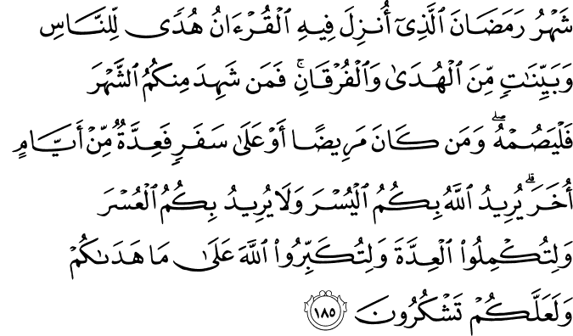
The month of Ramadhaan [is that] in which was revealed the Qur’aan ...

The Qur’aan was revealed in its entirety in this month. Yet, we know Allaah sent it down little by little. Again, here Allaah is mentioning the revelation from lawh al-mahfuz to bayt al-izza. This is demonstrating from the above verse in Surat’l-Qadr that the Night of Power is in Ramadhaan.

Everywhere else when discussing the revelation of the Qur’aan, Allaah uses tanzil because it was gradual and He is referring to the revelation to the Messenger of Allaah s.

What’s the significance of sending the Qur’aan little by little?
Allaah is giving the Qur’aan importance. He ta’aala is teaching us that the Qur’aan is meant to be digested, approached, understood, absorbed, internalized LITTLE BY LITTLE. Just like it was sent down. We may have the entirety, but we should still learn it in a portion of a time.

Now, from whom was it that the Qur’aan was coming down?
Remember, the purposes of Ya-Sin are to establish the truth of the Qur’aan and the validity of the prophethood of Muhammad s. Establishing that he s is the Messenger of Allaah.
This isn’t coming down from any random place. It is coming down from al-Aziz ar-Rahim referring to Allaah.

Al-Aziz| Word Analysis
It means the One Who dominates, but cannot be dominated. Powerful, firm, strong, dominating.

Ar-Rahim| Word Analysis
It comes from the root word meaning mercy (raHmah). It means the One Who is constantly merciful.

These two Names being mentioned is of importance because in the next few aayaat Allaah will discuss the peopel who reject the Qur’aan. They who don’t listen to it, they who choose not to believe in it. For them, Allaah is Aziz - firm, strong, powerful and dominating. His warning is being given - that His punishment will dominate these people.
Then in aayah 11,
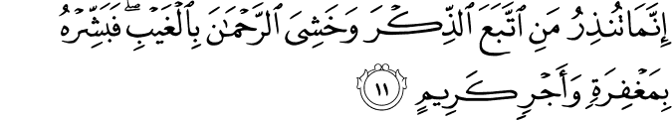
Allaah talks about people who do take the message of the Qur’aan. They accept it, they listen to it, they reflect upon it, they live it. For them, Allaah is mentioning the attribute of ar-Rahim - to them, Allaah will be constantly merciful.

Verse 6

That you may warn a people whose forefathers were not warned, so they are unaware.

{So that you may warn a people that there forefathers were not warned, therefore they are completely in (in a state of) heedlessness.}

Historical Explanation
Ibrahim ‘alayhi as-salaam, considered the forefather of the prophets and messengers. It is from him that the two major chains of prophets came - Bani Isra’il and the Arabs. We know there was the conflict there. He had two sons and their tribes: Banu Ishaq and Banu Isma’il.

The progeny of Ishaq ‘alayhi as-salaam were people amongst whom many of the prophets mentioned in the Qur’aan came: Zakariyyah, Yahya, Sulayman, Daw’ud, ‘Isa, Musa, etc. ‘alayhum as-salaam.

The progeny of Isma’il ‘alayhi as-salaam did not get any messengers until Muhammad s. So for these Arabs, the divine revelation did not come to them for at least 100s and 100s if not 1000s of years. Allaah says this book has been revealed to them from Aziz and Rahim whose forefathers were not warned. As a result of their forefathers not being warned ghafilun. Allaah did not say ghafalu, yaghfilu. Allaah uses the nominal form. These people were drowning in heedlessness. Heedlessness is simply people who are unaware, oblivious to reality, completely lost. They have complete lack of awareness of what is going on. Some of the scholars mention there are multiple forms of ghafla - some are accidental, others are intentional. These people had an intentional branding. They chose to be heedless. They liked the way things were for them.

Guidance has not come to these people for a very long time so it will take longer for the message to be absorbed, for them to take from it. At the same time, Allaah is hinting that amongst them, there are some who have the element of choosing to be heedless. They know about their situation and they like the way things are, they are content with the situation. Fahum ghafilun.

Allaah is reminding them of this. He is telling the Messenger of Allaah s that this is the purpose of the revelation of the Qur’aan . In (28, 46), He ta’aala makes mention of this in (28, 46)
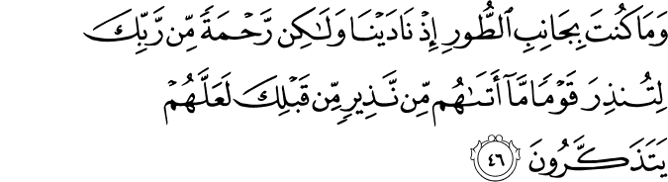
(...litundhira → qablika...) to warn a people to whom no warner had come before you
{So that you can use this Qur’aan to warn a people that no warner had come to them before you - nobody had come to warn them before you}

Allaah is saying what the purpose of the Qur’aan is. When we completely treat the Qur’aan as functioning to decoration and formality or opening of auspacious occassions we run into a problem Its main purpose is to wake people up. We need to develop this relationship with the Qur’aan for ourselves and for our communities. It wakes us from being lost.

Verse 7

Already the word has come into effect upon most of them, so they do not believe.
{Most definitely, the word has been confirmed upon the majority of them. Therefore they will not believe.}

We know the Messenger of Allaah s was sent for all of humanity, but the first recipients of his message were the Quraysh, the Arabs. So Allaah is talking about them specifically. In the previous aayah, Allaah has mentioned that he s has the job to warn them, to awake them from this deep sleep. Now in this aayah, Allaah is saying most definitely (laam is emphasis and qad is further emphasis = like pounding fist on table).

Haqq| Word Analysis
Haqq is from the root meaning “that which is stable/constant/solid” but it also carries the meaning of “that which is reality/confirmed/happens/no doubt about it”. The word or saying or decision has been confirmed upon you. What is this qawl?

Qawl| Word Analysis
In the Qur’aan, Allaah tells us the story about Adam ‘alayhi as-salaam and Iblis. When Allaah created Adam ‘alayhi as-salaam He commanded the angels to make sujud to him, but Iblis refused. He was arrogant, arguing with Allaah, denying, refusing, and disobeying. So Allaah casted him off, sent him away from His mercy.

Iblis requests time until the Day of Judgment to lead all of these human beings astray. These human beings to whom he had been commanded to prostrate, he commits his life to taking them astray. Coming at them from in front, behind, left, right, doing whatever it takes to lead them astray and You will say the majority of the will not be grateful. He swore by Allaah’s power (wa bi izzatihim) that he would lead them astray. Look at the arrogance (38, 82)!
[Iblis] said, “By Your might, I will surely mislead them all,

Allaah ended up cursing Iblis and saying the reality (38, 84-85)
[Allaah] said, ‘The truth [is My oath], and the truth I say -
[that] I will surely fill the Hellfire with you and those of them that follow you all together.

Anyone that chooses to follow Iblis and not the path outlined by Allaah will be cast into the Hellfire.

The story of Adam and Iblis occurs in seven places in the Qur’aan, Baqarah (2), A’araaf (7), Hijr (15), Israa (17), Kahf (18), Ta-Ha (20), Sad (38). Even at the end of Ya-Sin (36, 70) Allaah says that the punished has been decided and decreed upon those people who are ungrateful and disbelieve in Allaah.
To warn whoever is alive and justify the word against the disbelievers.

Al-Qawl is thus Allaah’s decision to punish these people, His decision to cast them into the Hellfire. That decision has been confirmed upon the majority of these people to whom the Messenger of Allaah s is giving da’wah therefore these people will not believe (it includes the future tense as in “don’t expect them to believe”).

In Conclusion
When Allaah al-Aziz ar-Rahim is telling His Messenger s that He has sent down the Qur’aan for him to warn these people, then why would Allaah mention that the punishment for the majority these people has been confirmed and he shouldn’t expect them to believe?
These aayaat are a consolation to the Messenger of Allaah s. In Makkah, a lot of difficulty was experienced. The second they’d take a few steps ahead, the people would become more stubborn, arrogant, aggressive, and violent. It was difficult to keep up the morale of the Muslims. This was to let him know that Allaah is watching these people and has made the decision for them.

The reason for telling the Messenger of Allaah s not to expect these people to believe was because the Messenger of Allaah embodied and amazing quality. To blame himself for what goes wrong. Some people automatically look to others when matters go wrong. A special person, however, blames himself in this selfless way. It is empathetic, sympathetic, and compassionate to blame one’s own self. He s embodied this quality like no other person. Allaah had to tell him (18, 6) to take it easy!
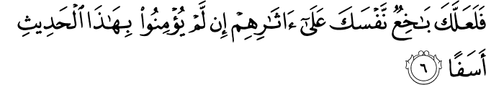
Then perhaps you would kill yourself through grief over them, [O Muhammad], if they do not believe in this message, [and] out of sorrow.

At the jarring and powerful moment in the situation of Ta’if, the Messenger of Allaah s after being ridiculed, stoned, humiliated, made to bleed from his body to the point of falling unconscious, he was given a moment of rest and made du’aa to Allaah. His s supplication is unbelievable!

O Allaah I complain to you of my own weakness, and my lack of effort, and I complain to you of my lack of respect in the eyes of people.

As if saying that these people didn’t reject the message because of Allaah or of what it contains or even because of themselves. Their rejection was associated with my own weaknesses and faults. Please forgive me.

Allaah would have to console the Messenger of Allaah s because of this quality. To prevent him s from destroying himself for the sake of people.

Aayaat 8-10 elaborate upon aayah 7

Verse 8

Indeed, We have put shackles on their necks, and they are to their chins, so they are with heads [kept] aloft.
{Most definitely we have placed in their necks collars (or shackles) and it is all the way up to their chins so their heads are slightly raised (stuck in that one position)}

Word Analysis
Here Allaah is attributing the action to Himself inna ja’alnaa. There is repetition of the first person plural subject to say that it is definitely Allaah, and only Allaah. There is exclusivity.

A’anaaq is the plural of unuq (neck). In their necks.
Aghlaal is the plural of ghul (shackle e.g. like shackline a prisoner). It is a very general term so it could be shackles put on any area (handcuffs, ankles, neck), but here it is specified to around their necks.
Ilaa al-adhqaan up to their chins so that it is elongating their necks. In this position, one no longer has any room to move. They have no ability to move, they are frozen in this position.

The result is fahum muqmaHun. MuqmaHun comes from the root qamaHa refers to when a camel comes to drink water. The camel then raises its head, just standing before the water, gazing at it. This would be called aqmaHal ba’i that the camel drank the water and has its head raised to stand over the water, perhaps gazing down at it. Another explanation in the lexicon is that the neck of the camel was sometimes tied to its back in such a way that its neck would stay erect to keep it alert. They would do this when they did not want the camel to walk or stand in a particular position and not have flexibility to move from the position.
So muqmaHun means the people have been tied into such a position that their head can neither be further up nor further down - especially lowering the head.

Why would their heads be raised?
1. It is in reference to their arrogance. They were provided the message, a messenger, the Qur’aan was recited to them. They were rude, they were extremely arrogant. It is as if Allaah set this curse of arrogance upon them: they wanted to be arrogant, so they not must deal with it. They were allowed to further indulge in their arrogance.

The Qur’aan defines to us very clearly (especially in Surat’l-Baqarah) that arrogance is the number one obstacle to guidance. The leaders of Quraysh could not speak ill of the Messenger of Allaah s, the Qur’aan was so attractive to them that they would go to hear it. Yet, they still did not accept.

Abu Jahl was asked why he didn’t believe.
  - Is Muhammad a liar? No.
  - What about the Qur’aan. It’s amazing.
  - Then why won’t you believe? We are Banu Makhzum and they are Banu Haashim. We have a rivalry, when they do something we do better than them. If we accept it, we cannot duplicate it. We cannot beat them at this, so we’ll just refuse and resist. Arrogance.
Allaah has fixed them in their own arrogance.

2. It is for their denial of the signs around them. As we’ll see later in Ya-Sin and have seen in Fussilat (41, 53),
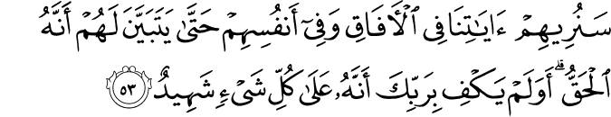
We will show them Our signs in the horizons and within themselves until it becomes clear to them that it is the truth. But is it not sufficient concerning your Lord that He is, over all things, a Witness?

and in Nabaa and in Mulk which speak of the miracles of Allaah in our surroundings, in these miraculous things are signs for people of intelligence, people who think. If these people looked around them, it would humble them. If their necks are in such a position, they can’t gaze around at the wonders. They can never see the beauty of the magnificence of Allaah’s signs. It is further drowning themselves in their own arrogance. They’ve made a choice and must not live with it.

Tense
All of this has been said in the past tense. Inna ja’alnaa = We have already put.
- Some scholars are of the opinion that this is giving a metaphor for their spiritual condition in the dunya.
- Other scholars say it will transpire with these people on the Day of Judgment. They will no longer be able to prostrate themselves, humble themselves. It is in the past tense because it is confirmed. There is such assurity in its occurrence that its as if it has already happened, thus the past tense is being used.

The coming verses, however, support the first opinion and make it clear that this is with reference to their arrogance in this world. It is a metaphor for their spiritual situation.

Verse 9

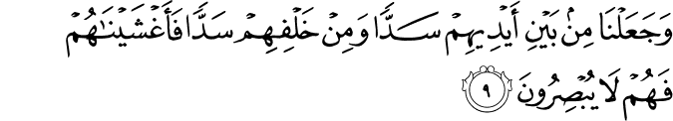And We have put before them a barrier and behind them a barrier and covered them, so they do not see.
{And We have made all the way from in front of them a barrier and all the way from behind them a barrier and we have covered them and they can no longer see.}

Allaah is further continuing that analogy of how pitiful their situation is and how cursed these people are. There is repetition of the word ja’alnaa in verses 8 and 9. The scholars say that this is because it is now discussing a different barrier. The first was their internal obstacle to seeing the truth - their arrogance which trapped them in a position. Now, it’s discussing the internal barrier. So even if they were able to overcome the internal barrier, they would not be able to believe because there is an external barrier.

Sad is a barrier between two things. Something preventing two things from coming together - between them and guidance, them and imaan. Allaah further says min bayni meaning that it is all the way from them, it is touching them. They are squeezed between two walls so tightly that they cannot move. There is such powerful imagery here. Imagine the suffocation. This is not a comfortable lifestyle they lead. Behind them there is another wall that is locking them in, trapping them.

Fa-aghshaynaahum there is even something on top covering them completely so that they cannot even see daylight. They are completely trapped that they cannot even see.

Verse 10

And it is all the same for them whether you warn them or do not warn them - will not believe.
{And it is equal, absolutely the same, whether you warn them or you do not warn them - they will not believe.}

Remember, andhar is to warn some of imminent danger out of care and concern for them. It doesn’t matter how much concern you warn them with or not.

What’s the point of giving da’wah then?
Allaah addresses this question in (7, 164)
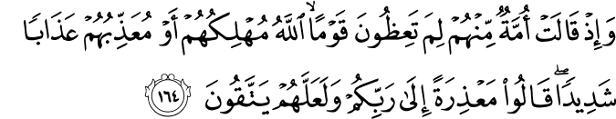
And when a community among them said, “Why do you advise [or warn] a people whom Allaah is [about] to destroy or to punish with a severe punishment?” they [the advisors] said, “To be absolved before your Lord and perhaps they may fear Him.”

So that when they stand before Allaah on the Day of Judgment, they have no excuses. The messenger will be able to stand before them and say that they did preach to them as best as possible. It completes the argument. Yet, at the same time to never give up because they may possibly becomes conscious of Allaah. We never know. Abu Sufyan accepted Islaam 20 years after it was revealed, after engaging in campaigns and battles against the message.

Why is Allaah attributing this to Himself?
This horrible situation that they are in, trapped and suffocating, Allaah is saying that “We have put them in it”. Why is Allaah doing it to them? Doesn’t Allaah want them to believe?

When you study the Qur’aan and its themes overall, and its discussion on guidance you understand this.
- Allaah has sent guidance clear as day, mercy, messengers, prophets, signs around us. He has put indicators to lead us back to Him all around us and even within ourselves. It is very clear and accessible.
- If these signs were all around us, but we didn’t have the faculties to access them it would be pointless. So Allaah has given us the faculties (76, 2)
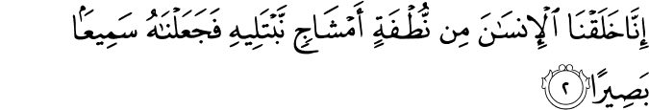
Indeed, We created human from a sperm-drop mixture so that We may test him and We made him hearing and seeing.

In order to test the human being, We gave him the ability to hear and see. In other places we are told we were given intelligence, ability to comprehend, ponder, think, walk around, feel, understand. We were given all the faculties we would need.

- Allaah gave the human being a clear choice (76, 3)
Indeed, We guided him to the way, be he grateful or be he ungrateful.

We were given a clear choice whether we choose to believe or disbelieve. Everything was made clear, we were given faculties to comprehend the signs, and then we have the choice.

Once someone makes the choice to not be grateful, to disbelieve, after being given all of these signs and opportunities, now Allaah says that He has put them into this situation. They walked until here and are now asking for the result. It’s like a person walking to the edge of a cliff and asking to suffer the consequences.

Then, who will the message benefit?

Verse 11

You can only warn one who follows the message and fears the Most Merciful unseen. So give him good tidings of forgiveness and noble reward.

One very profound message here is that da’wah is a responsibility from Allaah and it must be discharged. It is not just to benefit the person being invited (mad’u), but also for the inviter (da’i) regardless if someone is listening or not. We do not slacken in our efforts and accept failure. We strive because we are benefiting from this struggle. At the end of the day, the Messenger of Allaah s wanted to see some results, to see some validation, some vindication, to see that what he’s doing means something and it brings some change.

Innamaa in this form serves the purpose of restriction and specification, “in actuality, you are only”.

Attaba’a adh-dhikr | Word Analysis
Adh-dhikr points to the Qur’aan as time and time again it has been described as that (54, 40)
And We have indeed made the Qur’aan easy to understand and remember...

The fact that it’s in its proper form adh-dhikr is even more evidence of the fact that it points specifically to the Qur’aan.

So the one who will ittaba’ (literally meaning “to follow”) the Qur’aan. What does it mean to follow the Qur’aan?
In other places, we are told (39, 18)
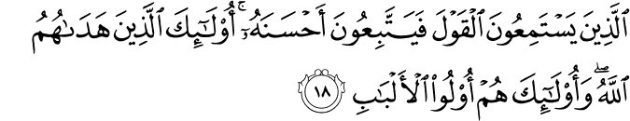
Who listen to speech (very attentively, carefully) and follow it (in its most excellent fashion). Those are the ones Allaah has guided and those are people of understanding.

Thus, following the Qur’aan means to listen, understand it, internalize it, act upon it, and even spend themselves in further spreading it. This is the real following of the Qur’aan. That is the one whom the Messenger of Allaah s is warning.

Khashiya ar-Rahman | Word Analysis
But that’s not all. This person has a second quality as well. Khashiya he fears, is overwhelmed by ar-Rahman. This is an interesting combination, to fear the Most Merciful.

Why not say Allaah? By saying Ar-Rahman the reader or listener thinks of all the blessings in his life and feels a sense of obligation to turn to and worship Allaah. The title, relationship, status is mentioned to make one feel a sense of obligation. He ta’aala has blessed you with everything you have.
Also, by mentioning Ar-Rahman it’s His right upon us to be worshipped and for us to fear disappointing Him. There is no contradiction.

Ghayb meaning in absence. When they are away from everyone, in the privacy of their homes. This person would have truly internalized the meaning of the Qur’aan. He is never heedless of Allaah, the One Who has given him everything, is watching him.

The Result
Give these people the good news of maghfirah. Maghfirah is the larger form of the word, meaning “complete forgiveness”.
And give them news of a ajrin karim - a most generous, noble word.

So these people had two qualities and were guaranteed two promises.
- For living a life following the Qur’aan they receive maghfirah. When we lead such a life we are cleansing and washing away all the sins we have committed in this life.
- For being fearful of Ar-Rahman even in private they receive a noble, generous reward (the life of Paradise).

Verse 12

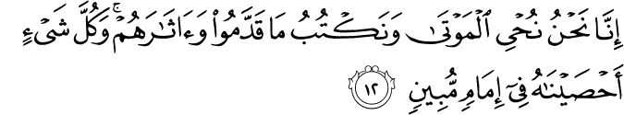Indeed, it is We who bring the dead to life and record what they have put forth and what they left behind, and all things We have enumerated in a clear register.

As in verses 8 and 9, there is exclusivity here by repetition of the first person plural subject (most definitely We and only We).

NuHyi al-mawtaa| Reviving the dead
This may be referring to either
- Reaffirming the life of the hereafter. On the Day of Judgment these people will be resurrected. This was the number one objection of the mushrikeen from the believers.
- The life of imaan (6, 122)
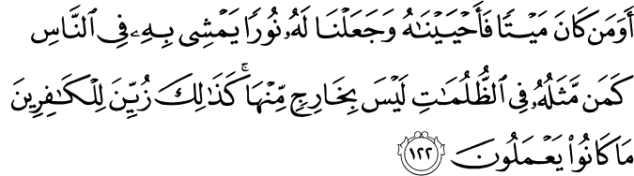
And is one who was dead and We gave him life and made for him light with which to walk among the people like one who is in darkness, never to emerge therefrom? ...

{The one who remembers Allaah and the one who does not, their example is like the living and the dead. [Tirmidhi]}
Allaah brings people to life by blessing them with imaan. Previously, there was reference to people who would not believe. Now He ta’aala is speaking of those who will accept it. Again, we continue to put forth our da’wah because we do not know whom Allaah will bless to come forward from death into life. Look to the examples of Abu Sufyan, Khaalid b. Walid, Ikrimah b. Abi Jahl.

Naktubu| The Recording
This focuses upon accountability. This was another objection of the disbelievers. They could not fathom how anyone could take everyone to account for what they have done. We are writing that which they have sent forward or invested for themselves.

Aathaarahum| Word Analysis
And their lasting effects or their remaining effects. But what does that mean?
- maa qaddamu (= that which they have sent forward) is referring to the good intention that one sends forward.
  - When a believer makes the intention to do a good deed. Allaah tells the Angel to write.
  - The Angel responds that the person has not done anything yet.
  - Allaah says that the person has made the intent to do some good so it should be written for him as a reward.
  - Then, when the person acts upon the good deed, Allaah again commands the Angel to write it.
  - In comparison: when the person intends for sin, the Angel asks Allaah if it should be written. Allaah says no do not write it. Then when the person commits the sin, Allaah tells the Angel to write it once. If the person does not commit it, though, Allaah tells the Angel to write down a good deed for the person because he fought his intention and resisted.

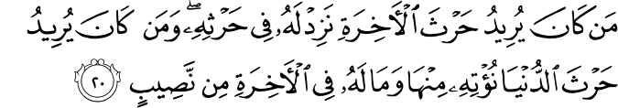
Whoever desires the harvest of the Hereafter - We increase for him in his harvest. And whoever desires the harvest of this world - We give him thereof, but there is not for him in the Hereafter any share. (42, 20)
Allaah did not say man kaana ‘amila, but He said man kaana yuridu. The one who would intend, not actually did. Iradah. Just a good intention is a profound good deed upon the believer.
  - The intention of the believer is better than his action.

Then the aathaar are the actual good deeds upon those intentions.

- maa qaddamu are the actual good deeds the person does and aathaar are what it encouraged others to do
  - Whosoever starts a good practice, he will get the reward of it and the reward of anyone who continues to act upon it.

When the human being dies, his actions are cut off except for three things (1) perpetual charity (2) knowledge the people continue to benefit from (3) a righteous child who continues to make du’aa for the deceased parent.

So they not only get credit of that which they themselves have done, but the after effects of what they have done.

- maa qaddamu are the good deeds being written and aathaar are everything that goes into making the deeds reality and comes about because of it
  - The scholars quote an incident from the life of the Messenger of Allaah s. There were a people living on the outskirts of Madinah, Banu Salimah, who accepted Islaam when teh message first arrived and supported Islaam.
  - Their neighbourhood was some distance from the masjid so they made intentions to move into the plot near it (today it is jannat’l-baqi’). He s heard this and went to them. He s said, “Ya Bani Salimah, diyaarakum (stay where you are now). Tubtabu aathaarakum (every little footstep you take to the masjid are written as reward for you).

  - When a person walks to the masjid, for every step he takes he gets a reward and one sin is wiped away from his slate.

  - This is like guarding the boundaries of the land of Islaam. Meaning the farther you live from the masjid and yet you still go, it is like preserving the Islaamic state.

  - Give good news to the people who walk, but walk frequently to the masjid in the darkness of night. They will have the most complete light on the Day of Judgment.

The principle is that when you do a good deed, the effort, time, investment, and intention, everything that goes into making the deed a reality are written for you.

Final Confirmation
Each and every single thing (abnormal sentence structure) (iHsaan) is already taken into account and has been preserved. There are books with the proof, with confirmation.

Imaam here means (according to Ibn Abbaas) the book of deeds, your record. This is because it will be presented before people and people will follow it (e.g. right hand to Paradise, left hand to Hellfire). This again creates that sense of accountability. What we do in this life will determine what happens to us in the Hereafter.

This life is an allusion, but it is significant because our result in the Hereafer depends upon what we’ve done here. What we do in this life will be our imaam in the Hereafter.

This ends passage one of Ya-Sin.

We’ve now discussed the validity of the Qur’aan, of the Messenger of Allaah s, and of the concept of their being messengers sent by Allaah to deliver His message to the people.
Then there are two groups people divide into when they are delivered this message. One choose to denounce it and Allaah discusses their situation and condition. The other choose to accepts it and Allaah discusses the reward set aside for them.

Verse 13

This begins the second passage of Ya-Sin. We need to understand the historical context for its revelation before proceeding further.
This was revealed to the Messenger of Allaah s during the Makkan period and at the height of the opposition from the Makkans. A lot of time in the city had passed, so this was nearing his final days in Makkah. He s has deliverd the message to the people in several ways like Nuh ‘alayhi as-salaam to his people (71, 5-15) publicly, privately, individually, giving them incentives. Yet, even with all of these efforts (71, 6)
But my invitation increased them not except in flight.

They would put their fingers in their ears, cover their faces when he would come to them, they would be insistent and arrogant and brush off Nuh ‘alayhi as-salaam. This situation was similar to that of the Messenger of Allaah s when these verses was to be revealed. The Makkans wanted nothing to do with him s and his message. They had complete apathy and became engaged in anti-da’wah; they were violent and aggressive towards those who were giving heed to the message. It was like Allaah tell us (41, 26)

And those who disbelieve say, “Do not listen to this Qur’aan and speak noisily during [the recitation of] it that perhaps you will overcome.”

They’ve made it personal to defeat the Messenger of Allaah s in his message.

At this point, Allaah is giving them a powerful reminder. To make someone realize the errors of their ways when they have been numbed by the warnings and advice, direct them to the situations of real examples. The horrific consequences that others have faced when they did not pay heed. Give these people the example of a people of a town that came before. The same thing may happen to these people as well if they do not correct their corrupt ways.

And present to them an example: the people of the city, when the mesengers came to it -

Strike for them an example - give an example for them (the Quraysh). Lahum means make this story of a people of a town previously relevant to these people. This is an implicit evidence that even when Allaah speak of disbelievers in the Qur’aan, even the Muslims should take heed. Ibn Abbaas said that in the aayaat directed to the disbelievers there is relevance for the believers. They ought to recognize these traits and tendencies and search for them within themselves. If they find them, it is a sign of disbelief and a sign to correct their ways.

Of the people of a town when messengers have come to them. There’s much discussion in tafasir about this “town”. Many mention the town of Intaqiyyah. It was an ancient city. These messengers, in their opinion, were not prophets but the disciples of ‘Isa ‘alayhi as-salaam. Ibn Kathir has a detailed discussion about the authenticity of these narrations. We don’t really need to get into this discussion. It is more important to see what message we can draw from these aayaat.

Verse 14

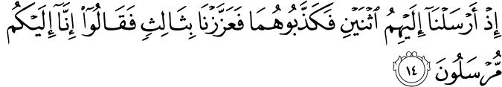
When we sent to them two but they denied them, so We strengthened them with a third, and they said, “Indeed, we are messengers to you.”

Idh is like saying “remember way back when”. First, Allaah sent two messengers to them. They rejected them. Takdhib means they called them liars. Everything they were given was called bogus.

Ta’ziz literally means to strengthen, to firm. Allaah says He reaffirmed the messengers with a third to reaffirm and strenghten their confidence and the message being delivered.

Their primary message was that most definitely we have been sent specifically to you. There is abnormal sentence structure here indicating that there is exclusivity.

Verse 15

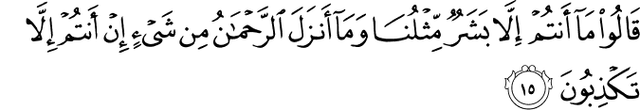They said, “You are not but human beings like us, and the Most Merciful has not revealed a thing. You are only tellings lies.”

You people are nothing but people just like us. This has always been the primary criticism of all messengers throughout time when they’ve come to deliver the message to people. Like the Quraysh when they said (25, 7)
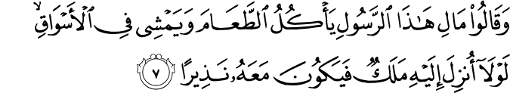
And they say, “What is this messenger that eats food and walks in the markets? Why was there not sent down to him an angel so he would be with him a warner?

This is the natural pride, ego of the human being: the aversion to authority. Even if Allaah would have sent an Angel down with the message, they would not have believed. According to them, the Angel would be a supernatural being unable to understand the situation of the human being. That is there situation.

There very first objection was: the messengers are people just like us.

And this Ar-Rahman you speak of (remember the name was mentioned in verse 11), He has not sent down anything. You (all three of you) are nothing but lying to us.

Verse 16

They said, “Our Lord knows that we are messengers to you,

The messengers now speak in response to the people of the town: Our Lord, He knows that most definitely we have been sent specifically for you people.

Their statement here is very profound. What did they use as evidence?
We know that messengers would receive miracles as evidence as well. They, however, did not respond with miracles. Just like how the Messenger of Allaah s did not respond to people with miracles. Remember when ‘Utbah bin Walid came to the Messenger of Allaah and asked him what he wanted (wealth? fame? women?). In response the Messenger of Allaah s recited the verses of Surat’l-Fussilat. Until he reached the point of sajdah performed it and then walked away from ‘Utbah who was left gobsmacked. The people saw him when he returned and said that he is not coming back with the face he left with. He advised them to leave the way because this would be a powerful storm.

We shouldn’t rely upon supernatural things to prove our point. Our message is enough evidence for us.

Verse 17

And we are not responsible except for clear notification.”

Now, there is the situation with the people. It is becoming difficult because they are being rude, abrasive, offensive. What’s the point to continue speaking with them? They know they are not obligated to do anything except balagh.

Balaagh is literally “to reach from one place to another”. The Qur’aan has been described as balaagh (14, 52)
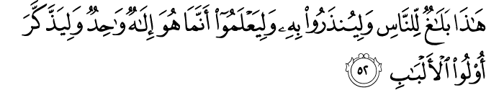
This [Qur’aan] is balaagh for the people that they may be warned thereby and that they may know that He is but one God and that those of understanding will be reminded.

At the same time the Messenger of Allaah has been commanded in the Qur’aan “balligh = convey, make it reach” (5, 67)
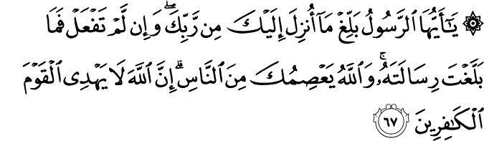
O Messenger, balligh that which has been revealed to you from your Lord, and if you do not, then you have not conveyed His message. And Allaah will protect you from the people. Indeed, Allaah does not guide the disbelieving people.

The Qur’aan is that which needs to reach people. Nothing affects people in da’wah like the Qur’aan. It needs to be the main vehicle of our da’wah.

Mubin means so clear that it is self-clarifying. So deliver a very clear, precise, pristine, understandable message to people. That is our task. It is not just to deliver the message, but to make sure the way of delivery is clear and pristine. For this purpose, we do not need to create any means - we have it in the Qur’aan itself.

In summary of verses 13-17, we see two things.

First, the beauty in the language
- At the end of aayah 14 the first time these messengers introduce themselves to these people as inna ilaykum mursalun - most definitely we have been sent to you people as messengers.
- At the end of aayah 16 they respond to the peoples accusations as rabbuna inna ilaykum lamursalun. There is an extra laam. Why? When they first introduced themselves, there was no exchange, argument, or refutation. It was just an introduction. When they rejected and placed accusations, the response is with emphasis.

Second, the biggest purpose of these aayaat was to be consolation to the Messenger of Allaah s and the believers as well. The Quraysh may be becoming more aggressive and offensive, but you are not the first (people or messenger) to experience this. Not one, but three messengers standing side-by-side were refused in this way by people. It is also consolation of the accountability (the task) of the Messenger of Allaah s. It is only upon him to deliver it clearly. He s delivered the message rightfully, above and beyond what was required for him.

Verse 18

This continues the discussion about the town’s people and their rejection of the messengers who came to them.

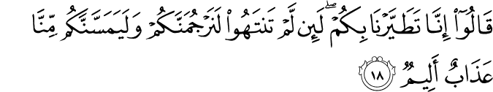They said, “Indeed, we consider you a bad omen. If you do not desist, we will surely stone you, and there will surely touch you, from us, a painful punishment.”

Now, Allaah is discussing what the response of these people is after the primary response of the messengers. This is showing the progression of the refusal and denial of the message. This passage, remember, is not just about this specific town, but about such events transpiring for every messenger sent by Allaah.

They say now, “We most definitely feel evil or misfortune from you...”

TaTayyar| Word Analysis
It comes from Tayr meaning “bird”. It also refers to making birds fly (e.g. throwing pigeons in the air to make them fly). In history, to test whether situations were good or bad, the people would throw birds in the air and based upon the direction and length of flight, they would make their decisions. It was superstition. So this word in this context means a bad omen, some misfortune coming one’s way. They sensed something bad would happen to them because of these messengers.

Is this statement substantiated or not? We look through the Qur’aan and find (6, 42)
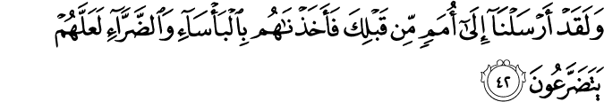
And We have already sent [messengers] to nations before you, [O Muhammad]; then We instantly grabbed them with poverty and hardship that perhaps they might humble themselves [to Us].

These people were befallen by something. What were they stricken with?
- Ba`sa = difficult economic situations (e.g. poverty, famine, drought, starvation, crop failure)
- Darraa = other difficult situations (e.g. of social nature, conflict, war, external other difficulties and problems)

So there were nations to whom messengers were sent and then there were difficulties sent upon these people but it was in order for them to humble themselves. It would crack that shell of ego they had placed around themselves.

This is repeated (7, 94) and made more explicit

And we sent to no city a prophet [who was denied] except that We seized its people with ba`sa and Darraa so that they may humble themselves.

They would come down from their delusions, from their high pedestal just a little. So when a messenger is sent and people refuse and deny the message, some difficulty comes their way. This is to reinforce the message of the messenger and serve as a wake-up call. This is after the messengers have given the first warning, been denied, presented a miracle, been denied, and now are on to the next step. This is the loud, blaring alarm clock to awake them from their apathy, insistence upon ignorance, stubbornness.

We know about the story of Musa ‘alayhi as-salaam who called the people of Firawn, then showed them miracles, and they still denied. Then Allaah sent upon them (7, 134)
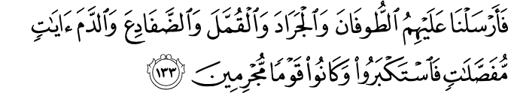
So We sent upon them the flood and locusts and lice and frogs and blood as distinct signs, but they were ignorant and were a criminal people.

One after another in waves, these adversities came to wake them up, snap them out of their deep sleep. This is a sunnah of Allaah, if you will, to bring hardships upon people who deny the messengers sent to them so that they may humble themselves.

Therefore, this statement of the townspeople does have some significance in that difficulty came upon for not believing. Their mistake, however, is attributing the misfortune and misfortune to come (taTayyar holds that future connotation of an omen) to the messengers as opposed to their own arrogance.

The Next Step of their kufr → Aggression, Violence, Threats
If you don’t stop, we most definitely will stone you and most definitely you will feel from us (experience from us) a most painful, tormenting punishment.
Rajam literally refers to “throwing rocks at something” and it can also mean “to cast something away, like garbage”. They say it with emphasis (laam) to say they will most definitely do it.

They have escalated to a high level.

Switch over very quickly to the life of the Messenger of Allaah s. Did not the believers experience similar torments? The mushrikin came to them Abu Taalib saying that he s had torn apart their homes and they were willing to give him whatever it took to make him stop. They even got to the point where the negotiation was for him s to continue practicing his religion, but stop preaching it. Abu Taalib called his nephew, told him what the people had said and asked if it made any sense to him. He s responded tearfully (even his own uncle did not support him?), if they put the sun in my left hand and moon in my left (even if they could do the impossible), I would not stop to do what I’ve been sent to do. Abu Taalib, in order to reassure the Messenger of Allaah s of his support, told him to proceed and he would continue to do what he had to do.
So the Quraysh had experienced similar hardships and they attributed them to their messenger s. Just like these people who attributed it to their messengers.
Then it progressed to violence. They killed Sumayyah and Yaasir f and several others were tortured mercilessly. Even women were not spared. All of this was the escalated aggression.

Verse 19

So what is the response of the messengers to these people?

They [the messengers] said, “Your omen is with yourselves. Is it because you were reminded? Rather, you are a transgressing people.”

These evils which they sense, feel, are alluding to - these are their own problem. The messengers are not substantiating the fact that their are evil omens. If there is anything bad happening to them, it is from themselves. They ought to look at themselves in long and hard in the mirror. Taairukum - it is their own problem.

Where did all of these complaints come from? From the simple fact that they were reminded and given a message telling them what is right and what is wrong. Dhukirtum. Rather than internalizing the message and seeing how it could benefit them they would turn it into something so negative and attribute any hardships to their warners.

Musrifun| Word Analysis
Rather you are a people musrifun. Musrifun comes from israaf meaning “crossing the line”. So they are people who cross the line. Allaah has not specified what line they are crossing because they are crossing several lines.
- They crossed the line of not believing in Allaah.
- They crossed the line of the messengers by rejecting them, slandering them, refusing them, accusing them of things.
- They crossed the line against themselves that when they are afflicted with difficulties they turn the blame upon others. They don’t see within themselves.
- Someone had come to them, sweating, bleeding, sacrificing, putting themselves on the line to benefit them. Rather than understand and appreciate the message and efforts, they turn the blame upon them. The messengers are actually the best thing to have happened to them!

This had occurred with all the messengers previous. For example, Musa ‘alayhi as-salaam (7, 130-131)
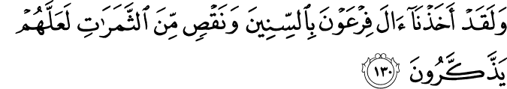
And We certaintly seized the people of Firawn with years of drought and a deficiency in fruits that perhaps they would be reminded.
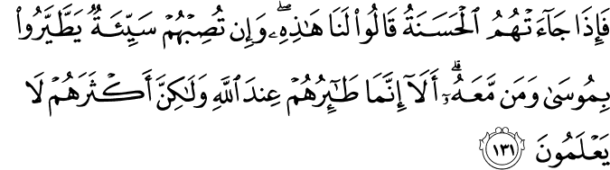

But when good came to them, they said, “This is exclusively for us [by right].” And if a bad [condition] struck them, they saw an evil omen (Tayar) in Musa and those with him. Unquestionably, their fortune is with Allaah, but most of them do not know.

Even about the people of Makkah, Allaah tells us (4, 78)
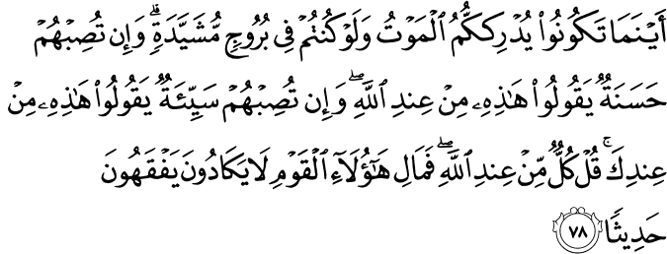
(...wain tuSibhum → ‘indik ...) And if evil befalls them, they say, “This is from you.”

When they began to act in this way, blaming the messengers for their own problems and eventually escalating to aggression, how are the messengers to respond? Allaah is teaching His Messenger s that the previous messengers told them rightfully what needed to be said - that it was the peoples own faults for crossing lines that should not be crossed. It was tarbiyah for the Messenger of Allaah s to not fall to their level, but to be firm.

The Concern of the Messengers
Finally, by speaking about what the Messenger of Allaah s is experiencing and the experiences of messengers past, Allaah provides him s with consolation. He s is deserving of this consolation because he spent himself for the betterment of creation.

Allaah mentions that the greatest mercy and blessing sent to creation and to the Muslim ummah in particular was that this messenger was sent to us (9, 128)
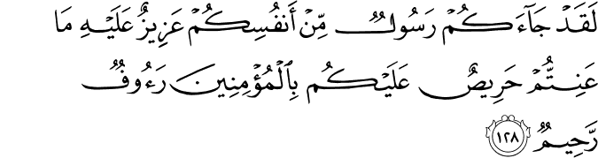
There has certaintly come to you a Messenger from among yourselves. Grievous to him is what you suffer; [he is] concerned over you and to the believers is kind and merciful.

This is a beautiful aayah in the Qur’aan. He s came from amongst you so he could understand you, he could relate to you. He was empathetic to you. It was rough on him, what you were going through. When he s saw others suffering or in pain, it would hurt him. He would cry for people, pray for them, stay awake at night in worry for them.

HariS comes from HirS which we usually associate with wealth, greed. We are greedy for money, cars, houses, fame, luxury, reputation, power, influence. He s desired something as well. It wasn’t, however, any of these things. It was the well-being of creation. This was the dedication of his entire life.

  - My example and then your example is like a man who lit a big fire.
  - All these bugs and fire comes to it. I’m trying to shoo them away from the fire.
  - You are like those bugs, not realizing what you are doing.
  - I try to save you, pushing you away, but you keep slipping by.
  - I try harder, but you pass right before my eyes.

He s is rauf very soft and gentle and raHim most merciful to the people who do believe. Look at how he s acted with the bedouin who urinated in the masjid and with the young man seeking permission to engage in zina. He intelligently spoke with them and treated them respectfully. He s reasoned with them at their level to make them understand, to show love and compassion, build a bond, to show that he loved them. He placed his hand on the young man’s chest and made du’aa that Allaah guide and purify him. All this showed to them how much he s cared. Even the young boy whose bird died (ya abba ‘umayr, maa fa`alan nughayr?). He s still took out the time to go sit with this boy and ask about his bird.

This is how much he s would do for us. The greatest thing we can do is try to live up to that standard, empathizing with people, sharing the message of Islaam with our compassion, care, and character.

Verse 20

This passage is essentially the core of this surah, the central theme. It is one of the most powerful messages of this surah in aayaat 20-25.

And there came from the farthest end of the city a man, running. He said, “O my people, follow the messengers.

Now the confrontation or situation has reached a very critical point (the townspeople are accusing, slandering, and becoming violent and the messengers will not stoop down, but will hold firm to their responsibility).

Yas’aa| Word Analysis
The messengers are delivering the message to a disbelieving people, but there is a man. He is not even from the same vicinity. In fact, he is from the farthest end of town and he is coming from there if that’s what it takes to get to the message. Not only that, but he’s rushing.
Yas’aa is from sa’i meaning to rush towards something when you have a target or a goal. He’s a man on a mission.

Itabi’u| Word Analysis
The said, “O my people, follow those who have been sent.”
Itaba’ means to listen attentively with an open mind and heart, to internalize the message, and then to spread it to others. This is the word used whenever we are told to “follow the messengers” like when Allaah commands His Messenger s to say (3, 31)
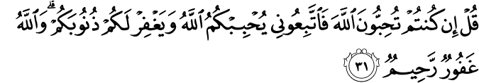
Say, [O Muhammad], “If you should love Allaah, then ittab’iuni (= follow me) so that Allaah will love you and forgive you your sins. And Allaah is Ghafurun Rahimun.

Following the messengers is what is key. Islaam, din, the core, basic tenets of it came to us from the Qur’aan. But the practical structure, the framework, practice of, implementation of Islaam comes from the Messenger of Allaah s. Otherwise, it all remains theory.

This man has not just said to follow them, but he has presented evidence. The mufassirun say he is providing three pieces of information.
- They are al-mursalin. Meaning they’ve been sent to us by Allaah. They are not ordinary people, they’ve come from a higher authority, the ultimate authority. Refer to Verse 3 for more information regarding this term.
- & 3. may be found in Verse 21

Verse 21

Follow those who do not ask of you [any] payment, and they are [rightly] guided.

This man has not just said to follow them, but he has presented evidence. The mufassirun say he is providing three pieces of evidence to follow them.

- (From Verse 20) They are al-mursalin. Meaning they’ve been sent to us by Allaah. They are not ordinary people, they’ve come from a higher authority, the ultimate authority. Refer to Verse 3 for more information regarding this term.
- They do not want any retribution from you.
Ajr means reward for some work having been done by you. This is someone’s entitlement, someone’s right. It is not a favour to someone. It is an exchange. These messengers are providing their services, sacrificing time, energy, money, resources, investing their own talents and intellects into bettering you and your situation. Even if you were to pay them for it, it would be completely justified and deserved. So these messengers are not asking for a justified return and this is from their own nobility and the nobility of the message they are delivering.
This is like when Hud ‘alayhi as-salaam said to the people of ‘Aad (11, 51):
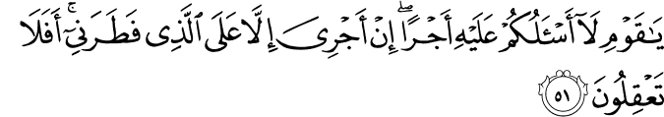
O my people, I do not ask you for it any reward. My reward is only from the One Who created me. Then will you not understand?

Their reward is due on the One Who created them. This is their nobility. They will do everything for the people, sacrifice for them and expect nothing in return from them.
The Messenger of Allaah s asked people for nothing. The people wanted to give him something and they felt their own honour in giving him a gift. He s would use a little from it to satisfy the people and please them and then he would distribute the rest to others. This is the nobility of the messengers.

3. And they most definitely are guided. They live a life of guidance. Their manner of living life shows that they are guided. When you look at them, watch them, observe them you will see they are guided. Their personal lives, family lives, and public lives always show guidance. Everything about them is amazing, it is exemplary. It is the most amazing way to do everything. The Messenger of Allaah s was the best at everything and in every relationship.

Verse 22

This man has provided the people with evidences for why they should follow the messengers. Now, he will try to rationalize with them regarding the message itself. Notice a point in da’wah: mentions the righteousness of the messengers and then follow up with the message. Make them understand what is at stake and that it is for their own good.

And why should I not worship He who created me and to whom you will be returned?

He takes a very interesting point in giving them da’wah. He speaks about himself, but not in an arrogant way. In a way to make it seem real, but non-accusatory.

FaTara| Word Analysis
What’s wrong with me? Why wouldn’t I worship the One Who has originated me? The One Who has given me existence in the first place?
Ibn ‘Abbaas f once said that he was trying to understand the difference between the words faTara and khalaqa. He was travelling and came across bedouins who had a dispute over a well’s possession. He asked them for their evidence.
  - One man said, “الذي هو فطرته” meaning “I am the one who originated this well”. So he was the one who had dug it up in the first place.

What would be wrong with me if I did not worship the One Who gave me existence in the first place?

Then he kindly has them reflect by changing the subject from first person to second person. He is the One to Whom you all have to return. He has engaged them into the conversation, he has provided food for thought.

Verse 23

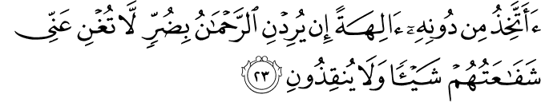Should I take other than Him [false] deities [while], if the Most Merciful intends for me some adversity, their intercession will not avail me at all, nor can they save me?

Now, he goes back to the message. He’s asking a rhetorical question for how foolish it would be for him to take other objects of veneration. How ungrateful, foolish would that be? Is that what they are suggesting?

Now, he uses a very interesting example. If my Lord, the One Who is Abundantly Merciful intended for me some difficulty, it would not help me in any way, the intercession, the intervention of those others gods whom I venerated.
If the One Who has blessed me with everything I have, if He has afflicted me with some difficulty, the intercession of other things I worshipped would not help me in the least bit!

Inqaadh is like someone is falling into something and you grab them and pull them out from there. It is like someone falling off the edge into something and you saving them. These deities would not be able to save him in the least bit.

Why does he mention adversity?
Why does he give the example? It is discussed in the Qur’aan a lot as in (10, 21)
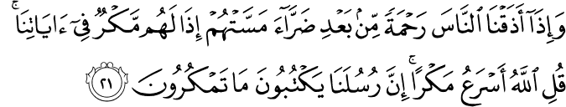
And when We give the people a taste of mercy after adversity has touched them, at once they conspire against Our verses. Say, “Allaah is swifter in strategy.” Indeed, Our messengers record that which you conspire.
When people are tested with difficult situations, they immediately turn to Allaah (10, 22)
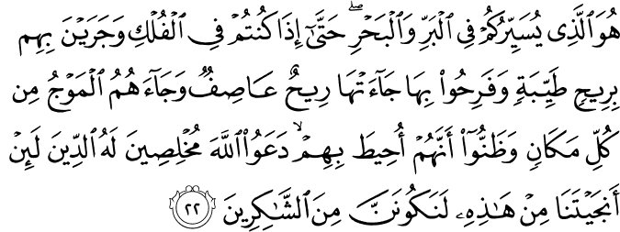
It is He who enables you to travel on land and sea until, when you are in ships and they sail with them by a good wind and they rejoice therein, there comes a storm wind and the waves come upon them from everywhere and they assume that they are surrounded, supplicating Allaah, sincere to Him in religion, “If You should save us from this, we will surely be among the thankful.”

In such a horrible situation they start making sincere du’aa to Allaah and promise that if they are saved they will always be grateful. Yet, when they are removed from the adversity, they go right back to their heedlessness. This is the nature of people. Adversity reminds them of Allaah, but in khayr they think it is all from themselves. They forget (6, 17)
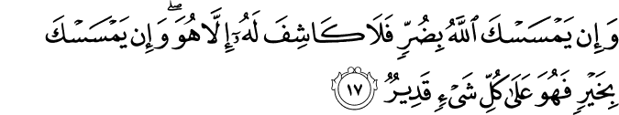

And if Allaah should touch you with adversity, there is no remover of it except Him. And if He touches you with good, then He is over all things competent.

He gives them the example of difficulty because in that even these townspeople can comprehend turning to the true Lord. We must give relatable examples to people.

Verse 24

Indeed, I would then be in manifest error.

If he were to do this (Verse 23), then most definitely he would be in that situation would be in very serious, open, clear misguidance.

Fi| Word Analysis
Fi means to be inside something. When Allaah speaks about misguidance, He uses this preposition fi. It connotates being inside something, as in a bubble that does not permit them to see outside of it. Everywhere he looks, he will only see more misguidance. Thus, it is as if he is drowning in misguidance.

Mubin| Word Analysis
Mubin was previously used in Verse 17 to mean the self-clarifying message. This man is telling them that if he himself refused, resisted, and was arrogant and stubborn against the message then he would be in a very clear misguidance. There is sharp contrast between there being self-clarifying message and clear, distinct misguidance.

Verse 25

Indeed, I have believed in your Lord, so listen to me.”

In this final verse, the man says something very powerful. He makes a proclamation to the people with confidence and firm stance. He openly declares his support for these messengers and their message.

Aamantu| Word Analysis
I have already believed. It is in the past tense. Meaning it is so certain and true that has he brought belief before now.

Birabbikum| Word Analysis
In your Lord. This is directed at the townspeople. Why would he use the second person possessive pronoun? You are not willing to believe in him, you are being arrogant and ungrateful, but regardless He is your Lord. I have believed in him so listen to what I am telling you. This is for your own good. He is not speaking to them for any personal benefit, but only for their own good.

Instrumental Lesson
The messengers were preaching the message. The townspeople were disregarding and desisting the message and behaving violently with the messengers. A man from, not there nor a witness feeling empathy for the messengers, but from the farthest regions of town comes forth. He hears about the message, understands it, believes in it, and understands his own responsibility. He mobilizes himself and takes it upon himself to rush to voice his support and provide his backing to the messengers.

This is speaking to us about our roles. This is Makkan Qur’aan. This is especially for us who are living in a Muslim minority area where we see more and more scrutinization and criticism.

Islaam is not just there for amusement and pleasantries. Part of our obligation, the blessing of Islaam, and being grateful for the blessing of Islaam is to become supporters of the Messenger of Allaah s and the message of Islaam.

We have nothing to be ashamed about. We are telling people to follow the most amazing person to step foot on this earth. Muhammad s.

Laa yasalukum ajran
The Messenger of Allaah s did not have any ulterior motives or agenda. For example, he s would give away personal gifts. We should help people for the sake of helping them. For the sake of pleasing Allaah.

Muhtadun
Next, we should be proper, good, effective presenters of Islaam. Our lives should show that we have guidance. We can’t just keep speaking or writing, we have to live it eventually. The primary means of da’wah will always be our behaviour and interactions with people. One of the biggest problems today for those coming into religion is seeing religiously active individuals saying one thing, claiming to represent one thing, but their personal life, business life, and self-conductance are not lived in accordance.

Speak about one’s own self
Come down to speak to people at their level. Don’t speak downwards to people. Empathize with people. The best one in speech is the one who relates himself to people (41, 33)
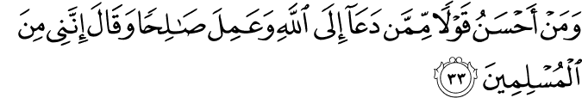
And who is better in speech than one who invites to Allaah and does righteousness and says, “Indeed, I am only one among the Muslims.”

The khatib, imaam, and scholar are just muslims at the end of the day.

Reflection
Give people something real to think about. Where will we return after this life?

Relevance to the recipients
Talk to people about something they understand and can relate to.

Firm in faith
At the end of the day, our da’wah requires us to be very clear and confident in what we believe in.

These are the major guidances from this surah. The messengers have come and done their job. This man could have thought what more he could have done if the townspeople were not listening to messengers? Did he, though? Of course not! What about the Companions f? They were carriers of the message and spread it to people with the etiquettes and guidance taught to them by the Messenger of Allaah s and presented to us in this passage.

Verse 26

It was said, “Enter Paradise.” he said, “I wish my people could know

There is a consensus among the mufassirun. When the Qur’aan describes to us a situation, tells us a narrative, it doesn’t tell us step by step everything that has occurred. When this man spoke up and stated his faith to his own people, it seemd to them as if one of their own had confronted them. These townspeople responded as people in such a situation usually do. The scholars agree that the transition is that they killed this man. Now, we will learn what happened to this man after his death.

Qil meaning it was announced, proclaimed to him udkhuli al-jannah enter into the gardens of Paradise. He’s being commanded! There is no reckoning, no questioning, no hisaab, no kitaab. This is that ultimate status of specific groups of people who will be entered into Paradise without any reckoning.

At that time, that man says that he wishes his people could have known this. This shows his sincerity of this individual. His true concern for his people is apparent even in his afterlife. When we give da’wah we take a lesson from this man. Its not done to establish hujja against people. Its done with sincere care for the people, to improve their condition.

Verse 27

Of how my Lord has forgiven me and placed me among the honoured.”

What does he wish his people would know? How his Lord has (past tense) forgiven him. His slate was wiped clean! Whatever he might have done, we don’t know. That’s the whole point, he could have been anything (a thief, liar, crook, mutaqiI), but it doesn’t matter because of what he has engaged in.

Ghafara literally means to cover something up. So this means not just to forgive, but to have it hidden such that nobody ever knows about it. We don’t know anything about this man before this situation. Allaah has hidden that from us in this narrative!

Wa ja’alni and he made me min from among al-mukramin.

Mukramin comes from ikram meaning to honour someone. Mukramin are those who are honoured.

This is an interesting sentence structure. He doesn’t say, mukramani (= He honoured me) where ikram is in the verbal form. Instead he used the nominal form (mukramin = the honoured people). The significance of the noun over the verb is that the verb is bound by time, but nouns are eternal. So it is as if Allaah has granted him this honour for all of eternity.

In the life of the hereafter, honour is eternal. In this world, honour today could be disgrace tomorrow.

What’s even more in the sentence structure is that he is min al-mukramin. He’s honoured, but he’s not alone. He’s among a group of people. He’s among others who are also equally honoured. The company we keep reflects upon who we are. We feel distinction and honour based upon with whom we associate. This person is among the most amazing, awesome people.

Verse 28

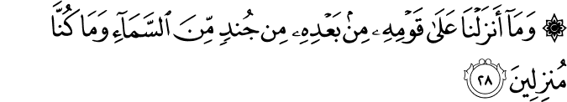And We did not send down upon his people right after him any soldiers from the heaven, nor would We have ever done so.

Now, Allaah the Exalted and Most High speaks. The man was speaking before because Allaah had given him that honour to speak from the Hereafter. Allaah allowed him to speak of his situation, but now He will speak of the townspeople who rejected and harmed His messengers and killed even the one man who came forth to support them.

Ba’dihi would mean “after him”, but the additional mim adds immediate action. Meaning the punishment of Allaah and his decision upon this people was not for much later even after this egregious act they have done - persecuting and killing a man who spoke on behalf of truth.

Allaah uses min again for jundin (= army). He could have simply said jundan, but by adding the min it means Allaah did not send upon them any type of army. No type of army (people, Angels, etc.) was sent to these people.

Allaah uses the word jundin (=army) because when the Angels would be sent down to people they would resemble armies in their organization, like a battalion. Think of the Battle of Badr (3, 125) and (8, 9)
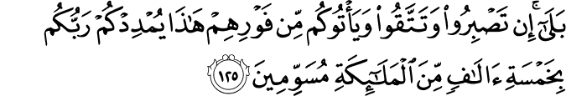
Yes, if you remain patient and conscious of Allaah and the enemy comes upon you [attacking] in rage, your Lord will reinforce you with five thousand angels musawwimin (having marks of distinction).
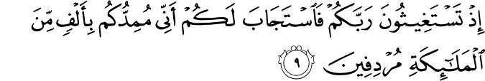
[Remember] when you asked help of your Lord, and He answered you, “Indeed, I will reinforce you with a thousand from the angels murdifin (following one another).

They came down in the form of an army, organized like a battalion. When Allaah sometimes gives them a punishment at the hands of others (e.g. defeat), we can still say that it arises mina as-sama (from the sky) because the command originated in the skies.

Nor would we ever said down
What does this mean? It is a phrase in Arabic and can be understood in a few ways:
- We did not send an army upon them nor are we ever going to
- We did not send an army upon them and it wasn’t even appropriate to do so because these people aren’t even deserving of such attention.
When Allaah decides just punishment for a group of people, He is not required to do so by sending an army upon them. Allaah’s will is not restricted in any way (16, 40)
Indeed, Our word to a thing when We intend it is but that We say to it “Be” and it is.

- We did not send an army upon them and there was no benefit in sending down an army.
Sending down an army or Angels is to send a message, teach a lesson, make a point. There was no point to do that with these people.

Verse 29

It was nothing except for one shout and immediately they were extinguished.

SiHah| Word Analysis
It means a very, very loud sound like a scream (e.g. he’s lying his head off). Such a loud scream that it is disturbing to people. When it is used to describe a punishment of Allaah it refers to such a huge piercing sound that it would literally make people’s heads explode.

Just a single sound! One screaming, piercing sound was enough to make their heads explode.

Then immediately (without warning) they became khaamidun.

Khamad| Word Analysis
It refers to putting out a fire, extinguishing a fire. As if they had been put out like a fire completely and suddenly extinguished.
This could refer to their arrogance, pride, boastfulness.
It could also refer to how they died; walking around one minute and suddenly fallen dead.

Profound Lesson
This lesson is being given to the Muslims being persecuted in Makkah and the Quraysh persecuting them. When somebody stands for what is right, he may not see the fruits of his labour in this world. These townspeople became more arrogant and ended up killing him. Yet, there is return on the investment - it may be the best long-term profit. Jannah, honour, being given distinction. The townspeople may have scoffed at the end of this person, but Allaah is telling them that there is more than they can see! Much more (4, 69)!
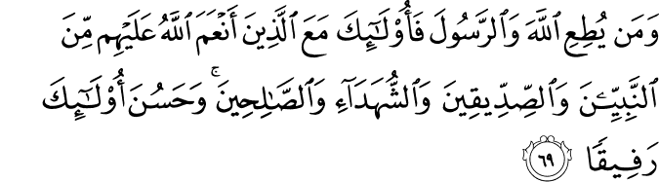
And whoever obeys Allaah and the Messenger - those will be the ones upon whom Allaah has bestowed favour of the prophets, the steadfast affirmers of truth, the martyrs and the righteous. And excellent are those as companions.

To be in the company of these people! That is where this man ended.

People who oppose the truth should not be deluded by what they perceive to be an immediate, short-term victory. Sometimes it is just another trap, another part of their errors. They would have used this as a lesson against other followers and people. They were increasing their arrogance upon arrogance (24, 40).
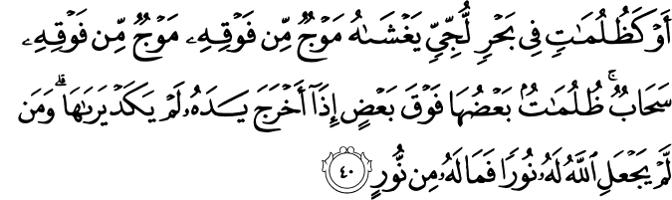
Or [they are] like darknesses within an unfathomable sea which is covered by waves, upon which are waves , over which are clouds - darknesses, some of them upon others. When one puts out his hand [therein], he cna hardly see it. And he to whom Allaah has not granted light - for him there is no light.

Look at what happened to them. Allaah did not even trouble His armies to bring the punishment upon them. A single, one, loud piercing sound was enough to bring them into destruction.

Verse 30

How regretful (hopeless) for the servants. There did not come to them any messenger except that they used to ridicule him.

Previously, Allaah spoke directly of His wrath and anger upon these people and the plight of them.

Hasrah| Word Analysis
This is a very, very strong word. It even sounds strong when one says it. Its even stronger than ندم (meaning remorse or regret). Hasrah literally means when a person becomes completely hopeless (67, 4)
Then return [your] vision twice again. [Your] vision will return to you humbled while it is Hasir (fatigued).

There’s no light left at the end of the tunnel. These people have experienced that Sihah and are khamad, now lying on the ground dead instantly.

These slaves
  - interesting to note that ‘ibaad is specific to slaves of Allaah. When one refers to a group of slaves, the word used is العبيد.
are in a hopeless situation. Why is it hopeless? Not because Allaah cursed them or did not want any good for them, but because no messenger came to them except that they would mock him, make fun of him, treat him inappropriately.

Istihza| Word Analysis
It means to make fun of someone, but even more it means to make fun of someone in a very foolish manner. Making fun of anyone is inappropriate. This is humiliation. It is as if one is making things up just to get a few laughs and kicks out of it. They woudl come up with senseless things. How uncomfortable would it be to say something like that about a messenger?!

This is a template of what happened repeatedly in history. Every single time these people were sent a messenger, they would mock them. No matter how bleak the situation becomes, however, it always works out in the end. This is the message to the Messenger of Allaah s and the Muslims in Makkah.

As well, this passage is shown elsewhere (43, 6-7), but the Qur’aan is never supfluous
And how many a prophet We sent among the former peoples,

But there would not come to them a prophet except that they used to ridicule him.

Here Allaah uses the word nabi, but in Ya-Sin Allaah uses rasul because He has been using it from the beginning of the surah! It is, thus, more appropriate to use the word surah and keep consistency in the surah.

Verse 31

Have they not considered (understood) how many generations We destroyed before them - that they (who have been destroyed) will not return to them?

This is now addressing the people of Quraysh.

La yarji’un it is in the present and future tense meaning that these people are not and will not ever come back to them. Don’t wait up late at night for them. They’re gone, wiped clean from the face of the earth. They were eradicated, erased.

To the point that there were sometimes no remnants of these people.

Verse 32

And indeed, all of them will yet be brought present before Us.

History is repeating itself. It has happened time and time again, previously, and now again to these people. Even though they were eradicated, all of them will most definitely be gathered together near Allaah.

In the Hereafter, they will eventually all be presented and placed before Allaah. It is a reminder fo accountability for their actions. It is not so easy that it is over once they have died after their egregious actions.

MuHDarun| Word Analysis
Allaah does not say حضرون (they will present themselves). He the Exalted uses the passive form, meaning “they will be presented”.
They will be forced. Allaah speaks about this elsewhere (41, 19) and (39, 71)
And [mention, O Muhammad], the Day when the enemies of Allaah will be gathered to the Fire while they are [driven] assembled in rows

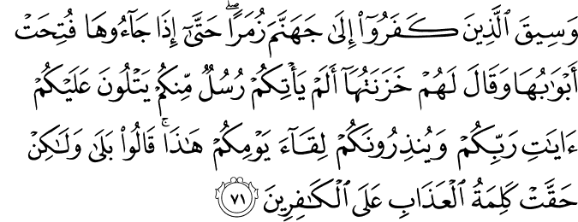
And those who disbelieved will be driven to Hell in groups until, when they reach it, its gates are opened and its keepers will say, “Did there not come to you messengers from yourselves, reciting to you the verses of your Lord and warning you of the meeting of this Day of yours?” They will say, “yes, but the word of punishment has come into effect upon the disbelievers.”

They will be herded like wild beasts and animals, cuffed and chained and collared, to stand before their Lord. And this will be in the truest form of justice because they will be shown what they have done to see for themselves (17, 14)
[It will be said], “Read your own record. Sufficient is yourself against you this Day as an accountant.”

It is as if Allaah is saying to you, “You tell me what I should do with you?”. This is the reality of the reckoning before Allaah on the Day of Judgment.

Underlying Lessons
We’ve seen this issue and lessons of da’wah. The progression of da’wah has been clear. There was aggression requiring people to speak up and support the message. The results may not be immediately seen, but the reward is with Allaah.
As a consolation and to build conviction for living by the truth, the truth is never eradicated and diminished. It never happens.

In Madinah, things became very difficult, but Allaah brought Fath’l-Makkah.

Allaah says (37, 171-173)
And Our word has already preceded for Our servants, the messengers,
Indeed, they would be those given victory
And [that] indeed, Our soldiers will be those who overcome.

As well, Nuh ‘alayhi as-salaam was presented with distress from his people so (54, 10)
So he invoked his Lord, “Indeed, I am overpowered, so help me”

Allaah wiped out the people against him and kept only him and his followers, those who were upon truth. Thus, the da’wah will never go away (17, 81)
And say, “Truth has come, and falsehood has departed. Indeed is falsehood [by nature], ever bound to depart.”

Injustice, falsehood, evil is meant to go away. Its purpose in life is to be temporary! A beautiful parable is given by Allaah (13, 17)
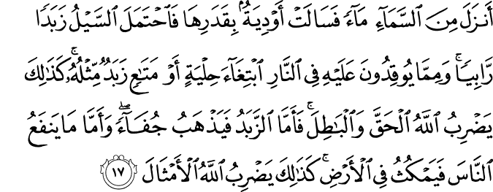
He sends down from the sky rain and valleys flow according to their capacity and the torrent carries a rising foam. And from that [ore] which they heat in the fire, desiring adornments and utensils, is a foam like it. Thus, Allaah presents [the example of] truth and falsehood. As for the foam, it vanishes, [being] cast off; but as for that which benefits the people, it remains on the earth. Thus, does Allaah present examples.

That foam will eventually dry up and the debris in it will fall to the bottom. And that which benefits people stays there in the earth. This is the example of truth and falsehood. Truth comes, falsehood rises to the top, but it is temporary until it falls away.

Our intent and purpose is truly to help humanity. The Messenger of Allaah s just wanted to better peoples’ situation. If that is our heart we need to continue to do good for people to better their quality of life. Bring them peace, tranquility and fulfillment in life by finding Allaah. That will overcome in every and all obstacles and difficulties. Allaah has presented this to us in the example of the messengers and previous people.

At the end of the day, whose right and wrong is not our decision. All of us, everybody, will stand before Allaah on the Day of Judgment whether he wants to or not and Allaah will make the decision.

Verse 33

A new passage begins. This is the middle part of the surah and it serves a pivotal role in the theme and concept of the surah. In the introduction we discussed the three main topics of Makkan suwar (tawhid, risalah, aakhirah). Ya-Sin very powerfully and emphatically speaks of all these three topics.
The first part of the surah focused heavily upon prophethood and messengership.
The end part of the surah will focus heavily upon the life of the hereafter and the reckoning.
The middle part, starting now, will discuss tawhid. This is a very fitting manner of presentation because messengers bring the message and the hereafter is the result of how that message is taken. What, however, is the crux of the message? What determines the faith of people? It is how well they accepted and founded tawhid. Their commitment to Allaah. How they were able to live by this creed.

Before beginning the tafsir, we must discuss some basic concepts by which the Qur’aan discusses the Oneness of Allaah.

Normally, especially today, in the Muslim community, the discussion of tawhid is very philosophical and logical to prove the presence of a Higher Being. That has become the tone of this conversation. Even Muslims are infatuated and enamoured by using this philosophical and scientific perspective.

The Qur’aan, however, teaches the existence of a Divine Being differently. It does not use philosophical terms. It uses deductive reasoning and deductive logic. There are certain observations to be made which lead us to a particular conclusion. Look to these verses (88, 17-20) and (67, 15)
Then do they not look at the camels - how they are created?
And at the sky - how it is raised?
And at the mountains - how they are erected?
And at the earth - how it is spread out?

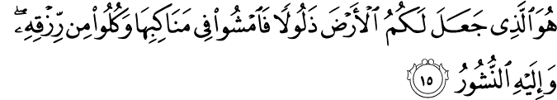
It is He who made the earth tame for you - so walk among its slopes and eat of His provision - and to Him is the resurrection.

This so powerfully summarizes the concept. The earth is here for us to trample all over it! We can walk all over it and eat from everything it grows and we will still be gathered exclusively before Allaah.

It is almost elementary how the Qur’aan teaches imaan, but that is the way it strikes us best that Allaah is One and He Alone deserves to be worshipped.

We will see this same introduction to Allaah in this verse.
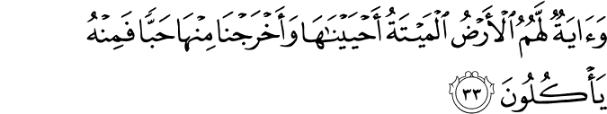
And a sign for them is the dead earth. We have brought it to life and brought forth from it grain, and from it they eat.

Aayah| Word Analysis
Allaah points to aayat to explain to us, to clarify to us (2, 242):
Thus does Allaah make clear to you His verses that you might use reason.

It means sign; a very obvious, apparent, unavoidable, immutable sign. You have to be trying to miss it in order to miss it. It is also such a sign that it does not engage or absorb you into looking at the sign itself. Rather it immediately points you to something else. You are not required to make a conscious effort. When someone gives you a gift - a plaque or card - you won’t think of its make. You will think immediately of the memories associated with it, the person who gave it to you.

These signs should immediately make us think of Allaah. If we look at these things and we don’t think of Allaah immediately then that means one of three things.
- There is a lack of intellect, mental awareness or consciousness
- Deficiency in the fitrah of that person, the core of that person.
Thus, all aayaat will lead one to immediately think of Allaah when there is intellect (mind is awake and open) and the fitrah is clean.

An Arab poet has said:
وفي كل شيء له آية تدل على أنه واحد
In each and every thing there is a miraculous sign pointing you to the fact that He (Allaah) is one.

The bedouins have beautiful and eloquent statements in this regard. There was once a bedouin man who was challenged by somebody. For every claim there is evidence, what is you evidence and proof for believing in Allaah? He said,

Camel droppings tell you that a camel was here.
Footprints in the sand tell you someone walked by here.
The earth is full of trees, the sky full of stars,
and the ocean full of waves, doesn’t that tell you Allaah is there?

Allaah uses a beautiful example in the Qur’aan (6, 59)

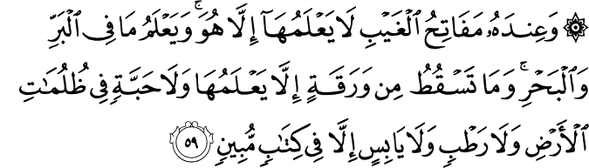
And with Him are the keys of the unseen; none knows them except Him. And He knows what it on the land and in the sea. Not a leaf falls but that He knows it. And no grain is there written within the darknesses of the earth and no moist or dry [thing] but that it is [written] in a clear record.

This is a beautiful example. Why a leaf? It is something so small and insignificant that we don’t even consider it. Every single leaf falling from a tree is by the knowledge and command of Allaah.

There is a narration in Tabaraani (graded hasan) that says the Messenger of Allaah s was passing by a bedouin man who was making du’aa in his prayer. The Messenger of Allaah s stopped to listen for a minute. The man was saying
  - “O You Who eyes cannot see in this world, minds cannot comprehend You! People cannot praise You as You deserve to be praised, and Who changes the incidences and occurrences which occur, but does not change Himself, He does not fear the trials and tribulations of time. He knows the exact weight of mountains on the earth, He knows the exact volume of water on the earth, He knows the exact number of rain drops that fall from the sky. he knows the exact number of leaves on every tree on the earth. He knows the exact number and details of everything that the darknesses of the night hide and the light of the day illuminates with its light. One sky cannot hide or shield another sky from Allaah. One ground cannot hide or shield another ground from Allaah. And a mountain in its deepest darkest caves cannot hide anything from Allaah and the ocean in its deepest depths cannot hide anything from Allaah.

This is how these people would believe in Allaah and this is how Allaah has taught us to believe in Him in the Qur’aan.

Second, the Qur’aan has a progression for how it brings change and enlightenment to the human being.
- Aayaat to direct attention. They are not just here to inspire awe in us. They are to lead us somewhere else (88, 21). It is for reflection, it is to remind. It is a wake-up call.
So remind, [O Muhammad]; you are only a reminder.

And what is a reminder? A reminder does not present new information. It is bringing to attention information that we already have and already know and realize (30, 30)
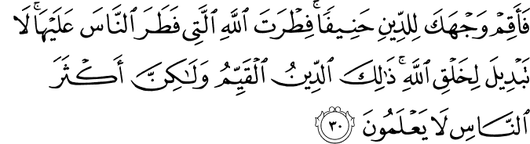
So direct your face toward the religion, inclining to truth. [Adhere to] the fitrah of Allaah upon which He has created [all] people. No change should there be in the creation of Allaah. That is the correct religion, but most of the people do not know.

We are all created upon this innate nature to turn to Allaah. to believe in Allaah, to dedicate and devote in worship to Allaah. The Qur’aan even tells us that when we were created we all testified to His Lordship (7, 172)
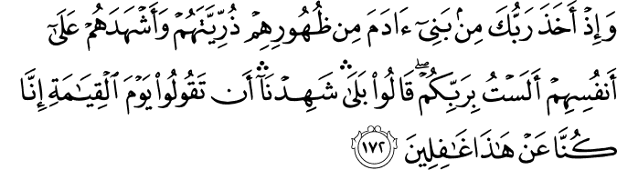
And [mention] when your Lord took from the children of Adam - from their loins - their descendants and made them testify of themselves, [saying to them], “Am I not your Lord?” They said, “Yes, we have testified.” [This] - lest you should say on the Day of Resurrection, “Indeed, we were of this unaware.”

That realization is hidden within each of us. These miraculous signs are to remind us. They lead us to the reminder.

When a person heeds the reminder, remembering his purpose in existence, he is at a very important stage. Shukr, gratefulness, thanks to Allaah for everything he has been given. The Qur’aan opens with the very verse to proclaim this gratefulness (1, 1)
The very best praise is to Allaah, Lord of the worlds

The opposite of shukr is kufr. It means to be ungratefulness and disbelief because we know shukr is the basis of imaan. Once that person becomes grateful, the manifestation of that gratitude is not just lip-service. It leads to ibaadah - enslaving one’s self to Allaah voluntarily. The most obvious form of this slavery is worship.

A person who takes heed of the reminders and signs does not need anything more to direct him to Allaah in worship. He feels compelled.

Now, let’s get back to the verse at hand.
And a sign for them is the dead earth. We have brought it to life and brought forth from it grain, and from it they eat.

Aayatun this is in its common form (nakira). This is either
- لتفخيم to magnify that this is something of importance being discussed
- to diversity that there are multiple ways of reflecting upon what is to be discussed لتنويع

A miraculous sign for these people who aren’t realizing the truth is the dead earth which We have revived. This is not difficult for Allaah, it simply rains. We bring out from it habban a grain, a seed. That is what they are living off of. Not only that, but what is the progression of that? See Verse 34.

Verse 34

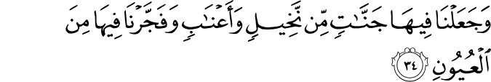And We placed therein gardens of palm trees and grapevines and caused to burst forth therefrom some springs -

The progression of that seed from which the people eat is that it evolves into many, many gardens in this earth. They are full of date palms and grapes. These are amazing forms of sustenance provided on this earth.

For the Arabs, nakhil is how they provided for themselves and sustained and grapes were a form of luxury. Not only does Allaah creates gardens of sustenance, but even luxuries!

And We have made gush forth in this earth from springs.

So first this earth was barren, there was nothing there. Not only did Allaah revive it, but he put forth fruit from it and even luxurious fruits. Then even water is gushing forth from it. Water is coming down from top (rain) and bottom (springs).

Verse 35

That they may eat of His fruit. And their hands have not produced it, so will they not be grateful?

And why was all this done? So that the people may eat from His fruit. But if you have forgotten, note, that their hands haven’t done any of this. Allaah makes this happen, don’t you forget (67, 30)
Say, “Have you considered: if your water was to become sunken [into the earth], then who could bring you flowing water?”

If Allaah made the water recede back into the earth, nobody could bring it back up for us.

There are two ways to understand this ما
- As negation e.g. their hands did not produce it
- Maa mansula e.g. and that which their hands have done
Meaning Allaah has provided all of this so they may eat the fruit from Allaah or even that which they do with their own hands - it is also only due to what Allaah has made possible. Nothing we do is possible without the facilitation of Allaah. A farmer requires the the temperatures and soil and water and conditions that Allaah provides. Without them, his crops are nonexistent.

So will they not be grateful? This is a conclusion. Don’t these people realize? Don’t they show gratitude? Why don’t they live a life of gratefulness if they can’t live without these provisions (the verse mentions food and water) provided to them by Allaah?

This was the physical understanding of Verses 33-35. There is also a spiritual understanding, a spiritual reflection. Verse 32 ended upon each and every single person being presented before Allaah at resurrection. We know the mushrikun of Makkah and all the other disbelievers always questioned being brought back to life once they have died and the bodies have decomposed.

They had doubts about humans being brought back to life, yet, they didn’t even look at the earth. This barren earth was brought back to life and then it was sprawling with lush gardens and vegetations. The same ground which was barren is flowing with water and people are benefiting from it, eating from it, making more out of it. Why don’t you realize? Why can’t you be grateful? If Allaah can bring it back to life, then He can do the same to you.

Even further, this shows how a person can be spiritually revived. A person without the understanding of tawhid is like a dead person.
  - AHyaynaha - When Allaah grants him the understanding of tawhid, imaan he is brought back to life.

  - wa akhrajna minha Habban - some good comes out of him

  - faminhu yakulun - he starts to benefit from it, people start to benefit from him

  - wa ja’alna fiha jannaatin min nakhilin wa a’naabin - if he continues to walk on this path, he can continue to climb the steps of taqwa, shukr, birr, tawakkul. He can become like the lush garden which has benefits in society, family, business, etc. Everywhere he goes, people benefit from him.

  - wa fajjarna fiha mina al-‘uyun - the Messenger of Allaah s has often used the example of water for knowledge.
  - “My example and the example which Allaah has sent me with is like abundant rain falling from the sky.”

  - What brings life to things? Water! What will spiritually revive society and people? Good people! So this person can then be a source of knowledge, teaching others about that source of good.

  - liya kulu min thamarihi - everyone will be able to live a good life

  - wa maa ‘amalathu aydihim - and he will be rewarded for this good he is doing

  - afalaa yashkurun - so will he not given thanks?

This spiritual understanding is not new to the Qur’aan? Look at these verses (14, 24-25)
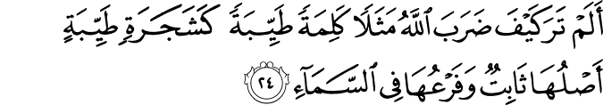
Have you not considered how Allaah presents an example, [making] a good word like a good tree, whose root is firmly fixed and its branches [high] in the sky?
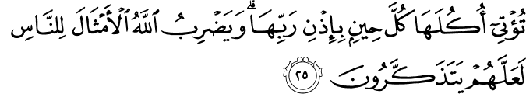
It produces its fruit all the time, by permission of its Lord. And Allaah presents examples for the people perhaps that they will be reminded.

That good word is imaan. That same dhikr is mentioned. It is to remind people of their purpose, goal, and objective in life.

Verse 36

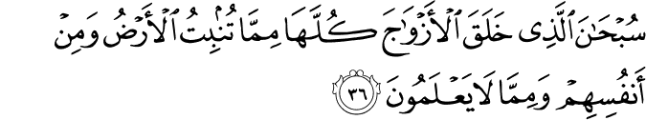Exalted is He who created all pairs - from what the earth grows and from themselves and from that which they do not know.

SubHaan| Word Analysis
This is an exclamation of the perfection of Allaah. It comes from tasbiH meaning to glorify Allaah. It means how amazingly glorious, how amazingly perfect is Allaah.
The root of this word as we’ll see in Verse 40, comes from the root (sa-ba-Ha) meaning to swim.

How do the root and word connect?
There is a process in the Arabic language that a word which is conjugated from a root word takes on a life and meaning of its own. TasbiH is one such word which means to speak of Allaah’s perfection.

There are, however, logical and spiritual connections. sa-ba-Ha means to swim with one’s head above water (e.g. not diving). Subhaana and tasbiH is like that head, meaning that Allaah is above creation.
Swimming is a very interesting action. When a person is swimming, in order to remain afloat he requires calculated, regular movements. Similarly, tasbiH is what keeps us spiritually afloat in this world otherwise we are surrounded by so many items which pull us down.

A companion once asked the Messenger of Allaah s “The different ahkam are various, but I ask you for something that will constantly keep me latched to Allaah.” He s told him to keep his tongue moist with the remembrance of Allaah.

Dhikr is not formal. The etiquette of the Muslim is to remember Allaah whenever something, anything occurs in his life. Sometimes in communities people find it awkward to make mention of these terms, but this is how the believer speaks.

Allaah is attributing glory and perfection to the One Who created pairs in everything. Slowly, we begin to realize how many pairs there are. The things we do not know, Allaah knows best.

Cross-pollination is a method of agriculture to increase the harvest.

Verse 37

Now, Allaah will point out some pairs He has created in particular.

And a sign for them is the night. We remove from it [the light of] day, so they are [left] in darkness.

Naslakhu| Word Analysis
It comes from the root sa-la-kha meaning to peel the skin off an animal. So from the night we peel away from it the day. The day comes in to cover the night, but when the sun sets the daylight recedes so that it becomes darker and darker. Until all of a sudden we are in complete darkness.

Verse 38

And the sun runs [on course] toward its stopping point. That is the determination of the Exalted in Might, the Knowing.

The sun is moving for a set course that has been fixed for it. Mustaqar typically means for something to be placed in a fixed place. The permanent fixture or setting of something. This, however, is obviously discussing the course and life cycle of the sun. So why use this term? Even if the sun moves and it has growth and movement, it is as if it is fixed in a place because Allaah has set it on its course and it cannot be moved from it.

That is the determination, that is what has been fixed, set and sent down. Done by Al-’Aziz the One Who is Dominating and cannot be dominated. He has put everything into its place and nothing can move from its course or divert away from its set path.

And He is al-‘Alim. He is constantly aware of everything. He is in full knowledge of everything. If that thing were to move from its place, He would know.

Verse 39

Now, because we are talking about pairs, it seems appropriate to mention the moon after the sun.

And the moon - We have determined for it phases, until it returns [appearing] like the old date stalk.

The moon has been fixed with manazil - stages, the 28 or 29 days we have.

‘Urjun| Word Analysis
It refers to a date stalk or date palm’s trunk. When it was alive and abundant and fruitful, it had dates hanging from it. This makes the trunk curve and bend over.

When it has become qadim, however, it is old, dry, and fruitless. It is standing there, fruitless, but frozen in that curved shape.

Look at the pair Allaah has made in this comparison - the moon in the sky, above the earth and the date stalk seated on the earth. Nobody else can create such a universal, such a flawless, symmetrical creation that has everything tied together. Day and night also have an effect upon everything that grows from the earth.

Verse 40

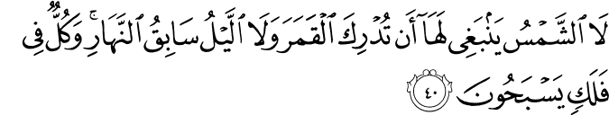It is not appropriate for the sun to catch up to the moon, nor does the night overtake the day, but each, in an orbit, is swimming.

The sun has its time and the moon has its time. Everything has its set time and it’s not appropriate for one to overpower the other.

Why mention the sun catching up to the moon and not the moon catching up to the sun? The sun is the more dominating figure. We know that from what we see. Astronomically speaking, the moon is there, but the sun is the centre of this solar system. Yet, even as powerful as that sun may be, it cannot catch up to the moon. Everything stays in its place and follows the orders it has been given.

Saabiq| Word Analysis
It means not just to precede, but to run away from it. As in the night becoming crazy and rabid until it speeds ahead until the night is for the entire day. Remember, He has just mentioned that the day is peeled back. This is from the blessing of Allaah (28, 71)
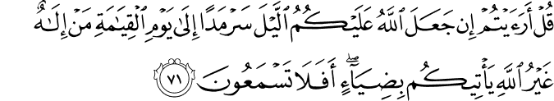
Say, “Have you considered: if Allaah should make for you the night continuous until the Day of Resurrection, what deity other than Allaah could bring you light? Then will you not hear?”

Likewise, what if Allaah were to make it day forever (28, 72)
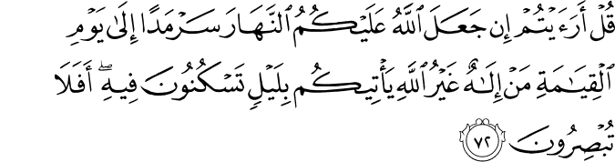
Say, “Have you considered: if Allaah should make for you the day continuous until the Day of Resurrection, what deity other than Allaah could bring you a night in which you may rest? Then will you not see?”

Finally, Allaah concludes all of this by mentioning that each thing is in an orbit, swimming.

Falaq| Word Analysis
It is like a pattern or a system, like an orbital path. It comes from the word referring to ships sailing in the ocean - they are set on a route, a path.

Each one of these things are yasbaHun (present and future form). They are constantly swimming. Once again, the swimming is that regular and constant action. They are on their set path, swimming like a ship on its set route.

Spiritual Reflection
Previously, the discussion was about the person who has died from the inside and how Allaah can revive his heart to make him a source of good for an entire community!

Now, Allaah has mentioned that things are in pairs. There is the life of the dunya , but there is also the life of aakhirah. Allaah has told us (87, 17)
While the Hereafter is better and more enduring.

The Messenger of Allaah s tells us that the life of this world is sweet and lush green (meaning it is attractive). Sweet things, however, spoil faster than bitter things. So even though it is very sweet, it spoils very quickly. A plant which is green and lush, however, dies sooner.

So it is better to sow the seeds for the Hereafter now because it will be better and eternal.

Other opposites also exist: imaan and kufr, khayr and shar, haqq and baatil, shukr and kufr, humility and arrogance. We must constantly make the choice of which is better between the two. Allaah has shown us the two paths and we must choose (90, 10)
And have shown him the two ways?
And we’ve also been told (18, 29)
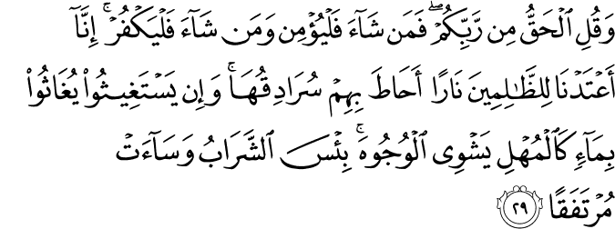
And say, “The truth is from your Lord, so whoever wills - let him believe; and whoever wills - let him disbelieve.” Indeed, We have prepared for the wrongdoers fire whose walls will surround them. And if they call for relief, they will be relieved with water like murky oil, which scalds [their] faces. Wretched is the drink, and evil is the resting place.

Allaah has given us the faculties and capacity and laid out all the signs, now it is his choice. There are physical and spiritual pairs. Paradise and the Hellfire.

Darkness and Light
It is easy to take for granted being born Muslim. Look at the darkness in peoples lives. The lack of peace and tranquility brought from the lack of connection with Allaah. The light is like guidance. Just like peeling the day away, Allaah can peel the guidance away.

Look at something as beautiful and glorious as the sun - it follows its path, non-diverging. Why cannot the human be like this?
Look at the moon going through its cycles. Look at the human being going through its cycles. Zygote, fetus, baby. Then becoming physically able, intellectual, ages, marries, grows old until there is no benefit from him just like the dry date stalk. The moon goes through this cycle every month, we as humans are going through a cycle.

The Messenger of Allaah s said to take the value of five things before five come. Youth before old age, health before sickness, wealth before poverty, free-time before preoccupation, life before death. (Haakim)

Make the most of what you have. Nothing will break this cycle of Allaah (48, 23)
[This is] the established way of Allaah which has occurred before. And never will you find in the way of Allaah any change.

This is what Allaah has decreed for His creation. Just like the sun and moon, we will not be able to escape this cycle (7, 34)

And to every nation is a [specified] term. So when their time has come, they will not remain behind an hour, nor will they precede [it].

When the fixed appointment comes for us to leave the earth it will not be alterable. One cannot take a step away from this world until he has taken all the breaths decreed for him and not a single less or a single more. Just like everything else is swimming in orbit, so are we.

Verse 41

And a sign for them is that We carried their progeny in a laden ship.

We had mention of the dead earth and the night and day pair. Now, this is the third major sign of reflection Allaah is indicating for these people.

MashHun| Word Analysis
It comes from sha-Ha-na which means to fill up something, specifically a boat. This is a boat that has been completely filled to capacity.

So a miraculous sign for them is that Allaah carried their progeny in a maximum capacity ship.

Allaah has directed our attention in different directions for His signs. First, we looked down at the ground, at the barren earth which becomes lush and fruitful. Then, we looked up at the sky, to the night filled with the moon and the day with the sun. Now, we look to the water, at the ship coasting on the water with people inside.

These are all facilities Allaah has provided for us to move around on this earth. We have been provided with transportation means. The most difficult type of travel is often considered crossing waters and Allaah is showing us that He has permitted that and there is a marvelous sign for us in it.

Who is this progeny? This is the progeny of humankind, of humanity. Human beings have been carried, allowed to travel in the ship that was filled to capacity.

This reference may be to one of two situations
- (Majority of Classical tafasir) The Ark of Nuh ‘alayhi as-salaam
One very important area of tafsir that is neglected in recent times (which was the first point for the classical scholars) is tafsir al-Qur’aan bi al-Qur’aan. Many secrets of the Qur’aan are unlocked by looking at other passages in other areas of the Qur’aan. It is a comprehensive discourse in its entirety and it is very cohesive.

A similar verse is found in (26, 119)
So We saved him and those with him in the laden ship.

this same wording (al-fulk al-mashHun) has been used to describe the Ark of Nuh ‘alayhi as-salaam.

- (Minority) Allaah is just discussing travelling in ships in general.
There is no harm in such an opinion because the Qur’aan is so deep, it has many layers of understanding.

This carrying on a ship permitted the survival of these humans (or humankind in general if referring to the people of Nuh ‘alayhi as-salaam).

Verse 42

And We created for them the likes of that that which they are also able to use for ride.

There have been other modes of transportation created by Allaah.

What is this referring to?
- Other modes of water transport
If Verse 41 was referring to the Ark of Nuh ‘alayhi as-salaam then this may be referring to all other ships, boats, and canoes - whatever else is used to move around in the water.
- Any other modes of transport
If Verse 41 was referring to boats in general, then this may be referring to other modes of transport on the earth. As Allaah has said (43, 12)
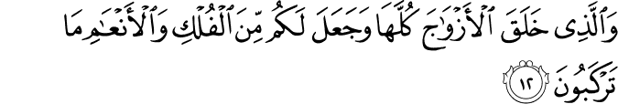
And who created the species, all of them, and has made for you of ships and animals those which you mount.

And following it Allaah educates us about the du’aa for transportation (43, 13-14). Whenever we board anything as a mode of transport, we ought to recite this supplication.

These other modes of transport may be other than ships; animals, carts, vehicles, planes, etc. Allaah has created it, facilitated for us, and permitted it for us. This is a huge sign and moment of reflection. How easy and faciltated are our lives with these modes of transportation?

Verse 43

And if We should will, We could drown them; then no one responding to a cry would there be for them, nor would they be saved

How often have we seen such an amazing mode of transport, but the people drown? We may think of the mode as colossal, but they can so easily be damaged. A little bit of ice on the road to make a car slip.

Sarigh| Word Analysis
It comes from the root of the word meaning to scream for help. It not only means the scream for help, but the one who hears the scream, and the one who rushes to the aid of the one screaming for help.

There would be no aid and no one coming to alleviate these peoples’ situation. Nobody would hear their screams in the darkness of night in the depths of the ocean. Look at that perspective! We’ve taken from a zoom in at the ships to the bigger picture.

Recall inqadh means to save someone who is akin to falling off a cliff, someone who is in very grave danger. So no one will come to these peoples’ rescue.

Allaah has placed emphasis by adding the pronoun (hum) and by placing the verb in the present/future tense in order to show that no one will ever come, nobody could ever come to these peoples’ rescue.

Verse 44

Except as a mercy from Us and provision for a time.

All of this - the facilitation of transport without people dying - would not be possible except by the mercy of Allaah.

Allaah has said raHmatan, it is in its common form. A mercy, not the mercy. This is one display of Allaah’s mercy. If all the transportation we have and our survival in this travel is only attributed to a mercy, then how abundant is that mercy and how much do we have to be grateful for? How vastly is transportation used and it is just from a drop of the mercy of Allaah. Things we don’t even know or realize are from His mercy.

This is a facilitation to be used and it is to be used for a Hinin. This is again the common form, meaning that time is fixed when we must leave this world, but nobody knows that time or how it will come. It is facilitated for us to benefit, but there is the reminder that it is for a short time.

Primarily, this discourse has been a reprehension for these people who don’t believe. A reference to these great travels is to tell these people to not be so engaged or lost in these temporary benefits. To realize that they are only for a limited time. Use these facilities to gain some benefit for what awaits from the greatest mercy of Allaah.

Linguistic Beauty
Here, Allaah has said raHmatan minnaa. In other places, Allaah says raHmatan min ‘indinaa.
For example, in referring to Khidr ‘alayhi as-salaam (18, 65)
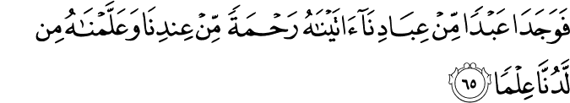
And they both found a servant among Our servants to whom we had given mercy from Us and had taught him from Us a [certain] knowledge.

The latter means a mercy especially from Us, as in a mercy as a gift from Us, as a favour from Us.

Also in discussing Ayub ‘alayhi as-salaam and what was bestowed upon him (21, 84)
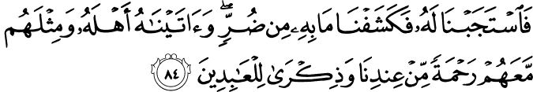
So We responded to him and removed what afflicted him of adversity. And We gave him [back] his family and the like thereof with them as mercy from Us and a reminder for the worshippers [of Allaah].

What is the difference?
The latter is a larger construction so its meaning is greater as well - as mercy that is a special gift from Us. Whenever Allaah discusses believers, prophets, messengers, pious individuals, then He uses this more powerful construction. When, however, Allaah is discussing the mercy He has bestowed upon general people (including disbelievers), then He uses the simple construction.

This also happens with ni’matan minnaa and ni’matan min ‘indinaa.
The simple construct is used for ordinary or unexceptional people (39, 49)
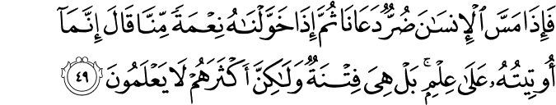
And when adversity touches man, he calls upon Us; then when We bestow on him a favour from Us, he says, “I have only been given it because of [my] knowledge.” Rather, it is a trial, but most of them do not know.

This person has arrogance within him. For this person the blessing is not special.

The elaborate construct is used for praiseworthy people, the family of Lut ‘alayhi as-salaam (54, 35)
As favour from us. Thus do we reward he who is grateful.

The promiscuity and shamelessness of societies are struggles for the people grasping imaan. Sexual perversion is exceptionally difficult because it is becoming an accepted practice. The people of Lut ‘alayhi as-salaam didn’t just have it accepted, but it was majority. These people dealt with threats and violence from people who lived this lifestyle, yet they stood firm with their faith and their messenger.

Verse 45

As a conclusion to the middle passage of Ya-Sin (regarding tawhid), Verses 45-50 proceed.

These people have signs all around them and these signs are being pointed out to them. They are being told to reflect upon these signs and to see the obedience that all of creation has to Allaah. Then, to sit and reflect as to why they are so disobedient to Allaah. Everything around them is a sign pointing to the oneness, power, magnificence and greatness of Allaah.

But when it is said to them, “Beware of what is before you and what is behind you; perhaps you will receive mercy...”

This verse begins with an interesting construction.
These people are not being told
وإذا قال لهم رسول/قرءان/الله - But when a messenger/the Qur’aan/Allaah said to them

Those would have been active constructs. Instead, the passive construct (majbul) is used. One of the benefits of using the passive in this manner is that it does pinpoint or elaborate who is the doer - who is the one saying this to them. This serves two purposes
- It makes the focal point of that address and aayah the one who is addressed and not the one who is addressing. These people are being told to consider themselves, to take a long, hard look in the mirror. Look at their own situation and condition. Nothing else needs to be looked at here except for these people.
- It creates variety, versatility in the meaning and interpretation. They were told time and time again from different angles, by different people. Allaah spoke to them, the divine scripture advised them, the messenger was tirelessly preaching to them, the other believers came to advise them. Everyone is telling them. From multiple angles, from multiple people.

Ittaqu| Word Analysis
They are being told to have taqwa. Taqwa does not just mean to be afraid or to have fear. It means to be aware, to be conscious, protect yourself, guard yourself, take precautions.

Take these precautions from what? From that which is in front of you and from that which is behind you. What does this refer to?
- In front of you is the result of your actions, their consequences. Behind you are the actions you have already performed.
- In front of you is al-akhirah and behind you is ad-dunya. The next passage will discuss the Hereafter and the first passage discussed these peoples’ rejection of the messengers in the dunya.
- In front of you is what is about to happen to you, your own situation. What is behind you is what happened to previous peoples. This message was for the Quraysh. They ought to look to ‘Aad and Thamud - their locations were know to them within Hejaz. The Arabs knew where these nations had existed and what had transpired with them. They ought to look at them and then see if they are headed along the same path or if they will differ.
- This is found in (34, 9). This is a collection of suwar that have similar themes and are like continuations of each other. Fatir and Saba’ both start with al-hamdu lillah al-ladhi. Then there is Ya-Sin in the middle after which there are Sad and Saffat which are also similar and have address like themes. Ya-Sin is like the centrepiece of these suwar. So in (34, 9) Allaah says
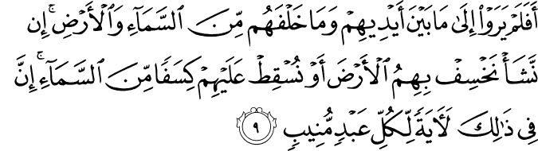
Then, do they not look at what is before them and what is behind them of the heaven and earth? If We should will, We could cause the earth to swallow them or [could] let fall upon them fragments from the sky. Indeed in that is a sign for every servant turning back [to Allaah].

This is talking about the punishment of Allaah. So one interpretation is that punishment of Allaah which could come from the sky, from beneath your feet, from the left, from the right. It could come anywhere at any time. So come to the obedience of Allaah. Grasp the understanding of being a slave of Allaah.

The Qur’aan is not simple in having a single meaning. It is sophisticated. We are simple minded. There is a concept called at-tawasu fi’l-ma’na fi’l-Qur’aan al-Karim that the meaning of the Qur’aan is very broad and to allow the meaning to be broad and not narrow it down. Sometimes one verse will have multiple meanings and understandings. We consider someone speaking with double meanings (double entendre) to be clever, but this is the kalaam of Allaah. It is an endless ocean that will never be completely understood.

La’alla| Word Analysis
Why should they be cautious of these? So that you may receive mercy. A correction is needed here. La’alla is translated in the Arabic language as “so that”, but it doesn’t actually mean this. It actually means “maybe, hopefully, possibly”. So if they lead a life of cautiousness, maybe they’ll receive the mercy of Allaah. It is also placed in the present/future tense to drive the incentive home. Strive for this mercy, the only thing that will protect anyone.

  - Nobody will enter jannah because of his deeds. Everyone will only enter jannah because of the mercy of Allaah.

Allaah has placed it there to make us alert, to become aware, to be conscious and aware and to lead a life in this way so that one day, hopefully in the future, we will qualfy for the mercy of Allaah. As Allaah says in (17, 8)
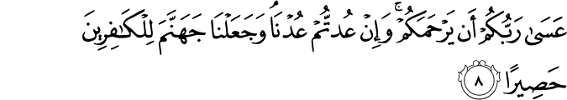
[Then Allaah said], “It is expected, [if you repent], that your Lord will have mercy upon you. But if you return [to sin], We will return [to punishment]. And We have made the Hellfire, for the disbelievers, a prison-bed.”

It is very near, it is a strong possibility that your Lord will have mercy upon you. If you return back, then We will also return back. Think of this like two people having a strife. If one comes back, the other comes back. Allaah has created, provided and protected us. If we turn back and make tawbah, just make effort by turning around, then the mercy of Allaah will rush towards us (e.g. with even more mercy than what we have received).

Verse 46

And no sign comes to them from the signs of their Lord except that they are from it turning away.

They end up willingly, intentionally turning away from the sign. This is apathy, arrogance, stubbornness. Allaah has said “whenever” from the many, many signs of Allaah. This tells us that Allaah continues to send these signs. These type of people, however, have ‘iraaD. They are arrogant, choosing not to notice.

This is like in Verse 30, when the townspeople would ridicule and mock the messengers who would come to them. Here, Allaah is mentioning that their standard operating procedure with the aayaat is just like it is with the messengers.

Imaan leads to Morality
Here we begin to see something about the character of these people. They display arrogance and stubbornness. Next, Allaah will refute their behaviour. He will mention how arrogant and sarcastic and stubborn they have literally become. In reality, they are mocking and jeering at the message which has come to them.

There is such poor conduct from these people. They threatened their messengers, killed an innocent man. They possessed no morals. Imaan, however, brings about morality. This is a profound connection.

Many will argue today that faith has nothing to do with morals, but morality is an independent entity. People who have the facade of religion, but no true spirituality, their horrendous actions are sensationalized. Allaah, however, makes a constant connection about a moral compass arising from having imaan. Imaan is the basis of morality.

For example, in (83, 1-6) Allaah is addressing the people who do not measure out the right due amounts when giving to people. When measures are due to themselves, however, they take the full measure from people. They don’t realize that they will be resurrected and brought to stand before Allaah. It is a direct connection being made between their morals and their lack of imaan.

Also, (107, 1-7) begins by pinpointing the one who denies the Recompense (e.g. the accountability of the Resurrection). Then it mentions that is the person who drives away the orphan, who does not encourage feeding the poor, who are heedless of prayer, who flaunt their dedds, but withhold simple assistance. Woe to these people.

This person doesn’t just avoid supporting it himself, but he degrades what others are doing. This comes around as a lack of imaan.
Imaan brings about the ultimate conduct and good character.

There’s a beautiful story mentioned by Ibn Kathir. True order in society can only come about as a result of imaan. Even if all the laws and best police force has been established, there will not be morality.
  - There was one man from Banu Isra’il who needed to borrow money. He went to another man and asked for a loan. This person then asked who can vouch for him. He said, “Allaah is enough as a wakil.” The man did not argue.
  - He said, let us at least get a witness. The man said, “Allaah is enough as a witness.” The man did not argue.
  - There was a river that separated their homes. The borrower promised to meet the man at a certain day and time at this place to return the money to the lender.

  - The time passed. When the man arrives at the river, the river is over-flowing. The people who normally run the ferries to cross the river are not there. The borrower is sitting there with the money, frustrated that he had given his word and now was in this predicament. He stands and waits, but gets more frustrated. He takes a log, carves a hole in it and puts the money in it. He writes a note to the man that this is the money he owed him and if it reaches him, then it is done.

  - He throws the log into the river and makes du’aa to Allaah that it reaches the lender. This was out of his frustration from the idea of cheating the man.

  - On the other side of the river, the man was waiting. He sees the condition and realizes the man cannot come. The time passes so he decides to go home. Before going home though, he wants to pick up some wood. He sees a log floating into the water. He takes it home. When he begins to chop it, he sees the money and the note. His loan is completed.

  - The borrower, however, is not comfortable in his position. He thinks he should have returned the money as it had been given to him. So he waits some days, the water subsides. He gets some more money and crosses the river to the lender’s home. He tells the man that he has returned to pay him back and how he could not make it previously. The lender could be thinking that he has already received the money, but he could be getting more from him. He told him that he received the log. Their imaan was firm. One man’s imaan wouldn’t let him rest and the other’s wouldn’t let him cheat.

Verse 47

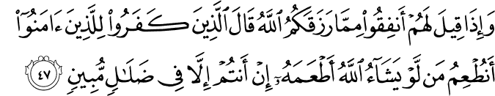And when it is said to them, “Spend from that which Allaah has provided for you,” Those who disbelieve say to those who believe, “Should we feed one whom, if Allaah, had willed, He would have fed? You are not but in clear error.”

This is the same passive construction.
Spend from that which Allaah has provided for you. This amount is not even yours to begin with! Allaah has provided you with everything. Keep most of it and spend from it a little in this sake. Just to show your devotion and dedication. Its just a gesture.

How do these ungrateful, disbelieving people respond to the people who are believing and advising them?
They have told them to give in charity to those who are poor and needy in difficult situations. Yet, they over-rationalize to mock the command of religion. If Allaah had wanted that person to have something, wouldn’t He have provided for him?

How to answer these questions?
Sometimes, some people are just saying things for the sake of saying them. Some people are just trying to make trouble. They have no interest in truth. Look to (25, 7)
And they say, “What is this messenger that eats food and walks in the markets? Why was there not send down to him an angel so he would be with him a warner?”

If Allaah had sent an angel they would have still argued that it does not understand their situation. Again, they are complaining for the sake of complaining

In antum fi Dalaalin mubinin| Analysis
You are in nothing but in very clear, open misguidance. Fi is as if they are drowning in their delusions. They are completely lost and astray. There are two ways this can be understood.
- This is the same kuffar saying it to the believers.
They are merely continuing with their complaining and ridiculing.
- This is an answer to the kuffar from Allaah. When they say something as foolish, stubborn, arrogant, and disrespectful as to say this, Allaah will tell them they are completely drowning in their delusions.

This is a powerful lesson in da’wah. People will make confusing and senseless arguments. We should not have a lapse in our imaan at that moment. Philosophical objections have existed from the beginning of time. Not only did the Messenger of Allaah s deal with this, but messengers before him dealt with the same. We are no different. This no new phenomenon.

We can only be that strong, however, if we have read the Qur’aan.

The counter is exactly what this surah has done. Remind them of the Oneness of Allaah. And if that doesn’t work, then remind them of the Hereafter when they will be returned to their Lord and then they will be woeful of their own situation (36, 51-52). Are they willing to sacrifice everything they have with this choice they have made? For all of eternity? Think about that before carrying on this light of discussion.

If the person continues to persist, remember there has been a Firawn, a Nimrod, a Haamaan, an Abu Jahl. These people have existed and Allaah and His Messenger s have informed us about them for a reason. Some people just aren’t interested in the truth. Allaah has given us a very powerful conclusion to this issue (41, 44)
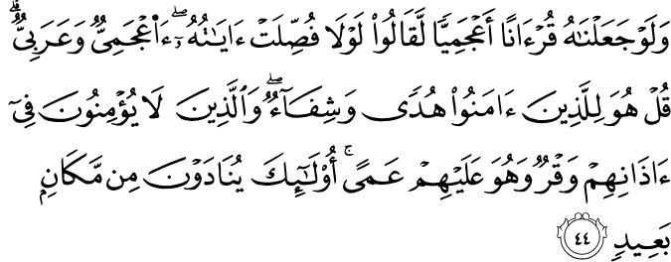
And if We had made it a non-Arabic Qur’aan, they would have said, “Why are its verses not explained in detail [in our language]? Is it a foreign [recitation] and an Arab [messenger]?” Say, “It is for those who believe, a guidance and cure.” And those who do not believe - in their ears is deafness, and it is upon them blindness. Those are being called from a distant place.

It is guidance and a solution to the problems of the believers. Those who do not want to believe are confrontational. They have an obstruction in their ears. They say they are listening, they have ears physically, but spiritually they are unaware of the truth - as if it is invisible to them.

Verse 48

And they say, “When is this promise, if you should be truthful?”

For these people who are told to lead a life of taqwa, but reacted with ‘iraaD and spoke in inappropriate manners where they went to the depths of stupidity, Allaah does not discuss the faculty nature of their logic. He lets is speak for itself, its stupidity, disobedience, and disrespect speaks for itself.

When they’ve reached this arrogance where they are reminded continuously in different ways, but react with ignorance, eventually a warning is issued to them. They need to realize the err of their ways otherwise the punishment of Allaah could befall them, as a consequence of their actions.

Their arrogance and kufr does not allow them to heed the warning. They respond with even more arrogance, with even more mockery. In this verse, Allaah is saying that these people would continue to say (present and future verb), “When will this promise come?” This warning that they are being given is being mocked.

They are questioning this morality and truthfulness of these people. Recall that morality arises from imaan. Look at their conceit.

Verse 49

They do not await except one blast which will seize them while they are disputing.

Then Allaah says a very stern warning. SiHah is that large, piercing sound. A single blast could take them in their refusing and rejecting states.

In the previous passage, a similar conclusion was seen (36, 29)
It was not but one shout, and immediately they were extinguished.

They had conceitedly disregarded the messengers and murdered the believer who advised them. As a result, Allaah punished them with this single, piercing sound. He did not make a huge, elaborate arrangement for their destruction.

This same note is used here. They may continue to reject the clear, evident signs of Allaah, but they are waiting for nothing but that one sound to extinguish them.

Their mockery will continue and at once they will be taken.

YanZuruna| Word Analysis
In this construction, Allaah does not say:
ما ينتظرون

Instead, He says:
ما ينظرون
These both come from the same root and intiZar means to wait for something.
YanZuruna comes for naZr which means to look. It can also be used to wait for something, but it is moreso waiting for something as watching it approach. This is like waiting for a train which you see coming. So these people will be standing there, it will be there before their faces. It will be a result of their own actions.

Verse 50

And they will not be able [to give] any instruction, nor to their people can they return.

They will not have the ability to tawSiyatan.

TawSiyah| Word Analysis
It means to will something, a last will, a last testament. Your last words, your last wish, your dying wish. They won’t even have the ability to make a dying will. Nothing. They won’t have the chance to say anything.
This has several ramifications.
- It shows how unfulfilled their lives were. They refused, rejected, and didn’t believe because they wanted to live this life. Yet, in this life they weren’t even able to make a last wish, something they desired to do.
- A known convicted criminal on death row may be a serial rapist or killer, but still receives a last wish. He is permitted to say something, to get a last meal, to visit a clergyman, to visit family - but these people will get nothing.

They won’t even be allowed to return to their families. This is the outcome of these people and what will transpire of them. It is very similar to the people who rejected the messengers (36, 30-31). It will still be regretful for them to have done themselves in. It was a result of their own actions, their own rejection.
How regretful for the servants. There did not come to them any messenger except that they used to ridicule him.
Have they not considered how many generations We destroyed before them - that they to them will not return?

