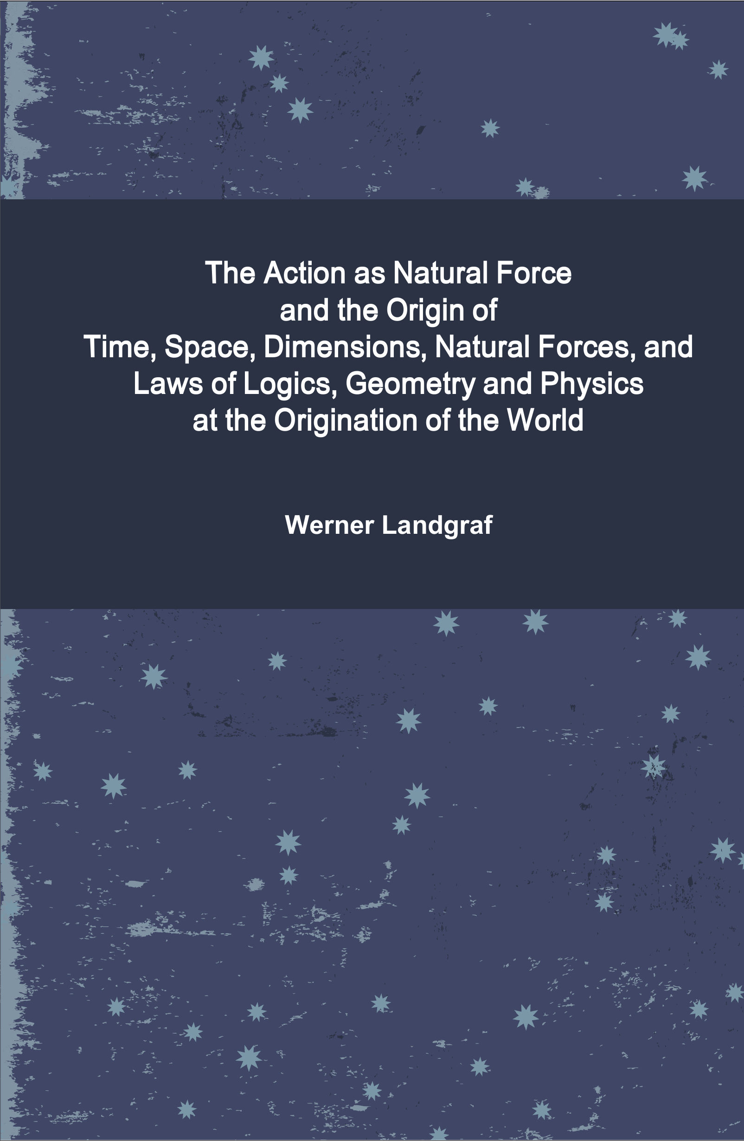

THE ACTION AS NATURAL FORCE
AND THE ORIGIN OF
TIME, SPACE,
DIMENSIONS, NATURAL FORCES,
AND LAWS OF
LOGICS, GEOMETRY AND PHYSICS
AT THE ORIGINATION OF THE WORLD

Werner Landgraf

2011

THE ACTION AS NATURAL FORCE
AND THE ORIGIN OF
TIME, SPACE, DIMENSIONS,
NATURAL FORCES, AND LAWS OF
LOGICS, GEOMETRY AND PHYSICS
AT THE ORIGINATION OF THE WORLD

© Werner Landgraf (1959- ) GND 111290759 VIAF 20300591
R. Guarujá Q7L40a , BR 24900.970 Itaipuaçu, Maricá, RJ
Pépinière de Zephir A5 , F 97300 Cayenne, Guyana-Cayenne

‏بسم الله الرحمن الرحيم

THE ACTION AS NATURAL FORCE
AND THE ORIGIN OF
TIME, SPACE, DIMENSIONS,
NATURAL FORCES, AND LAWS OF
LOGICS, GEOMETRY AND PHYSICS
AT THE ORIGINATION OF THE WORLD
by Werner Landgraf
is licensed under a Creative Commons Namensnennung -
Keine kommerzielle Nutzung - Keine Bearbeitung 3.0
Deutschland Lizenz
http://creativecommons.org/licenses/by-nc-nd/3.0/de/legalcode


Durch die Deutsche Nationalbibliothek in der
Deutschen Nationalbibliografie verzeichnet
http://dnb.de

1. Edition February 2011

ISBN 979-10-90349-10-0



Table of Contents

Summary 4
1. Empirical, obvious Properties of the World 7
2. Synthesis of the empirical Facts;
Considerations, Conditions, Principles 10
2.1. Preparation of the empirical Facts
for a Model 10
2.2. Motivation and Considerations not imme-
diately based on empirical Facts 14
3. Model of a successive Auto-Effectuation in
Correspondence with empirical
Properties, Dimensions, Natural Forces 16
3.1. General Properties 16
3.2. Attribution of the known Dimensions and
Fundamental Forces
to Primordial Events 24
Work by the author to this topic 30

Table of the Dimensions 6

Summary

We give an overlook about the current research and main results on the Action as a fundamental Natural Force and on the Origin of the Dimensions and Natural Forces and of the logical, geometrical and physical Effects and Laws. They result in an Action World Model with the following characteristics:

* Understanding of Events and their Action as a primary, discrete Dimension and immediately producing fundamental Natural Force;
* Sequence of the following dimensions as: Time and Energy, one-dimensional Extension and Impulse, Gravitational Mass and Normal Plane of the Space Curvature, where the previous ones are necessary for the effectuation of the subsequent ones;
* Origination of the logical, geometrical and physical Properties and Laws of the World, inclusive of these Dimensions with each its individual Statical and Dynamical Aspect, Observables, global State Variables, limited Range, and a corresponding Fundamental Force, as Aftereffects and Realization of corresponding primordial Events which successively effectuated themselves as new and linear independent from existing ones;
* A 1st Fact as an affirmation of the Existence and Action of the World is within itself unconditionally logically, geometrically and physically necessary and sufficient for its successive Unfolding inclusive its Basical Properties

It follows an interpretation of the model from different aspects of the physics. Cosmologically, the model means a successive Effectuation of reciprocally corresponding Dimensions and Fundamental Forces, individualized and unreachably separated from and proportionally expanding to its Predecessors as expressed by its novel Elementary Units. The basical Equations of Motion and global State Equations follow immediately from general Properties, like the relation between the Dynamical and Statical Representation of the Dimension itself and to its Neighbours. A generating mechanism beside of Existence and Effectuation of News as associated Aspects is not necessary. It also gives each Dimension and Force its casual individual Appearance, Concretization, and Realization, so that different ones cannot be mutually replaced or unified. The earliest primordial Events can be attributed consistently their concrete geometrical and physical meaning. After 3 evolutionary steps, the known Dimensions and Fundamental Forces were ready. Convenient properties are: a realistic model with clear conditions; details about the Origin; properties like 'Expansion', global State Variables like the Gravitational Mass of the World, or Natural Forces as Geometrical Effects without the need of additional mechanisms; a causal connection between everything; and others. For the relativistic effects, the model has almost no innovations. The most quantumtheoretic effects can be understand, according to situation, dimensions and observation manner of the Observer, as discrete logical or geometrical Conditions and Limitations for him for any representation of therein commonly expected Observables or Properties, like that the Number of Informations inherent to or produced by involved simple Objects or Interactions therefor is insufficient, specially for Light.
Motivation of the model is our extensive empirical knowledge of Basical Properties of the World which indicate the fundamental importance of immediate Action with effectuation of new Facts together with a corresponding Causality. Subsequently would be interesting, for example, detailed observations and careful interpretations of the single Photon; its autonome action-like Proper Frame constituted by the notidentical but immediately neighboured Events of Emission and Absorption; and its Action, effectuation, management of its Informations and their range, validity and effects, in its Proper Frame or for an Observer, for example during diffraction and other interactions with matter.

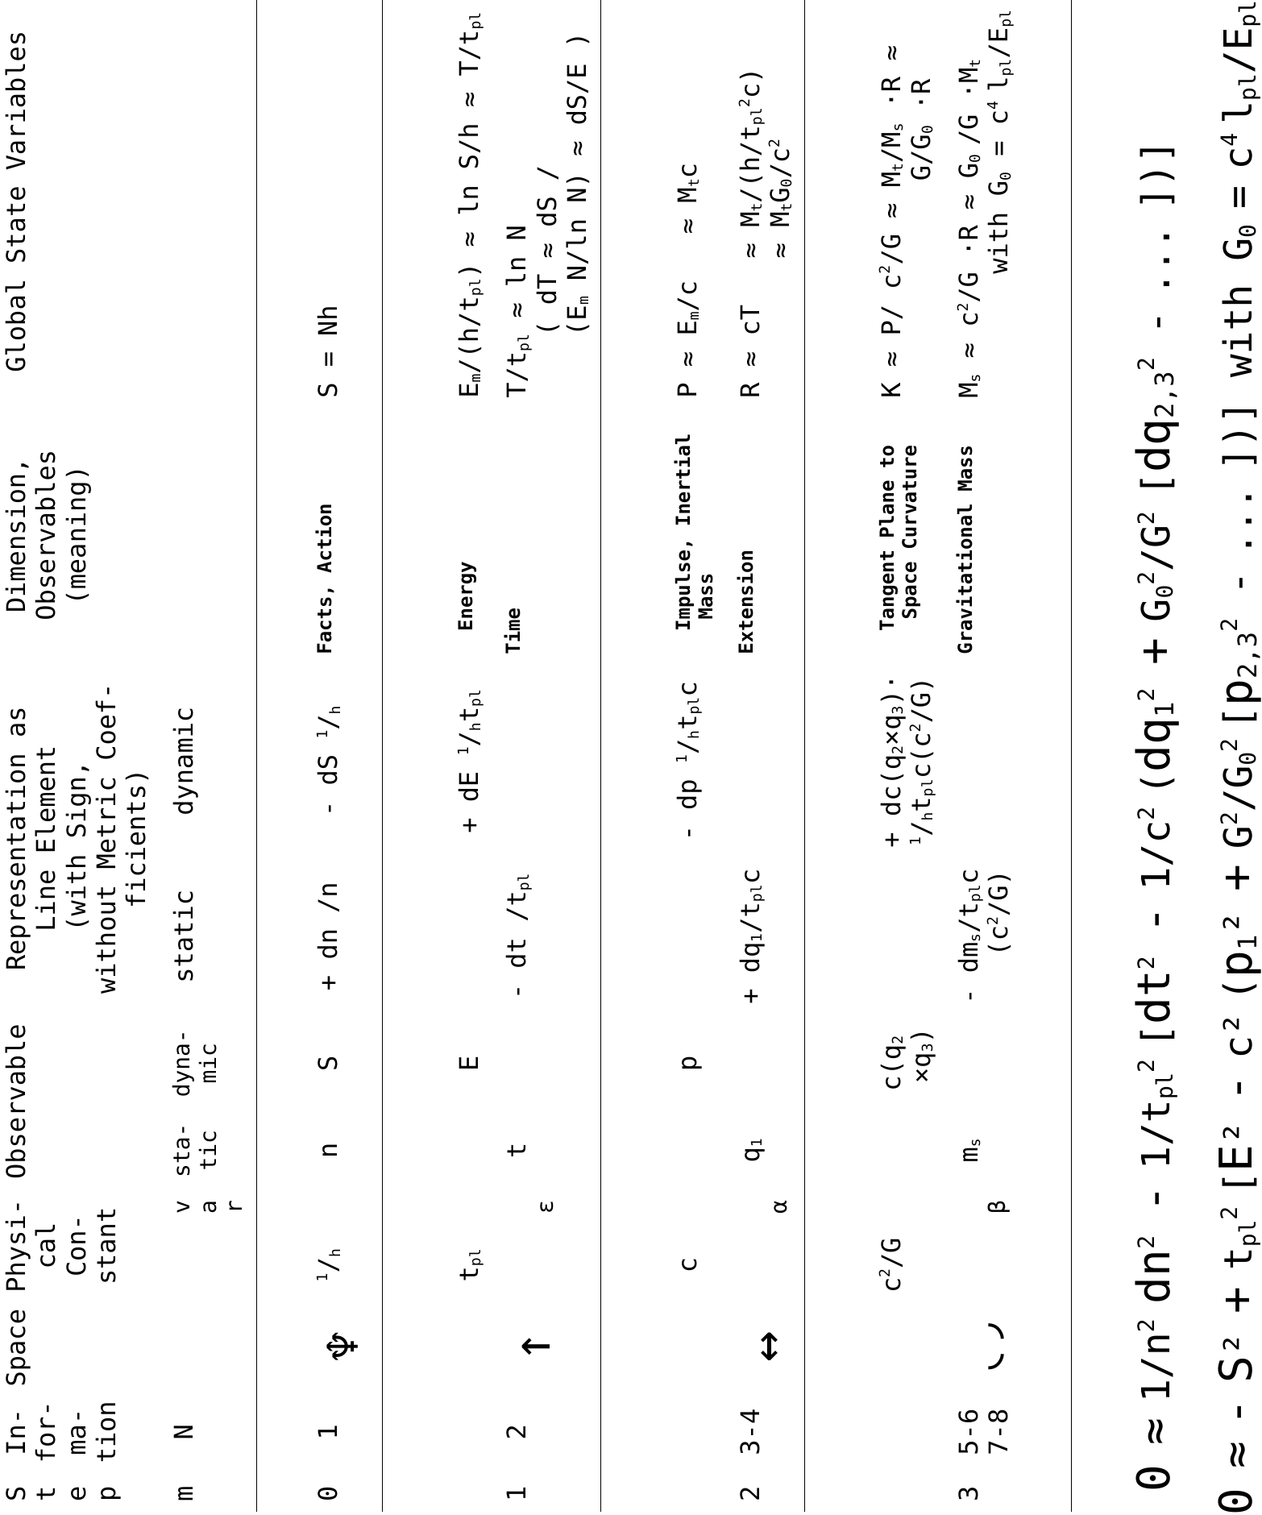

1. Empirical, obvious Properties of the World

* [recursive, automatic function principle] A successive Own-Effectuation of really News by everything already effectuated and without turning something unhappened, or a Causality in this sense, as a primary property and immediately producing and auto-reproducing Force of the Nature. At least effectively within and seen from inside itself, the World, with contribution by everything what exists and by its own Force, produces constantly News, thus not predetermined what exactly. This means for us a true inner progression of the World, not only an illusion, because a predetermined Future would be equivalent to and indistinguishable from the Past, and would make real changes and Events impossible and any objective or even subjective Causality and flux of Time auto-contradictory. The Past is but the Future is not contained within the Present. Linear Independence: new Facts neither can be represented completely by earlier ones or be a reproduction or affirmation, nor a destruction of or a contradiction with them, what also would not result in a progress of Time and thus nor become effective.

* [active autonomy; what exists, acts] The Concretization and Individualization of any Entity is corresponding how, where and when it produces Action; Existence and its Action are equivalent in this sense. Action and Concretization of any Existence as two Aspects of one-and-the-same; in principle Positivism or 'what acts, effectively exists', however with certain Limitations. Each Existence and its Action, exactly correspondingly how it is individualized and independent from Others, thus represents on its own the general Action Principle as the Function and primary productive Force of the real World inclusive its successive Effectuation of News. Evidently, as part of the Own-Perception and Logics, there exists a Free Will, which at least influences the Effectuation, f.ex. which permits to resolve by agreements otherwise fatal Contradictions if different Frames enter in contact, which thus gives Facts their Causers; on the other hand it cannot be exact about not yet imaginable News and even can be weak or imprecise, nor could it warrant any certain Realization, and thus is completed by the Accident. But externally in general and within our model and for physics, they can be treated as indivisible; the philosophy of the Animism is what treats the details of, interaction between, and compounding, equipping, dissolution of Objects by, the Free Will as an aspect of the concretization force, the Accident, and the generical or abstract Conditions, Properties or remnants.

* [passive autonomy; frame-variant facts] Autonomy, Unconditionality, 'subjective Objectivity' and Priority of the Self-Perception; Observers if any and their Perceptions are only relevant for them. 'I think, therefore I am'. The cat of Schrödinger lives if itself feels it alive; ad-hoc validity and priority of Facts and perceptions from the own surrounding. Action doesn't need to reach someone, it is sufficient its emission or Own-Perception. Own Independency from possible Observers; if and how they perceive something inclusive some alterations by the observation, and correspondingly how it exists for them, depends only on their conditions, and is only their problem. Also our World, within itself and for its own logics, exists unconditionally and independently from external or internal Observers. Something theoretically wrong or contradictory survives correspondingly as there doesn't occur factual Collissions. New Facts are created as compatible with already locally acting Facts. In order to avoid collisions of really incompatible Actions, we can expect effects like causal, temporal or spatial Limitations or even Subspaces for measurabilities, contacts, Facts and their validity and Action.

* [everything individualized, limited] Irreversibility, however spatial and temporal Limitedness of Facts and their Action; analogically also of other fundamental Forces and their corresponding Ranges or Dimensions, expressed in themselves or others. Imperfection, Not-Idealizedness, factual Limitedness of everything in the real World, inclusive no warrant of a Future. Evidently influences, relations, 'personal' affairs, dangers, improvisation and solutions occur to its biggest part within any temporal or spatial Vicinity; if more distant than some 20m to 200m (f.ex. at the neighbours) or minutes to days, then the most occurrences don't concern us, and generally don't fall over our head all farer problems existing in the World (f.ex. big problems and sufferings, like of a star being eated by a black hole); correspondingly, nobody can resolve all problems of the World, but only what him concerns, and this is sufficient for survive; Olber's Paradox applied to a limited practical (rather than a theoretical illimited) interaction and affection in the Event and Action Space. This general Limitedness is one Aspect of the Individualization and Diversification of the real World inherent in its Action Principle, with limited Substructures like Entities and Processes or Functions, and one condition for can distinguish, limit, observe something determined, isolate and treat problems, separate and calculate variables, instead of everything interconnected and mixed.

* [Time as a consequence of Events] Effectuation of News is accompanied with a progress of the Time. The Time is very similar to Events and Action, is their (at least subjective) consequence, and often represents them phenomenologically, however, isn't essentially the same. According to this conception, the Time is effectuated (at least phenomenologically) - namely, in the Proper Frame it goes along with the Proper Time or Action, and is synchronized in different Frames by their contact and reciprocal validation of their Facts - and successively also the other Dimensions should be. An observed equal speed of Time inside and near the most objects and their contribution to any external Time affirms an equal specific production of new Facts and Free Will inside them.

* [what exists acts but doesn't need a cause] Additional external creation in principle is possible; most adequate for a physical model is, to treat it neutrally - neither supposing nor excluding it, formally f.ex. treating it as indistinguishable from the Own-Effectuation and absorbed by Natural Constants (as a fraction or within time constants).

2. Synthesis of the empirical Facts; Considerations, Conditions, Principles

2.1. Preparation of the empirical Facts for a Model

* Seen from within itself, the Information about the Existence of the World indivisibly from its successive Action is always 'true'; unconditionally and independently from any Reason or Cause. Action and new Events or Facts, mutually complementary, constitute an autonomous, and namely the primary, discrete Fundamental Force and Dimension. In terms of and for our discretized model, the question about Cause or Origin of the World is summarized thereto, that it is necessary and sufficient one mere fact of the Affirmation of its Existence in unit with its Action (i.e., the Action Principle), anyway valid and effective inside the World itself, acting to and visible from there, inclusive as basing point and part of any Logics, Geometry, Physics which there will unfold itself. This understanding is not a fallacy, but concerns the conditions of any Logics of and inside our World itself, hence is indisposable to its avaluability, can be neither proved nor counterproved 'externally' but is internally necessarily autoconsistent and alternativeless. According to all our experience, Nature evidently contains a successively producing Action Principle. We have to include the Action in the Line Element. In geometrical representation, the Event and Action of the Origin of any Dimension, we have to understand as its unreachable and immutable point-like Boundary or Surface.

* The world should have auto-effectuated itself in a most simple together with most efficient manner. Already this indicates an exponential Growing; in the case of a successive Own-Effectuation starting from one Fact, by repeated Effectuation of a new one by each existing.

* The World and each part of it should be considered as Originated and be Effectuated as really News, at least in certain aspects, rather than only a transformation of Olds. Everything arises immediately from its own Singularity of its discrete Effectuation, which represents exactly in its correspondingly rising Dimension a Discontinuity and thus doesn't need to observe there its Conservation Law. If we want to describe the real Origin of the World rather than mere transformations or a steady-state, then we have to accept that, at least in a certain sense and aspects, something rose as really New. There set on new World Lines. At least for everything what proceeds along an existing one, the Line Element represents an overall, dimensionsembracing Condition, conservation and transformation rule, for intervals of the Statical or Dynamical Observables, inclusive for groups of them as special cases, like ... dS² - E² dt² ... for the progress of Time by Action. Although these dimensions can be very similar and near zero is their formal difference, the small difference between their Aspects is what expresses everything they make existing

* The effectuated Causet should have to do something with the Reality, especially the earliest Events with the Fundamental Properties of the World, most favorably effectuate all of them. The Aftereffect and continuous Embodiment of the first fixed Facts and the Informations describing them, inclusive the prevention of turn them unhappened by contrary, repeating or linear dependent 'new' Facts, thus appear us under Aspects like fundamental logical, geometrical, physical Properties, especially as the Dimensions and Fundamental Forces which realize them and which unlike mere abstract concepts thus have an Action content corresponding to their physical Concretization and Individualization by that of their underlying Facts. Logical, mathematical, geometrical, physical Properties inclusive Dimensions and fundamental Forces are not understand as predetermined, but as effectuated successively, namely as Aftereffect and Realization of Informations about occurred Events, equivalent Aspects of them. This also means that all Facts and Properties correspond exactly to all Logics and Natural Laws as they are; 'another world' would not be possible 'within our Laws of Nature'. At the beginning of the World there existed only the few discrete Informations, and Continuum, Dimensions, Forces not more than corresponding to these yet auto-effectuated successively; it would be senseless to apply nowaday's physics for its description or for determine surplus Properties, but is adequate only the consideration of these Events themselves. According to our model, as a characteristics of our World, in opposite to abstract ones, each really existing Fact or Dimension, itself, has its own Action, split in a complementary Statical and Dynamical Aspect or Space and Fundamental Force mutually corresponding. Also for a meaningful appearance of 2nd derivatives, intermediary points, or nonlinearity, we have to accept a fundamental Force which corresponds to any Dimension and realizes it by them, long time before f.ex. inhomogeneities of its dynamic or static Aspect (like Energy or Curvature) or particles appear. Inertia and Gravitation originated immediately as Aspects of Time and Space themselves but not by later Events or formed Objects. The geometric Aspect of the necessary Action of each realized Dimension is its necessary Imperfection, Limitedness, and at least minimal Curvature which for subsist needs and causes a next Dimension. All Dimensions are independent from each other (Time from Events; Curvature from Extension) and thus no one is embedding Space of others, although some are mutually similar and thus can be practically understand as such, and also their Whole embeds each of them.
We put the condition of an identification of the Earliest Events of our Causet with evident Basical Properties of our World also in the sense of warranting a strict introduction of the Evidence into physical models for their more narrow limitation to the Reality instead of a generality which get out of hand. This model presets Limitations for the Generality like it is adequate for separate unrealistic from realistic Properties.

* Facts as truly new, independent from existing ones, geometrically spread out new own Dimensions, and physically constitute new primary Fundamental Forces which realizes them. At least at the beginning, such Facts which arose 'synchronously' or of equal Rank we treat as of 'equal-type' and combine them; thus such a Dimension is subdivided depending on their number. In this sense, each Dimension automatically and necessarily was effectuated by its predecessor, and its Space itself, even 'empty', is not merely abstract but concretized, individualized and thus since its beginning equipped with its peculiar Characteristics and Natural Force, correspondingly to the Action content of its constitutionlly Facts. Thus, this refers to the first 1, 2, 4 ... effectuated Facts, which will be interpreted as spreading out the unidirectional Time; a bidirectionally passable Extension; a Tangent Plane or two more bidirectional Spatial Directions.

* Besides their peculiar concretizing, individual Characteristics, all Dimensions and fundamental Forces, themselves or in reference to their neighbours, accumulate generic Properties and Relations, which depend few (or only in higher order) on their Rank or order of origination. The common part of Principles and Laws of Logics, Geometry, Physics which represents combined Actions by earlier individual Facts and their Natural Forces and Dimensions, accumulates their generical Properties, and the really new individual Action content, effects, properties, laws are the deviations from this scheme; however for the Function of the Nature and its individual Forces exactly this individualization and concretization is operative. This Characteristics or Aftereffects exists since the Origination of each Dimension and Force, but as such with their appearance and any practical sense inclusive as a Continuum, more than the them underlying discrete Actions of initially immediately neighboured erratic Events of mixed type themselves, they will become relevant only during cooling off and larger distances between Events.

* Immediately effectuated by the Action, and to it neighbouring and very similar, obviously is the Time. Already because of this, we have to consider the Time as the first effectuated Dimension, prior to others like the Space, and independent from them. The Time is not pre-given externally or statically, but 'produced' by Action which goes along with the increase of effective, valid Informations; approximately is dS ~ E dt. By contact with an ambient, a Frame can be stimulated to react thereto, synchronizing its proper Time and making compatible its other Characteristics (or separating itself if impossible), and exporting these new Informations. Any groups of Facts like these constituting Dimensions are and continue to be realized, by receiving an Action attributable to the previous and sending one to the next Dimension, where their average intervals of single Actions or Realization of their Space can be understand as their Elementary Units and their Ratio as their 'speed' or 'length density' of one to another.

* To the first primordially effectuated Facts or Informations and their Aftereffects have to be attributed their concrete Signification, in Correspondence with the Experience, mostly represented by the evident Logics, Geometry, Physics of our real World. We can expect that nowadays and continuously the Earliest Events of the World are observable as its most Basical Properties, most easily and directly without instruments. The concrete attribution of Events and groups of them according to the model to real Dimensions and Natural Forces according to our nowadays observation, as demanded for its construction, and success and consistency with this, turns realistic the as yet abstract model.

2.2. Motivation and Considerations not immediately based on empirical Facts

* The Observables of the Dimensions have complementary ones, and both mutually are closely linked, represent conditions, and in a certain sense can be substituted. Their Product is the Action. They are mainly t,E and x,P . This indicates a fundamental significance of the Action for our real World and any realized Dimension within it. It arises the question, what Observable would be complementary to the Action. Obviously, it should be dimensionless, therefore n,S . To this corresponds as most basical Geometry a World Line, of which each Point is realized by an Event, Fact or newly produced Information and by its discrete Action towards the environment.

* Physical laws follow from variational principles of Action, Time, Way, Curvature, each less general or significante. At least Time and Way represent known own Dimensions. Thus we can assume that also the Action represents an own and the primary Dimension. The varied expressions for Time, Way and Curvature represent special applications of the Line Element, and also the general form of the usual approaches for the Action are compatible with such if extended by a term of the Action. The Action corresponds to a zero complement of the Line Element. In terms of the model, it emerges also that the Curvature is an essentially own dimension compared with the Extension, but these spacelike dimensions in certain aspects look very similar, like the timelike Action and Time too. The basical Physical Laws and their meaning follow immediately from the assumption and comparison of a Statical and Dynamical Aspect and Observables of each Dimension and its neighbours, together with their concrete attribution to the first primordial Events; more detailed ones one can expect from a total variation of the whole Line Element. Physical equations which were derived implying a certain kind of it, cannot be applied consistently to another kind.

* Formally and phenomenologically, one can treat the Action as proportional to a quantized Proper Time, Arc Length, Rest Mass; essentially, Action or Events are different from the Time; even a single Event has its Action, and the Causality is connected with the effectuation of and action by Events instead of with Time flux. An example for an Event independing from any existing Geometry and founding its own autonomous one, is the Proper Frame of a just emitted Photon. Intervals or global Parameters of Events and Time or other dimensions often are connected by Equations of Motion or State, thus cases of proportionalities in their solutions don't mean essential equality. For the irreplaceability of the Action by the Time, see also its different and stronger variational principle.

3. Model of a successive AutoEffectuation in Correspondence with empirical Properties, Dimensions, Natural Forces

The model is summarized in the table. In its logical, geometrical and physical Interpretation, it has the following Characteristics:

3.1. General Properties

* Causet of which, starting with a first one, each occurred Fact is concretized enduringly by its Action and effectuates further new Facts. Thereby produced Informations or Facts valid for certain Observers or Spaces may be an effective summary of groups or single Informations or components valid for others. Once happened, a Fact and its Action exist well-determined, irreversible, individualized, and it restrains further Facts as linear independent from it, and uses one degree of freedom of the Nature, what represents a part of its Aftereffects and fundamental Force; however its Action and validity can be restricted in some Dimensions (Causality, Time, Space)

* The Informations which are effectuated on each evolutionary Step or at least with the same Rank, new and not representable by others, as a whole spread out a new Dimension thus produced by the previous Dimension or its Informations.
* Action and Effectuation of Facts and their Informations are discrete. The Process of their formation and of Facts what they effectuate in turn cannot be considered as 'intermediary points' between stages, but 'complementary' to them as operations, both however equivalent and thus formally linked in a certain manner - including that the Statical Aspect to the Dynamical is shifted by a half phase and accompanies with its accumulation within one uncertainty. Thus, each Dimension has its Fundamental Force; both correspond themselves mutually and represent the Geometrical and Physical Aspect of the entirety of their founding primordial Facts. For what f.ex. the Time is generator of the dynamics, we get Position and Impulse as 'complementary' or essentially equal properties, even if phaseshifted; the Position has to accompany the accumulation of the Impulse. Formally, the physical Laws are included in the transformation between the Static and Dynamic expression of the Dimension.

* In this sense, each Dimension in its Dynamical Aspect appears as the first causal Effect by and effectuation of a new Property, development or unfolding Direction, Initial Impulse, Expansion, Separation compared with its antecessor and Causer, but alternatively it also will appear with an other Statical Aspect as readily efectuated and individualized.
Both Aspects are representable as a corresponding statical Fundamental Constant or Elementary Unit representing the Dimension itself and its mean Density of Realization as its own Space (like t_{pl} , l_{pl} for Time and Extension) and a dynamical Fundamental Constant as Ratio between it and that of its antecessor representing the Relations and Separation or awaydevelopment Speed between them or the linear densities between their variables (like c between Extension and Time, or c²/G between Curvature and Extension or Gravitational and Inertial Mass).
Correspondingly exist, since the beginning and immediately, approximately linear global State Equations between the Extent of Spaces of neighboured Dimensions and their Fundamental Constants. And evidently they are also globally valid, with the same ratios between global State Variables and Elementary Units (f.ex. with the same Length Density of big and small Spaces, formally even for plane ones with infinite Size and Mass but thus irreal). Thus we can understand all involved quantities and the relationships between them equivalently as logical, geometrical or physical - for example, the Mass of a Space as a just geometrical aspect of its Extension and vice versa, or a Local Concretization, Distinguishability, Measurability down to scales of Elementary Units anywhere in the Space of each Dimension as a geometrical effect of the average or local Action, Production Rate, Occupation (for example, each elementary unit of any space Direction by one of Energy or Mass), like also an approximately synchronous Spread of all Dimensions expressed in their Elementary Units.

* Correspondingly, each Dimension contains its own first, Oldest Spot. Its Origin however is not part of it, but of its antecessor; it isn't fully localizeable in it, and thus appears 'light-like' seen from it. The separation between its First Spot to its Origin is expressed by its dynamical Physical Constant alias expansion speed between both dimensions. This should make impossible for objects localizeable in and belonging to any Dimension to reach its Origin, thus it represents a Limit for its Space and Movements expressed in its dimension in relation to that of its antecessor, inclusive certain 'subjective' effects appearing us as the Natural Force as an aspect of the Realization of the Dimension itself and existing since its origination, which acts against approaching this Limit, and ensures that neither the dynamical nor the resulting statical Range of its Space can be surpassed by objects belonging to it, as a part of that its Existence and Action (like that of everything realized in the World) can express and effectuate only something limited, not including nor reaching its own cause. The Origins or First Spots of subsequent Dimensions form a sequence of Events neighboured immediately, separate from each other by only 1 of its Elementary Units, however insuperable, unreachable 'far' and 'fast'
For the Spatial Extension in relation to the Time, statically spread by the Elementary Length and Elementary Time or dynamically by the Light Speed, seen from Space, we have effects like Redshift, Time Dilatation and other delays as separations to any Event with only a time but not with a space coordinate like its Origin whose Action thereby continues and appears definitively, imutable, eternally as its Cause, warranting for us and everything belonging to the Space that one cannot leave it and that always for them and everywhere within it it's own Existence is true, and this Effects are a part of the Inertia as the whole aspect or Natural Force of the spatial Extension which realizes it.

* Each Dimension with its 'physical' quantities thus originates as New by its own sudden discrete occurrence as a 'symmetry breaking' or 'Singularity' of its own Space where are not valid its Conservation Laws; common principles and laws anyway cannot be applied to new Events (not contained in the past nor in rules as predictable by them) but only to States between them, therefore only become significant when Events become more distant and Dimensions more continuous.

Events, Facts and Existence, and their Action, under their aspect as Geometry like Spaces and fundamental Forces inclusive their finiteness or Range, for an Observer, depending on his situation, relevant Dimensions of his ambient, and observation manner, may have consequences like, that for him Facts are not valid if their Action don't reach him, or that in his frame for the accustomed representation for Objects or Processes with small information capacity and for the determination of Unknowns like Position and Impulse would be necessary a bigger number of Informations than exist in their proper Frame or is inherent in them, so that their Position cannot be transformed unambiguously to a Dimension and thus they aren't localizable in it, whilst otherwise, with reference to normal objects and any primary Dimension of our real World, we would say they belong or are bound to it. Depending on the importance of the Action changes and its term in the Line Element for the observed System or Process, the Geometrical Conditions where which of the (often few) Informations are how observable and interpreted, appear as 'effects' like Uncertainty or wave phenomena, or light-fast 'propagation' and apparent Nonlocality Effects.
Thus, the Matter as 6-bunchs of Informations belongs inclusively the threedimensional Space; the Light as 4-bunchs not but appears to it to move with Light Speed and will 'turn' like that only by its absorption and attribution of 2 further Informations, localization of its Energy, generally earning Properties of Matter, and participation on the Inertia; the Origin of the World by its 1 information is localized only in the Event Space, and veers away from everything localized in Time or Space by one Elementary Time and Distance each evolutionary step.

The us familiar dimensions Time and spatial Extension with the Inertia as associated fundamental Force are suited for illustrate some generic Properties of the model.
Usually, the statical representation of the Line Element of Time and Extension by means of the fundamental Laws of the (special-relativistic) mechanics is transformed to the dynamical representation as a Four-Vector of Energy and Impulse. In the present model exists the conception of Complementary Aspects as Property of the Dimensions themselves, so that we can write down directly the Static and the Dynamic representation of the Geometry. Thus, this Property contains the fundamental Laws of Mechanics usually used for their conversion, and as it is a generic one, analogous Laws for all Dimensions and fundamental Forces follows from both complementary representations of the whole Line Element.
Specially it are consequences, directly of the view of affine, here expanding, Dimensions with a constant Speed c between that of Time and Extension, and indirectly of a corresponding shape of the Metric as ... dt² - 1/c² dl² ... and its Transformation Properties, sufficiently within a nearest Surrounding and independent from any wider Extent or more distant Inertial Masses (or from the two other Spatial Directions, Gravitation and Gravitational Mass), and thus also as a Local Interaction: that an enduring Acceleration in the Comoving Frame doesn't produce in any other Frame nor after sufficient time any Speed, but relatively to each system will remain slower than c, this Limit Speed thus would be 'absolute' and is in no sense reachable; that this Effect manifests itself by the metric's Transformation Behaviour with mutually compensating increasing Energy and Impulse or complementarily slower Time and the Length, seen from any not comoving observer, and by a not-absolute classical kinetic Energy; that thus, other than Position and Velocity, Acceleration and these Effects cannot be transformed away (without the Dimension of Gravitation nor explained by stationarity), what however neither would mean any absolute Space nor need other Objects to be relative to it, but is a Property of the 'empty' Space itself even without marks or objects, observing alias that a Centrifugal Acceleration by Rotation, in fact possible only with the other spatial Dimension belonging to the Gravitation, corresponds to the Linear Acceleration of its part or oscillation in the same Direction; the Inertia - thus just a local 'Effect' or Aspect of the said kind of Metric, independently from external masses or objects - as the one Force, ~1/c² per energy and acceleration, which essentially prevents any approach, relatively to whatever and thus absolutely, towards the Light Speed or 'relative speed of Space to Time' as a Limit, and thus prevents the change to a light-like or not-localizable state and disconnection from the Space or of the grouping of the informations forming Matter belonging to this space; E/m_{T} = c² or S/m_{T} = c²t_{pl} as a mean 'speed' relatively to the whole Space, 'kinetic' Energy or Action per Mass, of anything, because its Localizability in the Space and participation on its Expansion to Time, temporally constant if it proceeds affinely; thus an infinite or absent Inertia in the case of a stationary or infinitely fast expanding Space, respectively. Even the 'empty' one-dimensional Space has as own geometrical Characteristics its Natural Constant, which for this kind of Metric can be understand equally as its light-fast Expansion c or as its Realization with a constant average Energy Length Density of one E_{pl} per l_{pl} as an effect by an enduring Action by the previous dimensions with proportionality in the Elementary Units and global State Variables, and the Inertia as corresponding Fundamental Force, what shows most clear that Inertia, Length Density and so on anywhere are present as local effects and representants of the global characteristics of the Dimension itself. Objects will be only local inhomogeneities of such geometrical properties arising much later.

Often are used field equations with the structure to transform for and between Dimensions their statically expressed Properties and Relations to dynamically ones or vice-versa or mixed - for example, for certain Metrics and the t,x₁,x_{2,3} their Distribution or metric coefficients the relations with or conversion to the E,P₁,P_{2,3} their Distribution or densities. Actually it's in vogue to derivate this field equations by the principle of stationary Action. During this is assumed such a plausible function for the Action or Lagrangian that the results have convenient properties like correspondence with the established physics.
Understanding the Action as an own Dimension, then this function should be compatible with the Action expressed by the other Dimensions according to the Line Element, like it is also the case for Time or Way if one would use their minimum principle. This means, however, that such field equations are only applicable for Metrics which are equal or similar to that used for their derivation, especially which includes no other Dimensions; therewith the concept of separated field equations and line elements becomes doubtful. Thus it appears inconsistent, that in the function for the Action often is used a common coefficient for all terms, instead of the respective Fundamental Constants of all Dimensions and terms of the Line Element of the real World; that beside of this however the structure of the commonly used function for the Action agrees with it, dS² ~ dτ², is a favourable correspondence of our model.
This item is not important for a discrete description of the first Development, sequence of Dimensions, and their attribution, however a consequence of the model for the description of the later cosmological evolution.

3.2. Attribution of the known Dimensions and Fundamental Forces to Primordial Events

The concrete attribution of the individual first Primordial Facts to the most fundamental evident Properties like Dimensions and Fundamental Forces is rather clear and almost unambiguous inclusively by the required correspondence with the physics as a summarization of our empirical knowledge.

The 1. Fact is obviously the Affirmation of the Existence and Action of the World, within itself valid unconditionally and necessarily, and fundament of everything else. It represents the 0. efectuated Dimension, namely Fact or Information and Action.
By its Action over a new t_{pl} , or by 1 new Fact with it as the only reference, is founded the 1. Dimension. This suffices just for the Time fixed therefore as an oneway directed Dimension. Complementary to it the Energy, with the global State Equation T ≈ E/h .

By the subsequent 3. and 4. Fact is spanned the 2. Dimension. This is obviously an Extension, by a Beginning and End defined by and passable bothway among them, which was effectuated by the Action of the already existing Time over the Light Speed c as new Physical Constant, complementarily with the Impulse, and with a mean Realization Interval l_{pl} or an inverse Energy Length Density of E_{pl}/l_{pl} ≈ h/t_{pl}²c of this Space. Its Extent is about R ≈ cT , this also is the Range of the Inertia which prevent to leave it and therefor to reach the Light Speed. Even from the oldest lobe of the Space one would 'see' its only timelike localized Origin as infinitely redshifted, recoiling with light speed, and meanwhile in a Distance of the Age of the World, unreachable.

The 5. and 6. as well as the 7. and 8. Facts of the 3. evolutionary step and the Dimension spanned by them corresponds Action by and during the previously arised Extension which appears like Isotropy c²/G (≈ c⁻² E_{pl}/l_{pl} *G₀/G ≈ M_{s pl}/k_{pl}) as a new effect, or stepping forwards and a proportional spreading of a tangent Plane of a Curvature, as two other directions defined and passable bothway, corresponding to a complementary Gravitational Mass, with a global state equation M_{s} ≈ c²/G ·R or K ≈ R . Natural Force is the Gravitation, which realizes this its own Space in a manner that by Shifts in it its Range will not be left, understandable as a corresponding Curvature; details involving other dimensions like the Time follow from equations derivated from the Line Element including their terms. Practically we can add the Curvature Gradient term with the Action term what for a central field gives a factor 1-R/r ; also, the statical and dynamical terms are often interchanged, accurate to one elementary unit.

Only so many independent Parameters as occurred primordial Events are inherent in the Reality and senseful for a physical Description. At least initially, in this model would not be imaginable a Grow Rate with a further parameter; however, for the two Spatial Dimensions, instead of own Origins, an alternative could be any kind of fixation by the Extension, and parameters like Secular Variations of their Physical Constants and correspondingly of the Topological Properties and Metric, for what however the current Properties of the World set a narrow scope. Without such variations, global State Variables like Surfaces or Volumes of all Dimensions which were initially finite or properties like Closedness should continue like this.
However, like variations of Physical Constants can look global parts of the Metric Coefficients. At least at the very beginning, they may depend on previously but should not depend on only later effectuated Dimensions and their Variables but perhaps in a generic manner - thus the global Metric Coefficient of the effective Information Content or the Grow Rate should not depend on the Time or Position; that of the Time not be a function of the Position; that of the Extension not depend on the direction Angle.
A privileged place has the Action as primary Fundamental Force, lacking antecessors and without sense to distinguish its individual and generic or first and higher Rank order Effects. An initially exponential Grow Rate of the effective Information Content should not can continue after 6 to 10 evolutionary steps if other dimensions continue to grow only linear or potentially. One has to expect effects like Nesting into Subspaces or Bunching of Informations; for objects belonging to previous Dimensions (Light, Matter) a lower sensibility or Not-Localizability for processes relevant in subsequent Dimensions; Cooling down with increasing distances between Events, and others. If a Dynamical Global Variable is distributed over a proportionally increasing Statical one in portions according to their Physical Constants, then this means a growing Number of inversely smaller portions (for example, if new total Energy as geometrical effect of an expanding Extension Space appears notlocalizably as Photons with its Extent as wavelength, then decreases their Energy and increases their Grow Rate with the Rank or Energy or Extent of this Space, or their Number with their product or its Surface). Alternatively, later inflationary Grow Rates also of other global State Variables would not be impossible in our model, but are not necessary and only few plausible.
For the Transition of our model from a Discrete Treatment to a Continuum and to the later cosmology, the local Metric near the Oldest Area of each Dimension could be of interest. Each Dimension contains its first, Oldest Spot in opposite direction to its (depending on the metric more or less important) Spatial Center; its Origin, Surface, Horizon and Spatiotemporal Center or Oldest Spot of the previous Dimension however is from it unreachable and Not-Localizeable and 'appears' in a distance of its global State Variable. Here are all Metrics possible for each Space - from a local Curvature proportional to the distance from the Oldest Point, or unchanged as it was effectuated so that the temporal evolution remains 'freezen' spatially and the Oldest Areas of the space lag behind far and almost light-fast, over a discrete, sudden drop of the Metric a few Elementary Units near the Oldest Spot, till no change at all and the Oldest Area almost indistinguishable from other areas. Also quantummechanical considerations about the initial local Energy distribution gave only few significant results. In principle are possible the most Metrics usually considered as realistic, and for a distinction observations by the common methods are necessary.
However, all these analyses confirm the explained Order of the Dimensions. Besides of the successive Effectuation of and the Relationship between the Dimensions, Fundamental Forces, Physical Constants and global State Equations, inclusive the attribution of these of the model to the observed ones of the real World, the exact shape or Metric Coefficients are of secondary interest for our model.

Subspaces can arise as simple objects or other Systems of Events with the Complementary Aspects of their Action as own Dimensions within a Proper Frame, after sufficiently time isolated and evolving, further than Photons; as effects to avoid collisions or simultaneously validity of occasionally effectuated contradictory Informations; by transformations of some contributions of the Line Element like Action to others like Time or Curvature, and by similar occurrences, besides by the classical Gravitational Collaps.

* As a final state of the World one would expect, that more and more Space and Objects together with all its Aftereffects or Forces fall into nested Subspaces which grow whilst the Expansion of Volume and Size slackens or the Metric changes essentially. Therefore, the Action per Energy diminuishes, but also the Energy per Volume, so that Events become much more distant than only by the Cooling down. The persisting and increasingly complicated Abstract like Aftereffects overtops more and more the fading Concrete, Individualized, new Action, until it hinders them and itself completely, reaching its insuperable contradictions, the Limits of the Dimensions and Natural Forces within them as functional. Finally, the outer Space would lose its identity. It seems on the other hand, that the Fundamental Force of each Space, for everything inside or efectuated by it inclusive for its Subspaces, makes logically impossible and prevents its separation from its constitutionally Facts, until an end of Events and Action there.

In this manner, the simple model describes very plausibly an immediate Origination of the Dimensions relevant for us, within 3 Elementary Times, with transition and correspondence to the current Physics and Evidence, inclusive continuation of their initial properties and relations until today and biggest scales, and with further properties like Causality favourable for describing the later evolution.
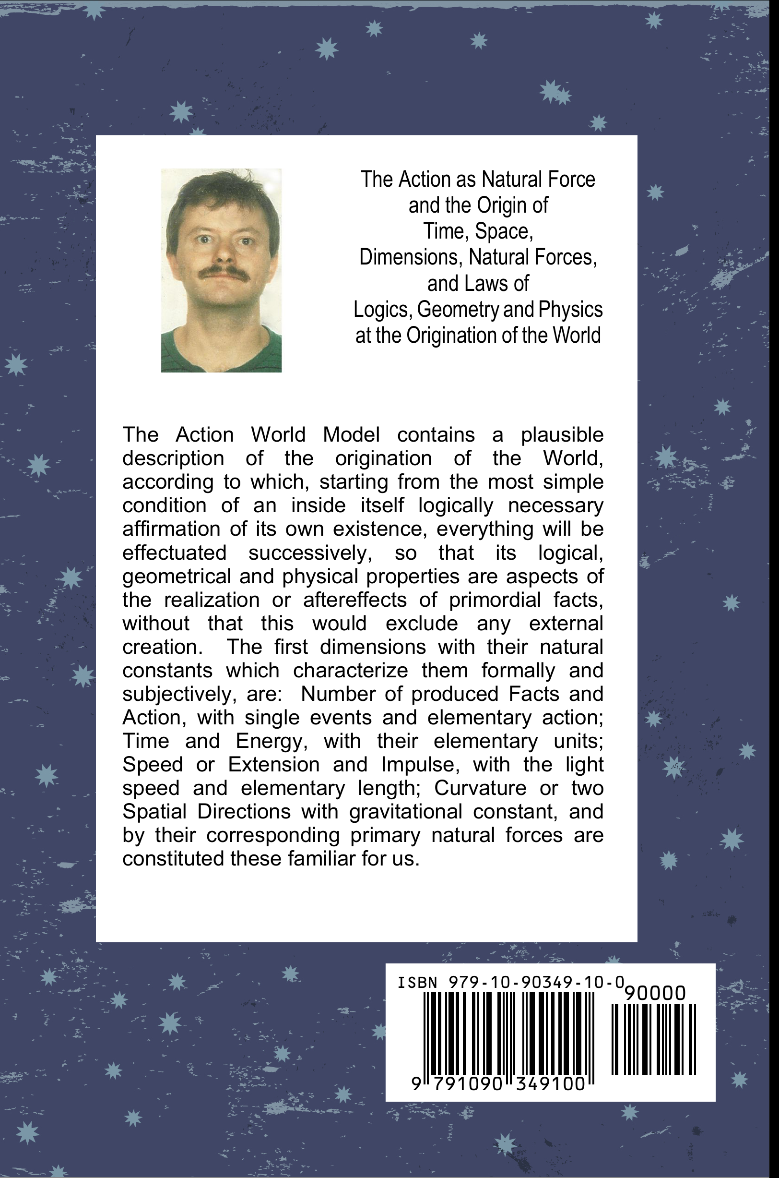

Work by the author to this topic

Landgraf, W.: Welt und Wirkungsprinzip. 1997 (1.Aufl.) ISBN 979-10-90349-00-1 , 978-1-4457-3829-1 , 2010 (2.Aufl.) ISBN 979-10-90349-01-8 , 979-10-90349-02-5 , 978-1-4457-4129-1 , 978-1-4457-3071-4 , 978-1-4515-8456-1

