Adding favourites in the Internet

There are some web pages that you use all the time, for example the ones with English grammar, exercises, etc. You can mark them and keep them in Favourites so that next time you want to visit them it’s easier and quicker.

- Choose one of the web addresses in the box below
- Open the Internet
- Open the website you have chosen
- Click on Favourites on the toolbar

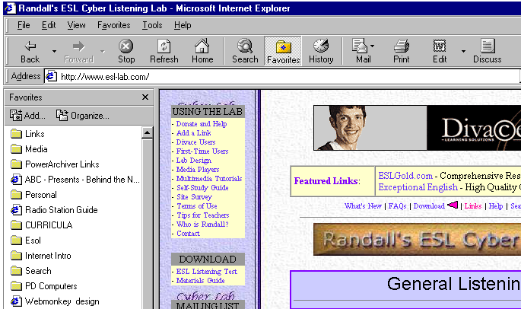
- On the left hand side of your screen a new window will appear. Click on the Add button
- An Add Favourite dialogue box will appear. Click on OK.

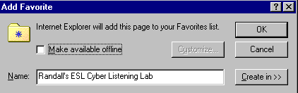

Pronunciation | http://www.esl-lab.com/pron1.htm
Listening | http://www.englishlistening.com/
Randall’s ESL Cyber Listening | http://www.esl-lab.com/
Grammar exercises  Dave’s ESL Cafe | http://www.pacificnet.net/~sperling
TFLGames | http://www.teflgames.com/interactive.html
ACL | http://www.acl.edu.au/englishnet/
The Internet TSL Journal | http://iteslj.org (go to For Students)
Self-Study Quizzes for ESL students | http://www.teflgames.com/interactive.html
Sofweb: Using the internet | http://www.sofweb.vic.edu.au/internet/intro.htm
Meet the Sotomayor Family | http://www.lsilver.net/readhispan4.htm
Enchanted Learning | http://roble.pntic.mec.es/~rgonza3/cpr.html
IATEFL Young Learners | http://roble.pntic.mec.es/~rgonza3/cpr.html
CNN ESL Web exercises | http://lc.byuh.edu/CNN_N/CNN-N.html
Englishforum ESL exercises | http://www.englishforum.com/00/interactive/
E.L.Easton | http://eleaston.com/quizzes.html

You can save this page and add any interesting websites to it.

